MFC2 Data Analysis Master Document

Grace Rubin

February, 16, 2025

Table of Contents

# Overview

This is the master document organizing all MFC2 data analyses! Think of this as a data summary + table of contents. Specific analyses will be conducted and figured generated within linked RMarkdown files, acting like chapters. With this file, you can easily locate specific analyses of interest.

## *Study Design and Main Goals Review*

**MFC2** = “Maternal-Fetal Conflict 2” = 2nd pilot study investigating the role of the gut microbiome in mediating maternal-fetal conflict over gestational energy allocation.

We investigated two main questions in this pilot:

1. How do placental lactogen *(PL)* and placental growth hormone *(PGH)* alter the composition of the gut microbiome?
2. To what extent are the metabolic effects of each hormone dependent on the presence of a gut microbiome?

Here’s an unpolished schematic overview of the study design: 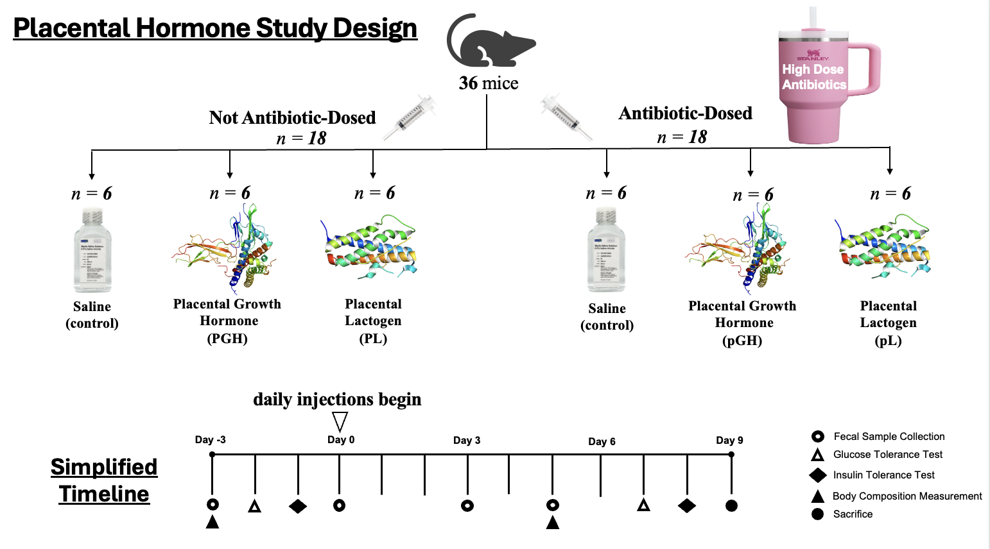

* We had six different groups spread out over two arms. In the first arm, we had groups for mice receiving each of the two hormones, as well as a group of mice injected with saline as the control group.
  + This allows to target our first question and assess the effect of each hormone on gut microbiome composition using fecal samples taken over the course of the experiment.
* Our second experimental arm used mice that received high doses of antibiotics (enrofloxacin + ampicillin) in their drinking water to knock down the gut microbiome. This allowed us to see the effects of each hormone on metabolism in mice with a typical gut microbiome and those with a greatly reduced microbial load.
  + This allows us to identify what, if any, of the metabolic effects of these hormones might occur through interactions with the gut microbiome.

## *Data Structure*

Here’s a schematic overview of the various data types collected and analyses that were run: 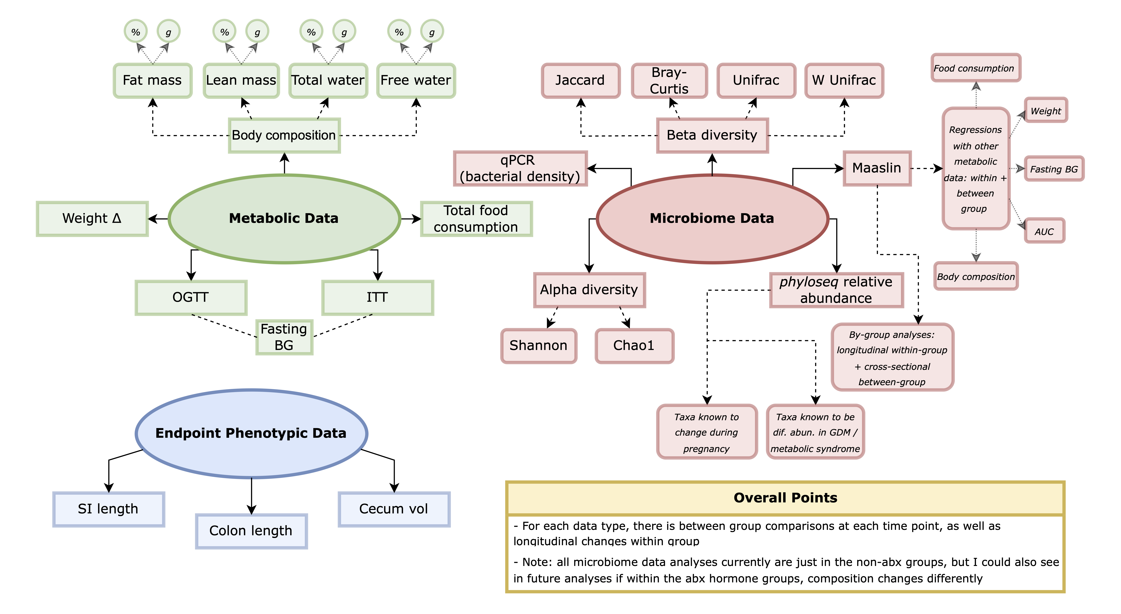

# 1. Endpoint Phenotypic Data

Note: This was probably the least interesting data collected.

## 1.a. Overview

Our endpoint phenotypic data consists of the following measurements:

1. Small intestine length (cm)
2. Colon length (cm)
3. Cecal contents (g)

Here’s an interactive table to take a look at the raw endpoint data:

Here’s a summary table of the three endpoint phenotypic parameters across the six groups:

**For phenotypic data, our analyses will be broken down as follows:**

1. Does Measurement A significantly differ between Hormone X and Saline within the same ABX group?
   * *e.g. does SI length significantly differ between ABX mice receiving saline and PGH?*
2. Does Measurement A significantly differ between mice with and without a typical gut microbiome receiving the same hormone?
   * *e.g. does SI length significantly differ between ABX and Non-ABX mice receiving PL?*

## 1.b. Regressions of SI vs Colon

Before examining each individual metric, I was curious what the relationship is between colon and SI lengths. Do mice with larger SIs also tend to have larger colons? 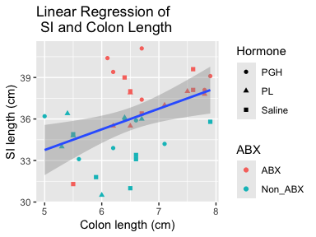[1] “The linear model is significant. p = 0.00756 and R^2 = 0.168 .” 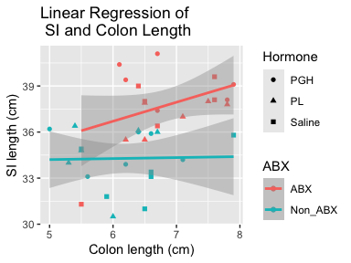For the ABX mice, The linear model is not significant. p = 0.105 and R^2 = 0.103 . For the Non-ABX mice, The linear model is not significant. p = 0.92 and R^2 = -0.0618 .

Those results were not particularly interesting.

## 1.c. Small Intestine Lengths Across Groups

First let’s just take a look at the data across all groups: 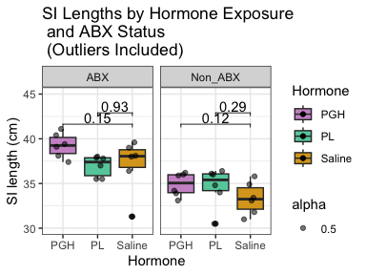

NOTES:

* There are some outliers in this data. I’m going to filter to remove those points and replot.
* I think ideally I’d want to include the outliers in the visualization and just remove them from the stats, but I couldn’t figure out how to do that.
* I’m running these stats as t-tests for now. Could change to wilcox later if I wanted / needed to.
* The y-axes ranges look a bit wonky because I want them to be consistent across plots while leaving room for the labels.

Outliers detected and removed: 2 outlier(s). 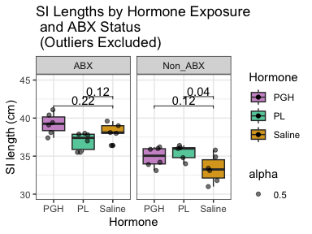

*Takeaways:* *With outliers excluded,* there is a signif difference in SI length between PL and saline-exposed mice with a conventional gut microbiome, but not between those who received antibiotics. No other within-abx-group comparisons reached significance. When the data is left as-is, there are no significant differences between hormone groups.

Now let’s rearrange the data to be faceted by hormone group, comparing abx and non abx mice. 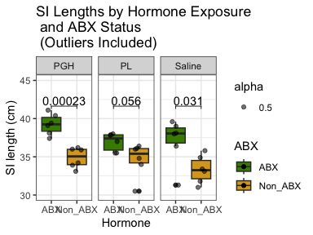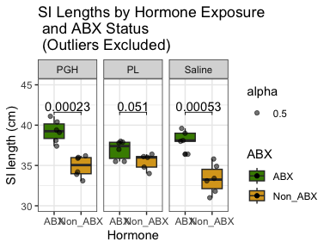 *Takeaways:* As expected, mice exposed to antibiotics have longer small intestines than those with a complete conventional gut microbiome. However, this difference only reaches significance in Saline and PGH mice. In PL mice, we approach but don’t quite hit the 0.05 threshold. This is true regardless of the inclusion or exclusion of outliers.

## 1.d. Colon Lengths Across Groups

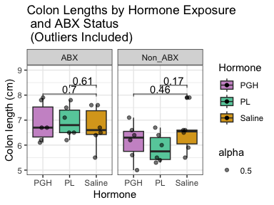 *Takeaways:* No observed difference in colon length across hormone groups. I didn’t bother to remove outliers from this data because it seemed clear to me that it wouldn’t make any difference.

Now let’s rearrange to compare each hormone group by abx status: 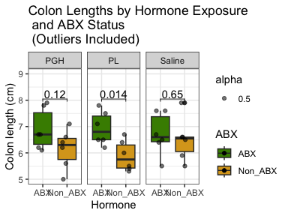

*Takeaways:* Colon lengths were generally longer in mice exposed to antibiotics in all hormone exposure groups, but this only reached significance in the PL-exposed mice. Note: I reran this excluding the one saline non-abx outlier, but it made no difference. The range of colon lengths within each group was also quite large, especially for the abx-exposed mice.

## 1.e. Cecal Contents Across Groups

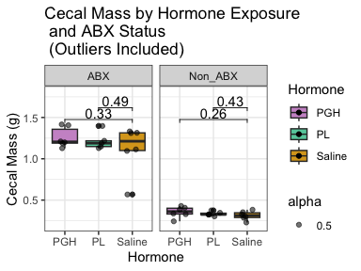 *Takeaways:* No observed difference in cecal mass across hormone groups. I didn’t bother to remove outliers from this data because it seemed clear to me that it wouldn’t make any difference.

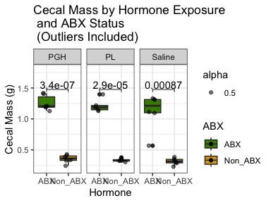 *Takeaways:* As expected, regardless of hormone exposure, mice exposed to antibiotics have much larger cecums than those with a conventional gut microbiome.

# 2. Metabolic Data

# 2.a. Glucose and Insulin Tolerance

## 2.a. Overview

* Each mouse received an OGTT and an ITT at baseline and endpoint. Therefore, we can assess the effects of hormone treatment via:
  + Intragroup / intramouse longitudinal changes from baseline to endpoint
  + Cross-sectional differences between groups at endpoint
* Useful group comparisons:
  + We can compare metabolic test results in hormone-exposed mice with results in saline-exposed mice within the *same microbiome condition* (Non-ABX or ABX) to quantify the metabolic effects of each hormone under a given gut microbiome environment.
  + We can compare metabolic test results in mice exposed to the same hormone but under *different microbiome conditions* to isolate any additive or interaction effects of hormones and gut microbiome presence on glucose homeostasis.
* For each test, we can look at:
  + The response over time (typical curve) in absolute numbers
  + Area under the curve (AUC)
  + The response over time as a % change from the fasting BG
    - *In the literature, this is more commonly shown for ITTs than OGTTs*
  + Fasting blood glucose from both tests (2 baseline and 2 endpoint measurements per mouse)

Here’s a simple review of the difference between what OGTTs and ITTs tell us:

* **OGTT**: Measures how efficiently an organism processes glucose, assessing glucose tolerance and the overall function of glucose regulatory mechanisms. A mouse’s response to an OGTT depends on both the ability of the pancreas to secrete insulin in response to glucose and the effectiveness of tissues (e.g., muscle, liver, adipose tissue) in taking up glucose out of circulation. Poor glucose processing during an OGTT suggests **glucose intolerance.**
* **ITT**: Measures how effectively insulin lowers blood glucose levels (i.e. the sensitivity / responsiveness of tissues to insulin). Reduced glucose clearance during an ITT suggests **insulin resistance**. Together, OGTTs and ITTs provide us with a complementary look at glucose homeostasis.
* **AUC** is a quantitative measure of the total blood glucose exposure over time during an OGTT or ITT. It is calculated by summing the area under the glucose curve generated by plotting glucose levels against time (i.e. integration). AUC allows for easy comparison between groups or treatments by summarizing complex time-series data into a single, interpretable metric.

NOTES:

* Two glucose measurements were taken for each mouse at each time point. If the 2 measurements were >25 apart, a 3rd measurement was taken. Mean blood glucose (of the 2-3 measurements) was calculated. Measurements >1 SD away from the mean were removed, and the mean was re-calculated.
* While OGTTs have a nearly 100% successful execution rate, ITTs occasionally are unsuccessful (likely due to human error in injection). For this experiment, I set a cutoff for a successful ITT as a >15% drop in blood glucose levels from fasting (time 0) to time 15. Data from tests that failed to meet this threshold were not included in the final data files. Unfortunately, this means that some mice do not have both baseline and endpoint ITT measurements.

## 2.a.i. OGTT and ITTs at baseline

While less relevant to the hypotheses of this project, it’s notable that there are differences between responses to the tolerance tests in abx and non-abx mice prior to any hormone injections (at baseline).

### Absolute Responses

Here are two visualizations of those baseline differences. The first shows the mean response with standard error bars, and the second shows each individual mouse’s response with the group means overlaid: 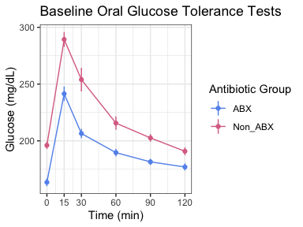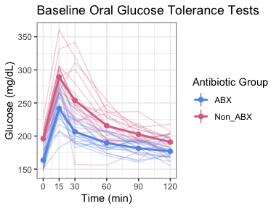

Below is the same two visualization styles, but for ITT responses: 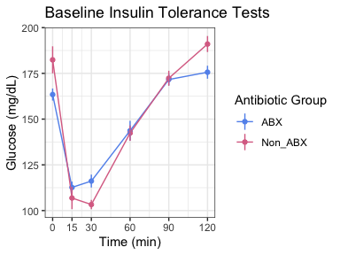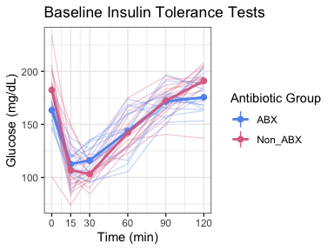

### AUC

Now let’s look at the AUCs for the baseline OGTT and ITTs in ABX and Non-ABX mice:

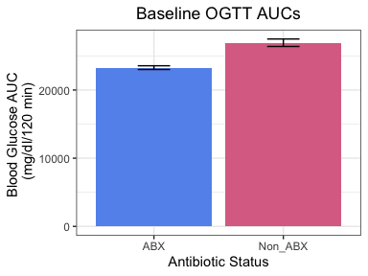

Is there a significant difference at baseline between ABX and non-ABX OGTT AUCs? [1] “The t-test result is significant. p = 3.17e-06 .”

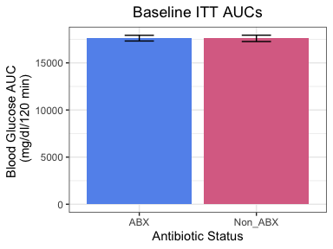

Is there a significant difference at baseline between ABX and non-ABX ITT AUCs?

[1] “The t-test result is not significant. p = 0.962 .”

*Key takeaway:* We are observing discordance between the OGTT and ITT data. The OGTT data shows greater glucose tolerance (indicating lower insulin resistance) in the *ABX* mice (as expected), while in the ITT data, the *Non-ABX* mice exhibit greater glucose drops (potentially indicating lower insulin resistance). This apparent contradiction may be resolved by looking at both in terms of % change in addition to absolute change:

### Percent Change Responses

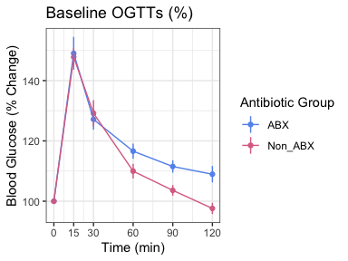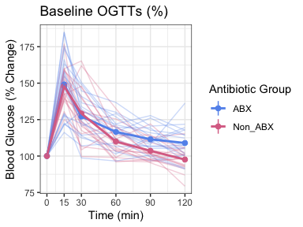

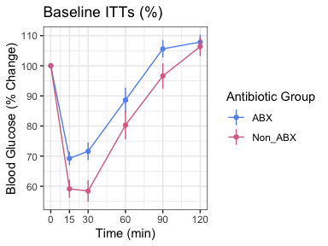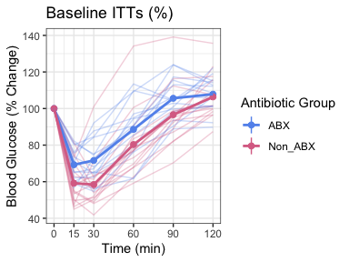

NOTE: I’m unsure if it would make sense to calculate AUCs for the %-based graphs. There’s certainly an argument for it, but I don’t think I’ve ever seen it.

### Fasting BG

In both tests, there is a clear pattern of lower fasting BG in ABX mice. This aligns with our previous findings. We can combine the fasting BG levels at both tests (since both are baselines, just a day apart), and run an LME to test the significance of these fasting differences.

[1] “The linear mixed-effects model shows that the effect is significant. p = 1.98e-05 .” As expected, there is a significant effect of ABX-status on fasting blood glucose levels (p = 0.00002).

## 2.a.ii. Longitudinal changes in OGTTs and ITTs in each group

### Absolute Response Over Time

OGTTs Each hormone longitudinally in mice with a conventional gut microbiome: 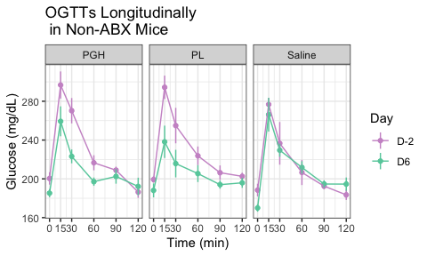

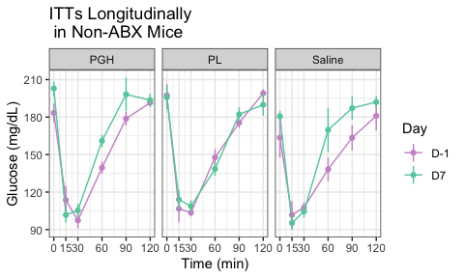

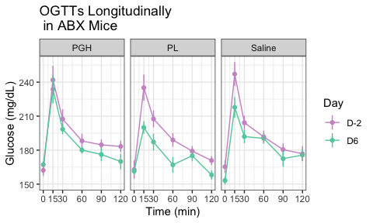

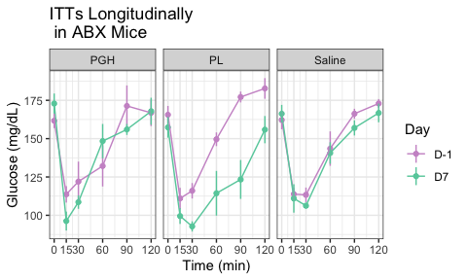

### AUC

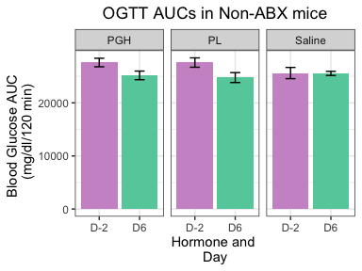

Are any of these differences statistically significant? Since this is longitudinal changes, I can run paired t-tests.

1. PGH Non ABX Baseline to Endpoint OGTT: [1] “The t-test result is not significant. p = 0.0646 .”
2. PL Non ABX Baseline to Endpoint OGTT: [1] “The t-test result is significant. p = 0.013 .”
3. Saline Non ABX Baseline to Endpoint OGTT: [1] “The t-test result is not significant. p = 0.951 .”

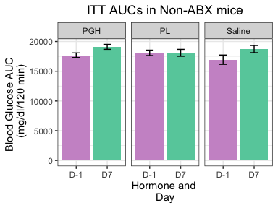

Are any of these differences statistically significant? Not that while for the OGTTs, I could run paired t-tests, since some ITTs failed, I can only run unpaired t-tests.

1. PGH Non ABX Baseline to Endpoint ITT: [1] “The t-test result is significant. p = 0.0437 .”
2. PL Non ABX Baseline to Endpoint ITT: [1] “The t-test result is not significant. p = 0.995 .”
3. Saline Non ABX Baseline to Endpoint ITT: [1] “The t-test result is not significant. p = 0.111 .”

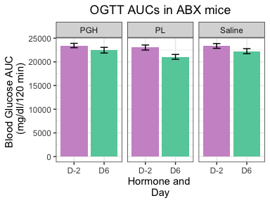

1. PGH ABX Baseline to Endpoint OGTT: [1] “The t-test result is not significant. p = 0.133 .”
2. PL ABX Baseline to Endpoint OGTT: [1] “The t-test result is significant. p = 0.00985 .”
3. Saline ABX Baseline to Endpoint OGTT: [1] “The t-test result is not significant. p = 0.297 .”

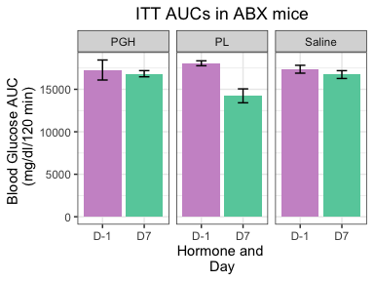

1. PGH ABX Baseline to Endpoint ITT: [1] “The t-test result is not significant. p = 0.752 .”
2. PL ABX Baseline to Endpoint ITT: [1] “The t-test result is significant. p = 0.0133 .”
3. Saline ABX Baseline to Endpoint ITT: [1] “The t-test result is not significant. p = 0.366 .”

### Percent Change Response Over Time

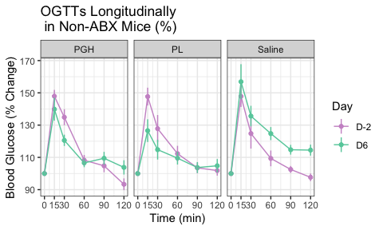

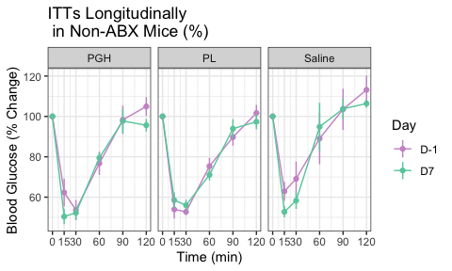

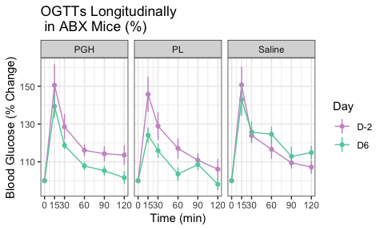

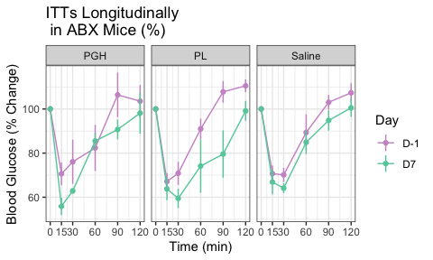

### Fasting BG

In each of the six groups, I want to see if there is a longitudinal change in fasting BG.

* Similar to what I did for baseline, I can combine the OGTT and ITT fasting BG values and run LMEs with mouse ID as a random effect (i.e., 4 values / mouse, 2 at each time point) to increase my power to detect longitudinal changes.
* Note that particularly in the ABX mice, I predict that fasting BG may decrease in all groups, including saline, because even though they are on ABX at both timepoints, there may be an additive effect of longer-term ABX exposure on BG levels.
* I’m actually not sure by looking at the figures that any will be significant, but we’ll see!
  1. PGH Non-ABX Baseline to Endpoint: [1] “The linear mixed-effects model shows that the effect is not significant. p = 0.67 .”
  2. PL Non-ABX Baseline to Endpoint: [1] “The linear mixed-effects model shows that the effect is not significant. p = 0.304 .”
  3. Saline Non-ABX Baseline to Endpoint: [1] “The linear mixed-effects model shows that the effect is not significant. p = 0.254 .”
  4. PGH ABX Baseline to Endpoint: [1] “The linear mixed-effects model shows that the effect is not significant. p = 0.623 .”
  5. PL ABX Baseline to Endpoint: [1] “The linear mixed-effects model shows that the effect is not significant. p = 0.282 .”
  6. Saline ABX Baseline to Endpoint: [1] “The linear mixed-effects model shows that the effect is not significant. p = 0.649 .”

So *NO* groups saw significant changes in fasting BG from baseline to endpoint. Despite some clear changes in tolerance test responses. That’s interesting!

## 2.a.iii. Endpoint OGTTs and ITTs in each hormone group vs saline

### Absolute Responses

Endpoint OGTTs in each hormone group:

*We can include all 3 hormone groups together, or to make seeing patterns visually easier, separate each hormone to just be vs saline* 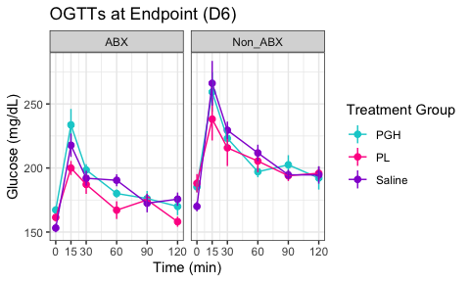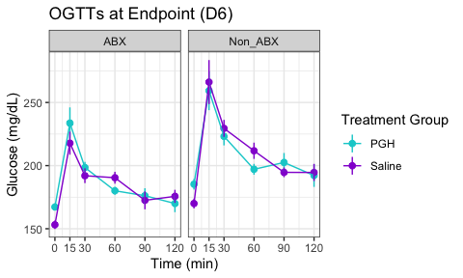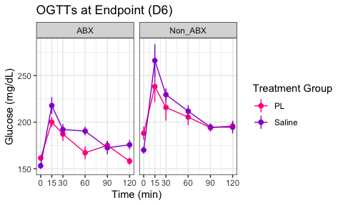

Endpoint ITTs in each hormone group: 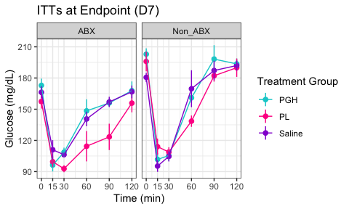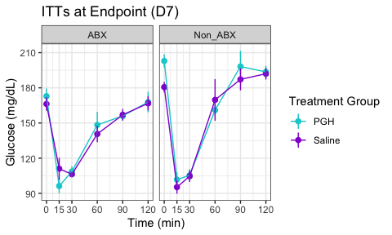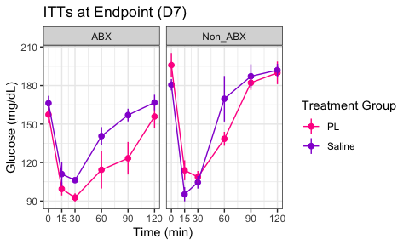

### AUC

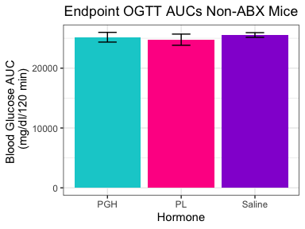

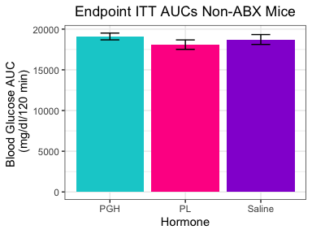

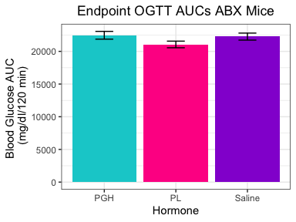

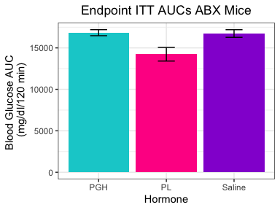

Now we can test the stats for each of these AUC pairings.

**Non-ABX**

***PGH vs Saline***

*OGTT* [1] “The t-test result is not significant. p = 0.692 .”

*ITT* [1] “The t-test result is not significant. p = 0.627 .”

***PL vs Saline***

*OGTT* [1] “The t-test result is not significant. p = 0.465 .”

*ITT* [1] “The t-test result is not significant. p = 0.472 .”

**ABX**

***PGH vs Saline***

*OGTT* [1] “The t-test result is not significant. p = 0.803 .”

*ITT* [1] “The t-test result is not significant. p = 0.869 .”

***PL vs Saline***

*OGTT* [1] “The t-test result is not significant. p = 0.135 .”

*ITT* [1] “The t-test result is significant. p = 0.0475 .” ***  
### Percent Change Responses

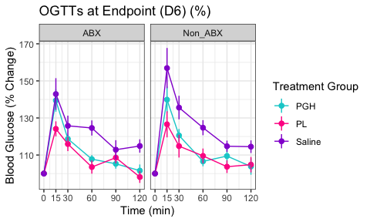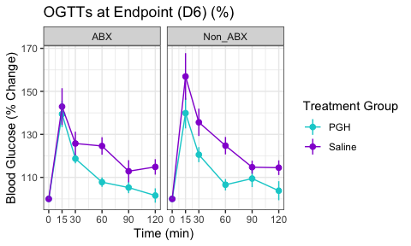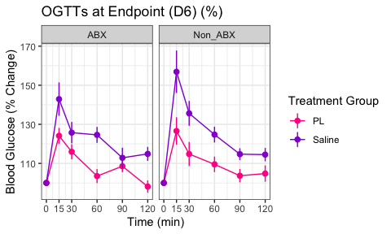

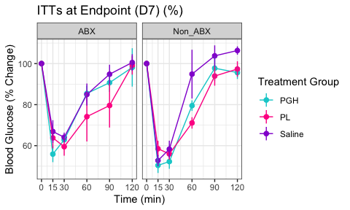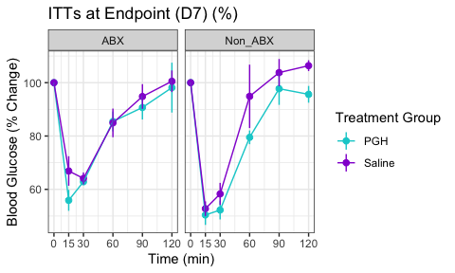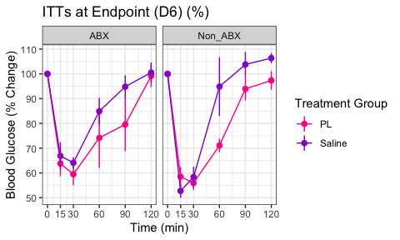

### Fasting BG

Now let’s see if there are statistically significant differences between the hormone groups in endpoint fasting BG values.

* Similar to what I did for the prior fasting BG analyses, I will combine the OGTT and ITT fasting BG values and run LMEs with mouse ID as a random effect (i.e., 2 values / mouse) to increase my power to detect group differences.

**Non-ABX**

***PGH vs Saline*** [1] “The linear mixed-effects model shows that the effect is significant. p = 0.00257 .”

***PL vs Saline*** [1] “The linear mixed-effects model shows that the effect is significant. p = 0.0497 .”

**ABX**

***PGH vs Saline*** [1] “The linear mixed-effects model shows that the effect is significant. p = 0.0294 .”

***PL vs Saline*** [1] “The linear mixed-effects model shows that the effect is not significant. p = 0.772 .”

## 2.a.iv. Endpoint OGTTs and ITTs in each hormone group abx vs non-abx

### Absolute Responses

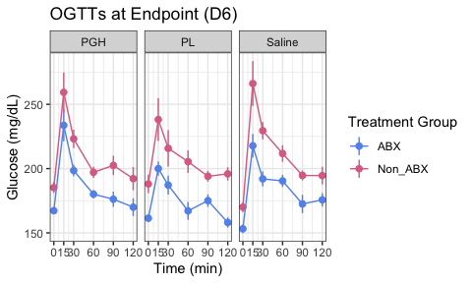

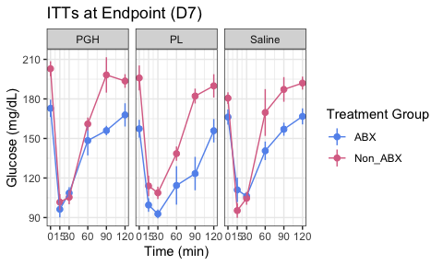

### AUC

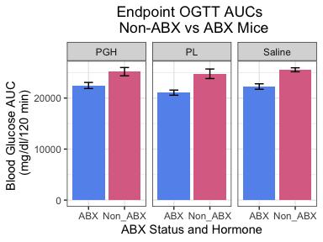

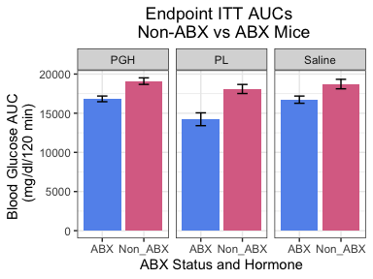

Now we will test the significance for each antibiotic group pairing. I’m guessing these may all be significant.

***PGH ABX vs Non ABX***

*OGTT* [1] “The t-test result is significant. p = 0.0246 .”

*ITT* [1] “The t-test result is significant. p = 0.00461 .”

***PL ABX vs Non ABX***

*OGTT* [1] “The t-test result is significant. p = 0.00881 .”

*ITT* [1] “The t-test result is significant. p = 0.00882 .”

***Saline ABX vs Non ABX***

*OGTT* [1] “The t-test result is significant. p = 0.000758 .”

*ITT* [1] “The t-test result is significant. p = 0.0351 .”

As expected, for all 3 hormone groups, there is a signif dif in AUC for both OGTT and ITT between mice with and without a normal gut microbiome.

### Percent Change Responses

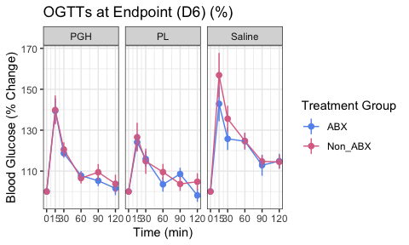

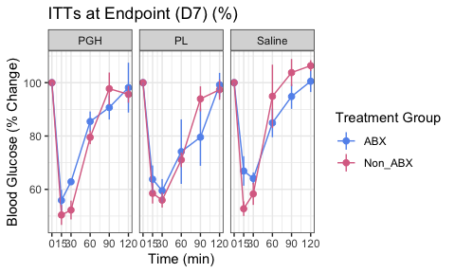 Basically, it looks like the metabolic differences between ABX and Non-ABX groups are largely driven by changes in fasting BG, so converting to % change makes them go away. But the metabolic differences between hormone groups are NOT driven by fasting BG, so they largely remain or sometimes magnify upon converting to % change.

### Fasting BG

Now let’s see if there are statistically significant differences between the abx groups for each hormone in endpoint fasting BG values. Based on what we’ve seen so far, we can expect them all to be significant.

* Similar to what I did for the prior fasting BG analyses, I will combine the OGTT and ITT fasting BG values and run LMEs with mouse ID as a random effect (i.e., 2 values / mouse) to increase my power to detect group differences.

***PGH ABX vs Non ABX*** [1] “The linear mixed-effects model shows that the effect is significant. p = 0.000278 .”

***PL ABX vs Non ABX*** [1] “The linear mixed-effects model shows that the effect is significant. p = 0.00312 .”

***Saline ABX vs Non ABX*** [1] “The linear mixed-effects model shows that the effect is significant. p = 0.00287 .”

# 2.b. Body Composition

## 2.b. Overview

The EchoMRI produces the following measurements:

1. Fat mass
2. Lean mass
3. Total water
4. Free water

These are recorded as absolute masses in grams, but I have also converted them to percentage of body mass for an additional way to assess body composition.

Similar to the metabolic tests, each mouse was measured at baseline and endpoint. Therefore, we can assess the effects of hormone treatment via:

* Intragroup / intramouse longitudinal changes from baseline to endpoint
* Cross-sectional differences between groups at endpoint
  + We can compare endpoint body comp features in hormone-exposed mice with results in saline-exposed mice within the *same microbiome condition* (Non-ABX or ABX) to quantify the effects of each hormone on body comp under a given gut microbiome environment.
  + We can compare body comp features in mice exposed to the same hormone but under *different microbiome conditions* to isolate any additive or interaction effects of hormones and gut microbiome presence on glucose homeostasis.

## 2.b.i. Intragroup Longitudinal Changes in Body Comp

Longitudinal changes can be visually represented in a few dif ways:

* Box plots
* Stacked bar graphs (particularly for percentages)
* Line graphs

### Lean mass (g)

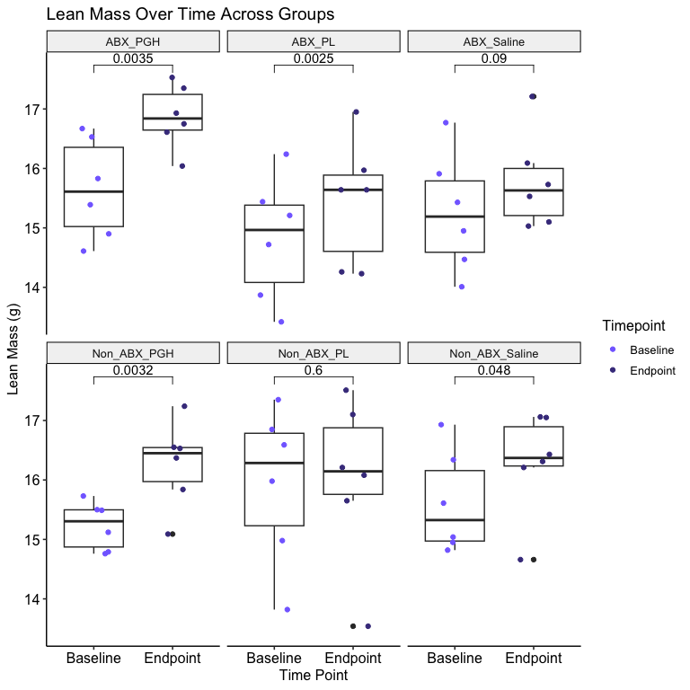

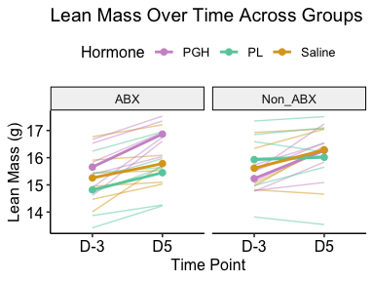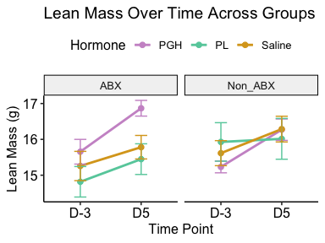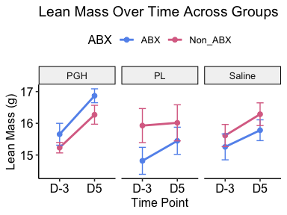

NOTES:

* Because the mice are getting older, we might expect absolute lean mass to increase across the board. That’s why looking at % can be useful too.
* There are some outliers I could consider taking out. I didn’t for now…

### Lean mass (%)

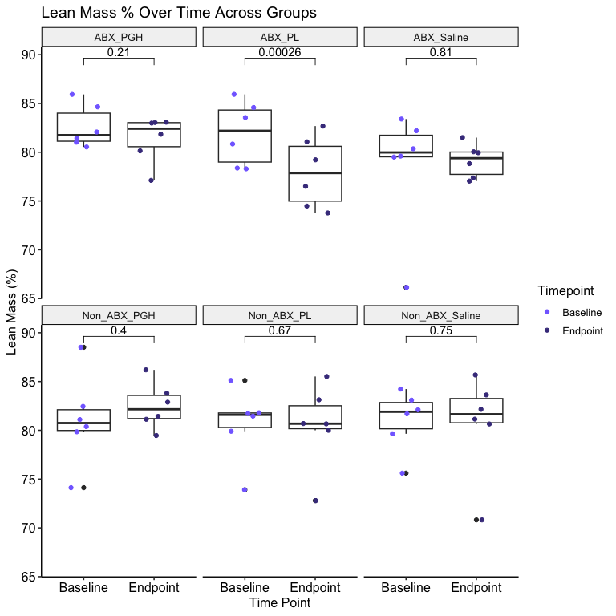

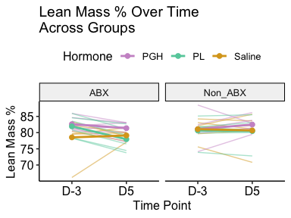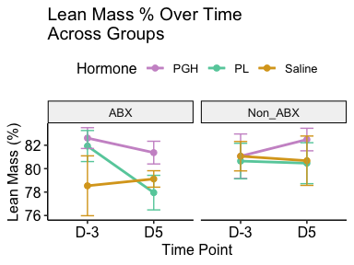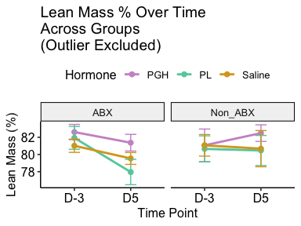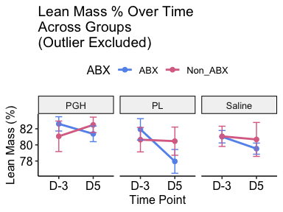

### Fat mass (g)

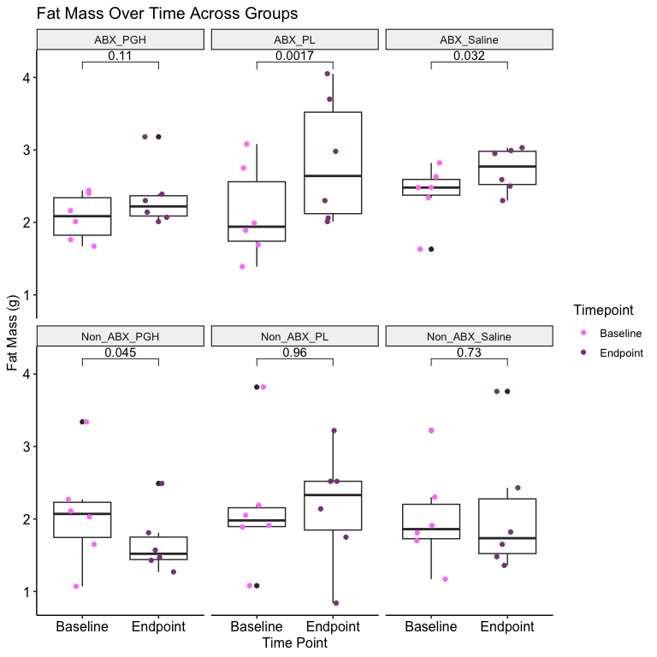

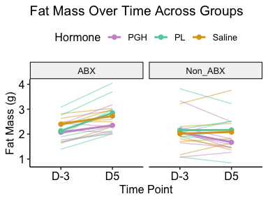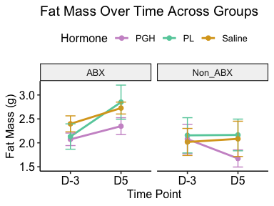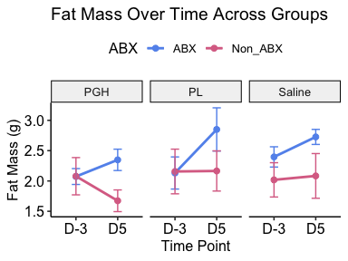

### Fat mass (%)

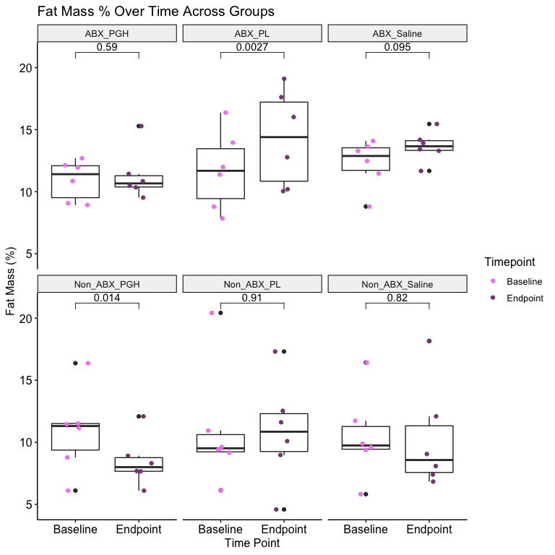

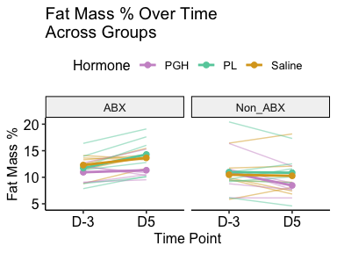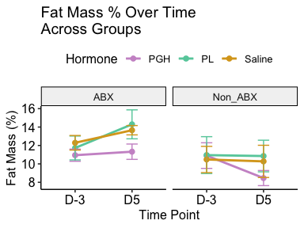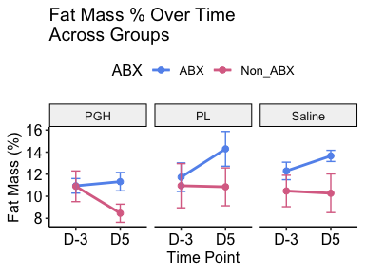

### Total water (g)

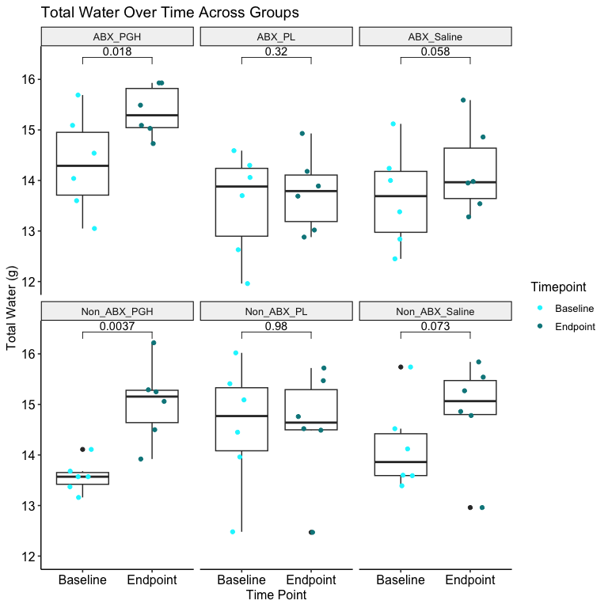

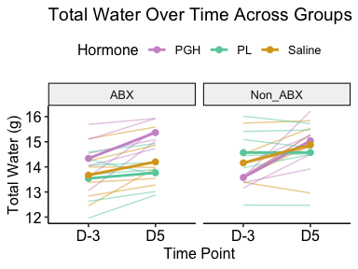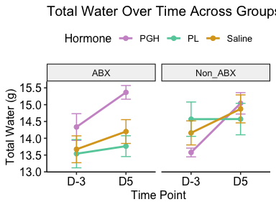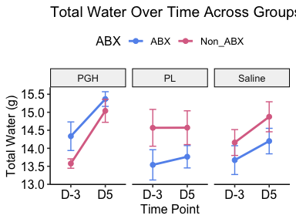

### Total water (%)

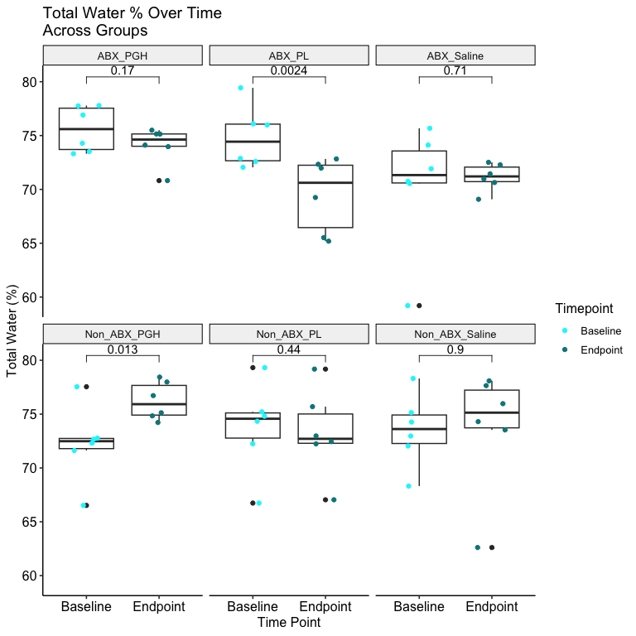

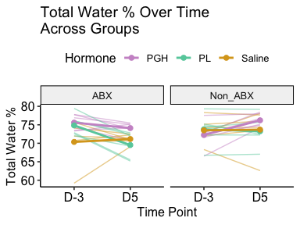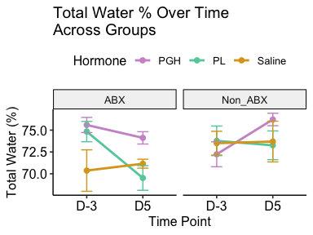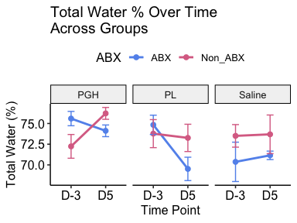

### Free water (g)

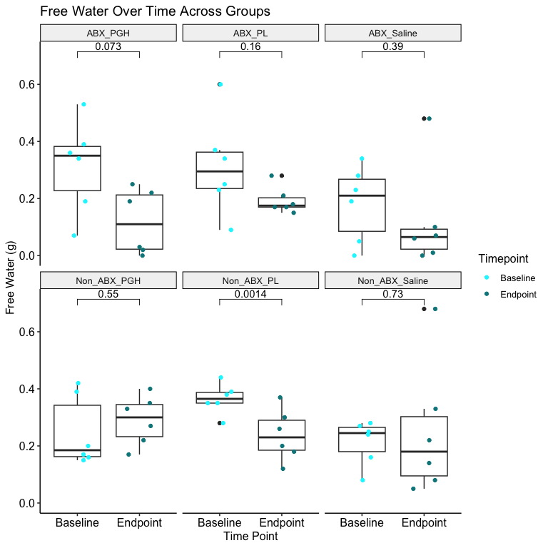

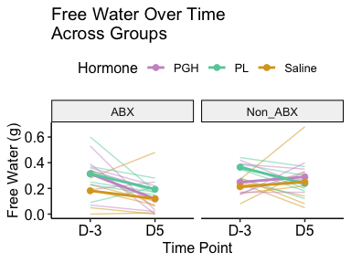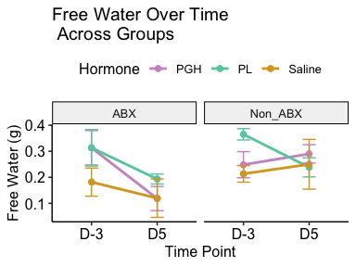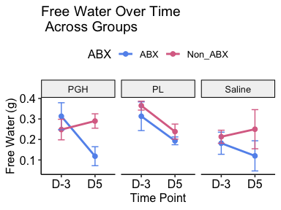

### Free water (%)

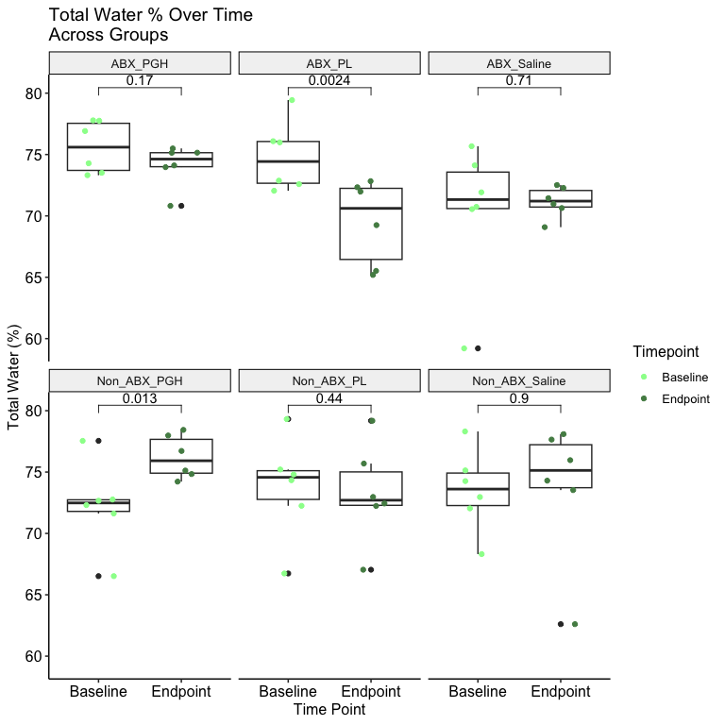



## 2.b.ii. Endpoint Body Comp in each Hormone Group vs Saline

### Lean mass (g)

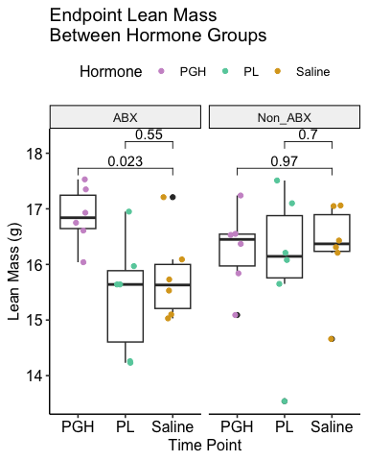

### Lean mass (%)

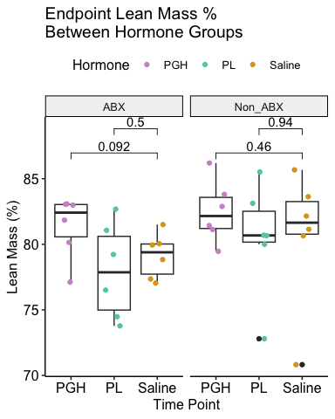

### Fat mass (g)

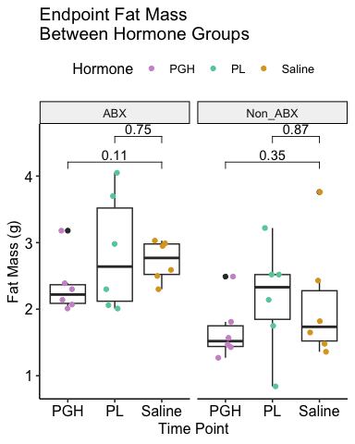

### Fat mass (%)

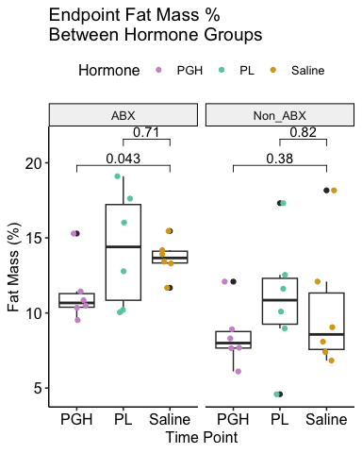

### Total water (g)

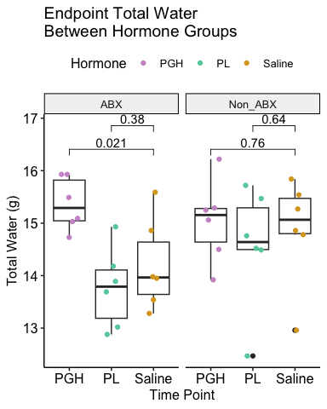

### Total water (%)

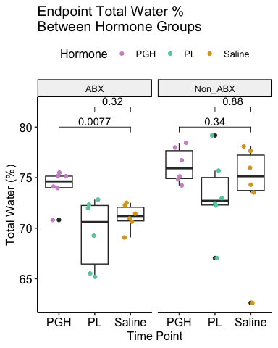

### Free water (g)

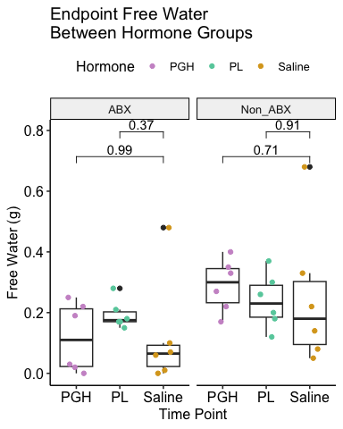

### Free water (%)

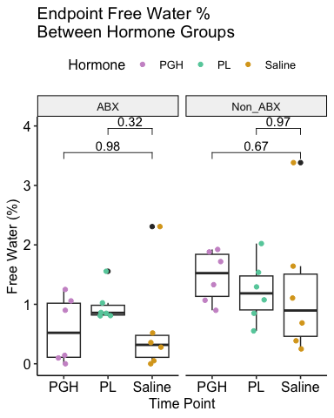

## 2.b.iii. Endpoint Body Comp in each Hormone Group ABX vs Non-ABX

### Lean mass (g)

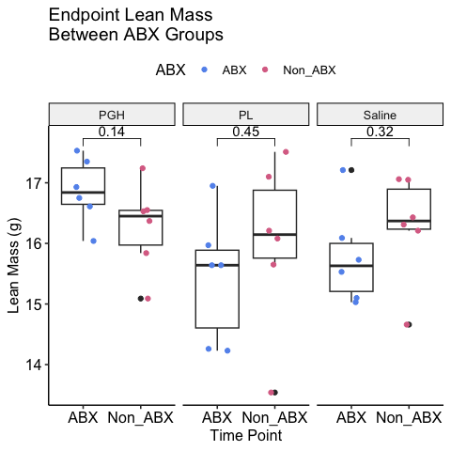

### Lean mass (%)

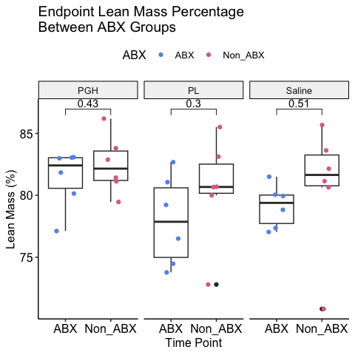

### Fat mass (g)

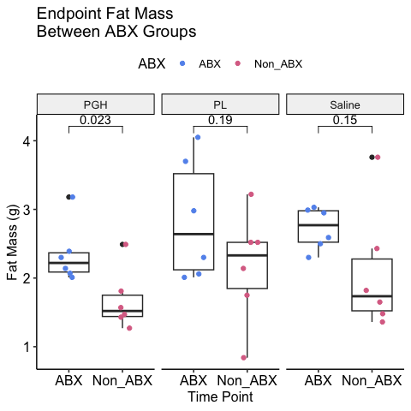

### Fat mass (%)

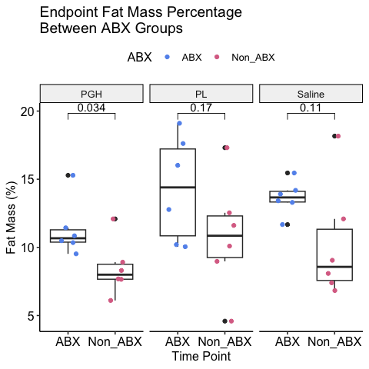

### Total water (g)

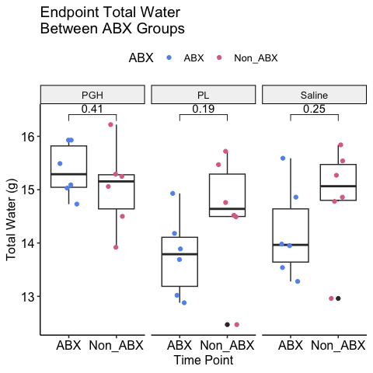

### Total water (%)

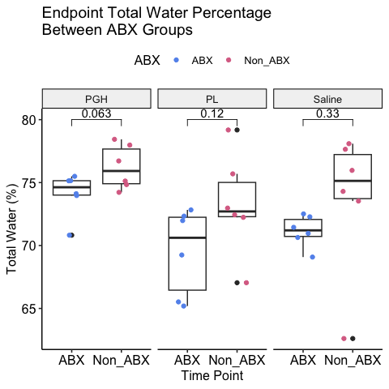

### Free water (g)

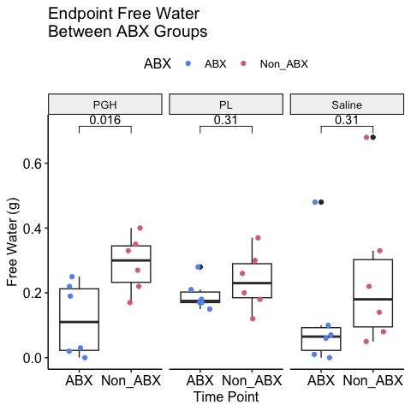

### Free water (%)

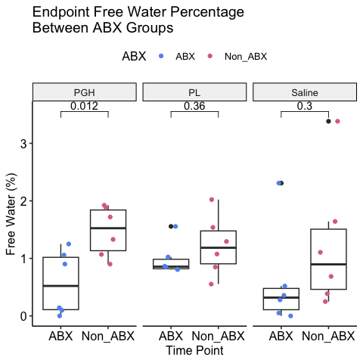

## 2.b.iv. Correlations of Body Comp with other Factors

### Correlations with body weight

Does the relationship between these variables and total body weight differ by ABX status? 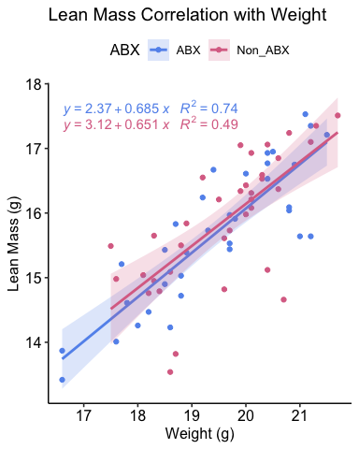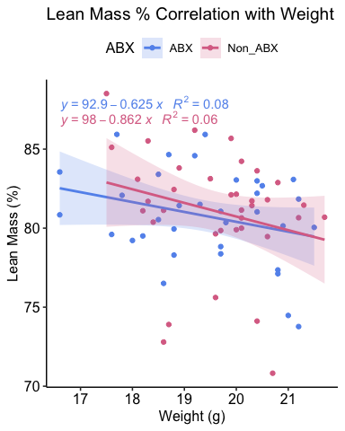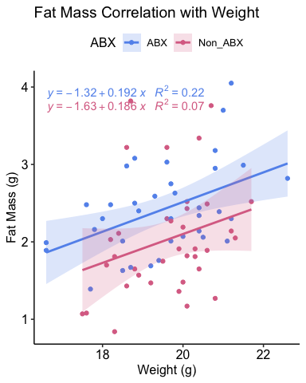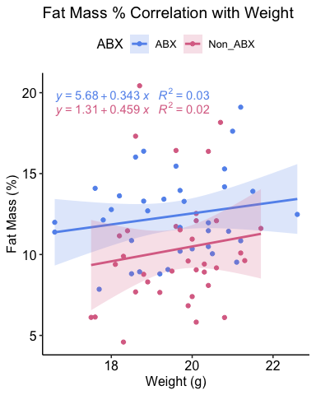 No clear differences in relationship by ABX status.

Let’s plot absolute lean mass (g) vs absolute body weight (g) in each group.

To see if there are differences in this relationship between hormone groups, we will have to filter to only include the endpoint values. This means we will be working with very low sample sizes for a regression, so these are probably going to be not informative graphs. But nonetheless here they are! 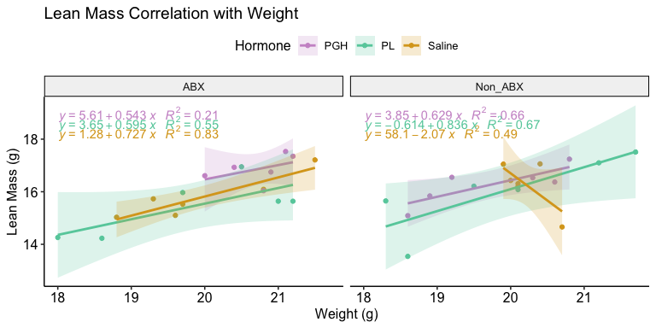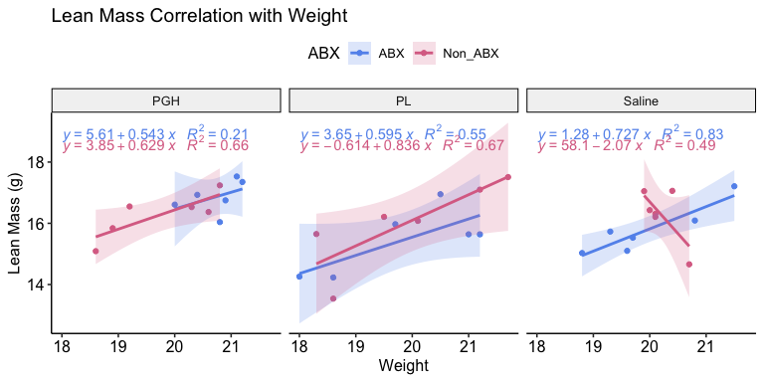

How about lean mass percentage vs absolute body weight (g)? 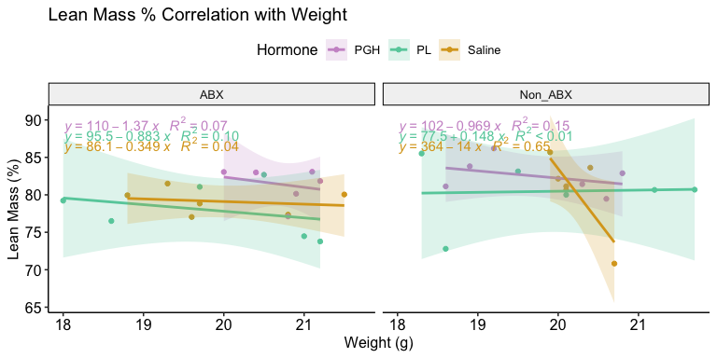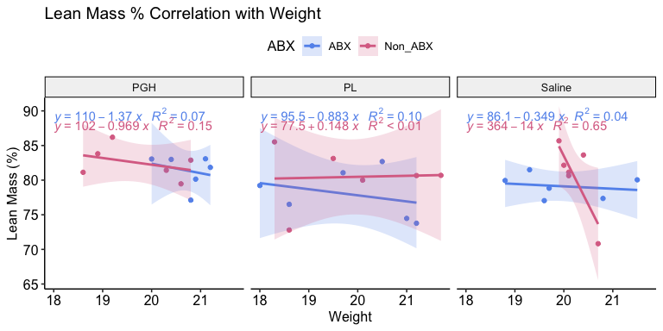

Let’s plot absolute fat mass (g) vs absolute body weight (g) 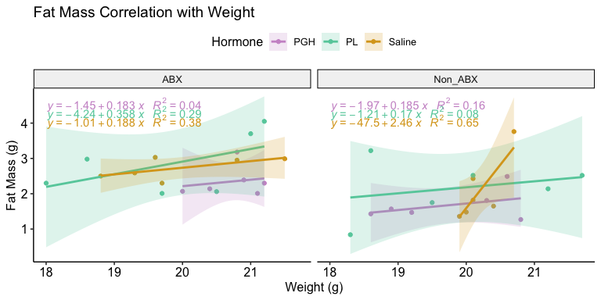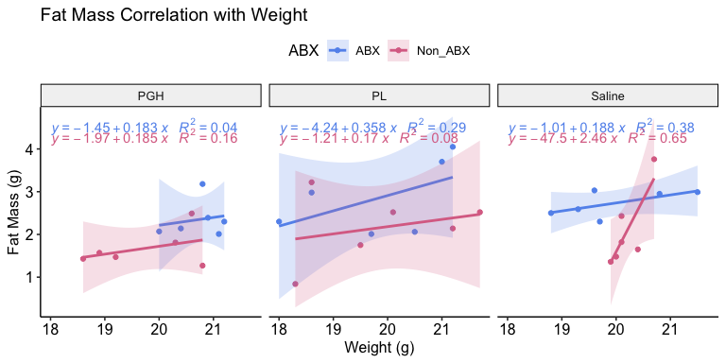

How about free mass percentage vs absolute body weight (g)? 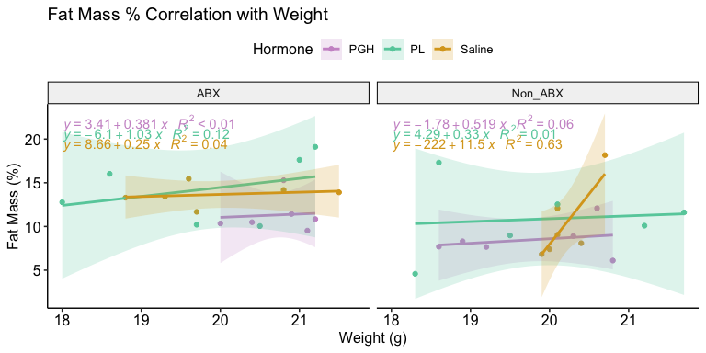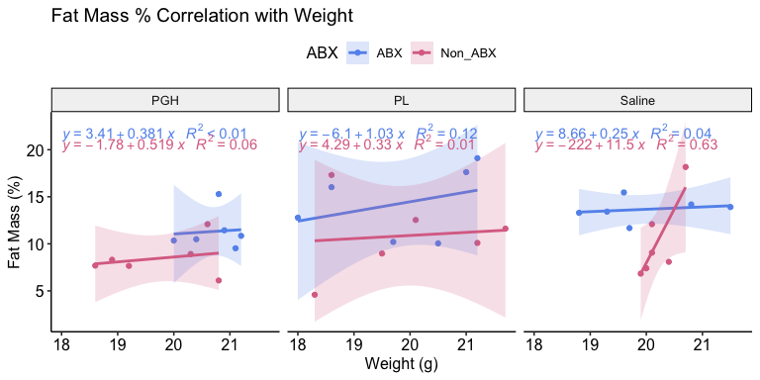 Not that interesting.

# 2.c. Weight

## 2.c. Overview

This section is a simple look at both rates of weight gain and endpoint body mass across the six groups.

## 2.c.i. Longitudinal Changes in Body Weight

### Comparing Hormone Groups

*NOTE:* The longitudinal visualizations below reflect actual recorded weight. No corrections were made for cecal mass. 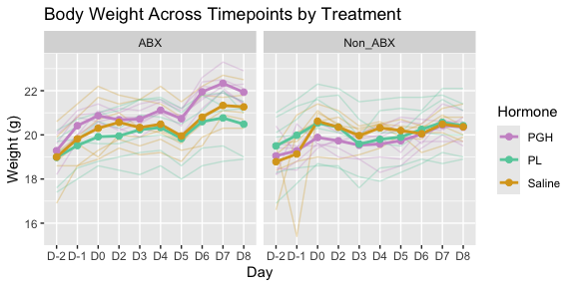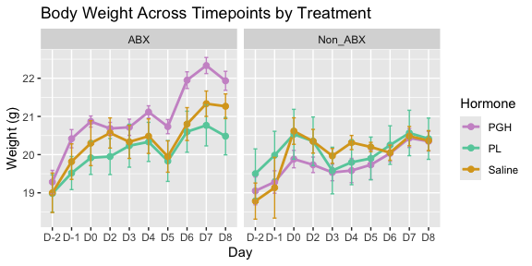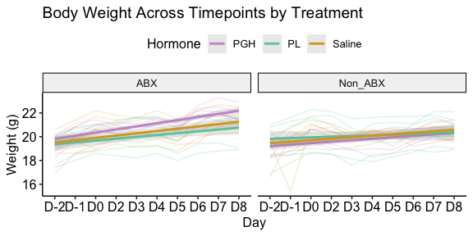

### Comparing Antibiotic Groups

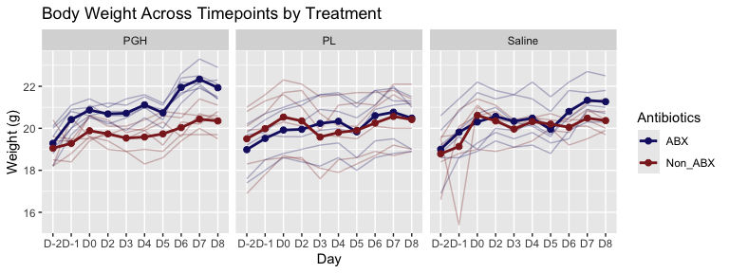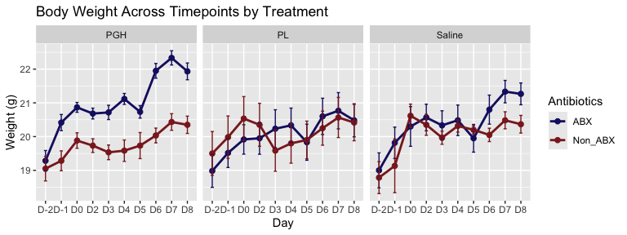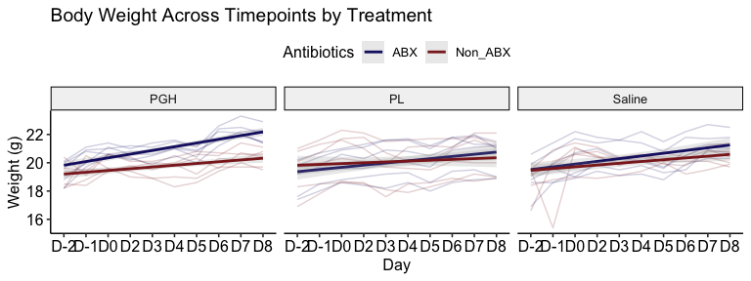

### Statistics

We can use LMEs to see if the rate of change in body mass is significantly different between different groups.

First let’s see within the Non-ABX mice if hormone affects the rate:

Though they don’t look visually distinct to me, some points are significant.

* At Days 0 and 4, there is a significant difference between PGH and Saline. Day 2 is also approaching significance (p = 0.0567).
* At Days 3, 4, and 5, Weight gain rates in PL and Saline are significantly different.

Next let’s see within the ABX mice if hormone affects the rate:

* There is a significant difference between PGH and Saline at Days 6 and 7. Day 5 is also approaching significance (p = 0.066).
* There is a significant difference between PL and Saline at Days 2, 7, and 8

Now we can see within each hormone group if the Non_ABX and ABX mice significantly differ in weight gain rates (remembering that these LMEs are not considering cecal mass).

As a simple non-interaction fixed effect, antibiotics affects weight gain in pgh mice (p = 0.001). As an interaction effect, antibiotics are significant at every day.

As a simple non-interaction fixed effect, antibiotics do not significantly affect weight gain in pl mice.

As an interaction effect, the weight gain slopes significantly differ at days 3, 4, 6, 7, and 8.

As a simple non-interaction fixed effect, antibiotics do not significantly affect weight gain in saline mice.

As an interaction effect, the weight gain slopes do not significantly differ at any days.

## 2.c.ii. Endpoint differences in Body Weight

By D8, we can assume that cecum mass is contributing significantly to body weight in the antibiotic mice. For these endpoint comparisons, we will calculate them both corrected for cecal mass and uncorrected. I’m subtracting by full cecal mass rather than cecal contents, because the effect of abx on the mass of the cecal epithelium also seems worth correcting for to me. But I could easily switch this to cecal contents!

### Comparing Hormone Groups

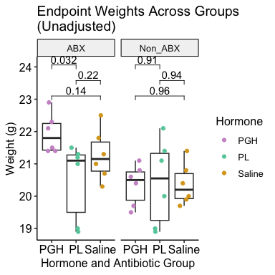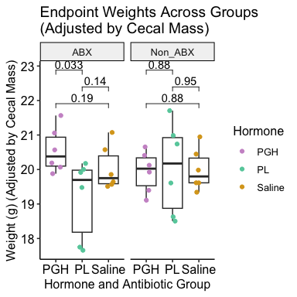

### Comparing Antibiotic Groups

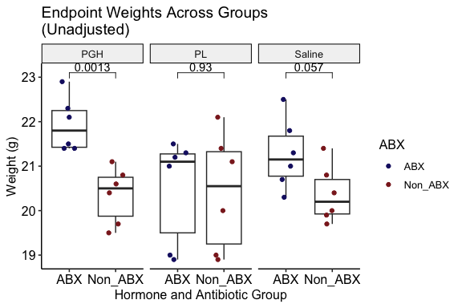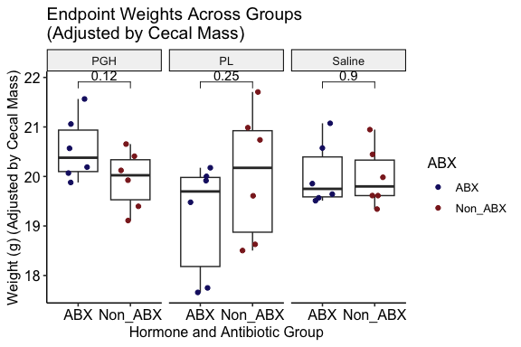

# 2.d. Food Consumption

## 2.d. Overview

Because our data collection plan included regular fasts, the easiest and most useful way for us to quantify and visualize and quantify food consumption is via total food consumption, rather than daily food consumption (over 24 hour periods).

## 2.d.i. Total Food Consumption Across Treatment Groups

To start, I’m going to plot the total food consumption of each mouse individually with a trend line. This will help us see the extent of variation in our data and point out any possible errors.

### Food Consumption in Each Indiviudal Mouse

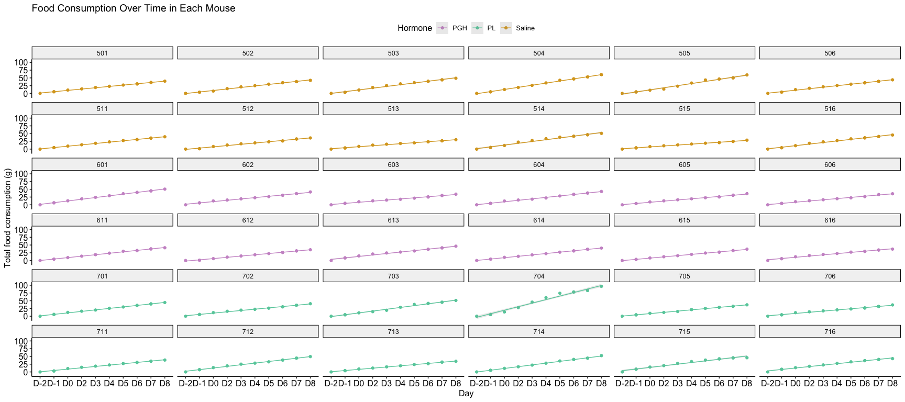

Mouse 704 is weird and needs to be filtered out!

For the next visualization, I’m going to create a faint line for each individual mouse, plus a thicker group average.

### Food Consumption Across Hormone Groups

First I’ll group just by hormone, *NOT* considering ABX status: 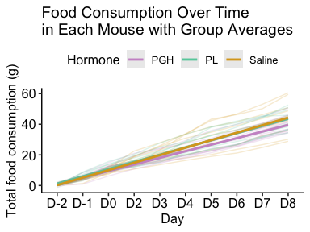 PGH mice potentially consuming less food?

Now I’ll split the above into ABX and Non-ABX and see if that alters paterns: 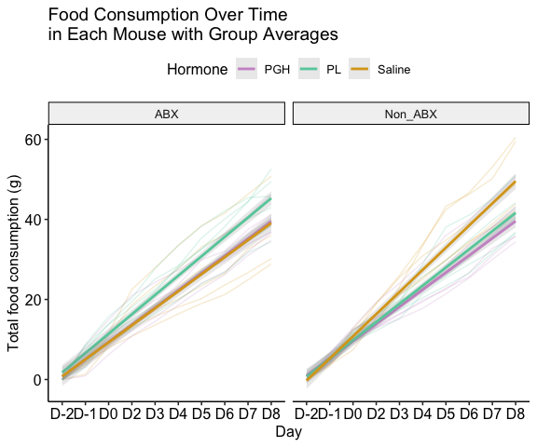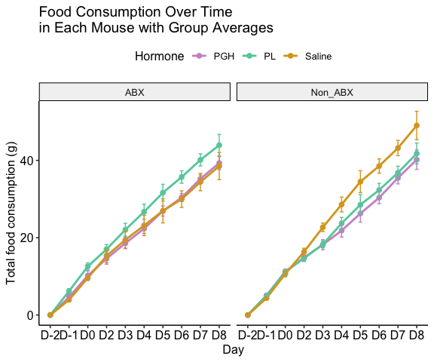 Interesting! Potentially an interaction effect between ABX and hormone status.

### Food Consumption Across Antibiotic Groups

Next I’ll group just by ABX, *NOT* considering hormone status: 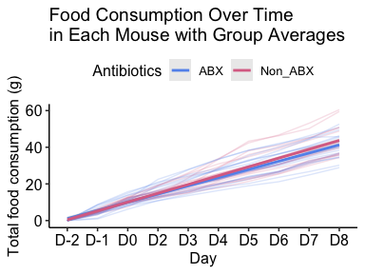 No obvious difference between groups, and lots of noise.

Now let’s compare ABX and non-ABX mice within the same hormone group: 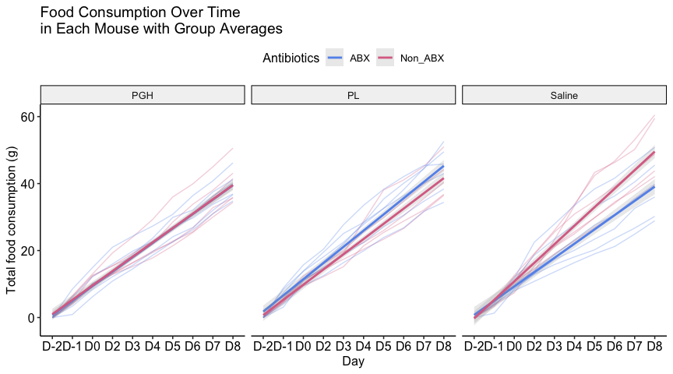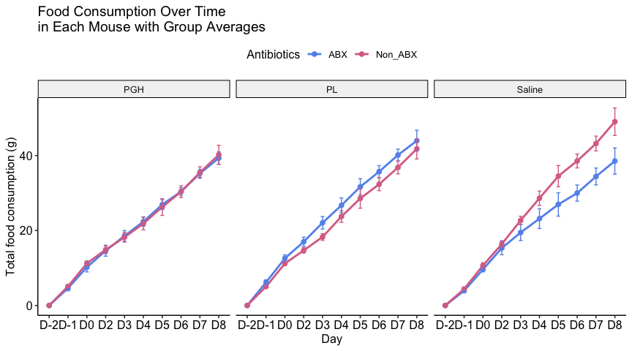 Hm! Group seeing the largest effect of ABX is saline!

*NOTE: I believe in style 1, the shading around the line is showing the confidence interval, not standard error. The second format shows actual standard error.*

### Food Consumption Rate Statistical Testing

***The outputs for these models are super long, so I’m just going to summmarize. Explore the child docs for the full outputs!***

Now I’m gonna test if there’s a significant difference between the slopes of these food consumption lines for each group.

* I will start with comparing the rate of food consumption in PGH and PL mice to Saline mice within the Non-ABX groups:

**Recap of results:** From Day 4 onward (to Day 8), the slopes of the food consumption lines for PGH and PL both significantly differ from the slope of the Saline line, indicating a reduced rate of food consumption in the hormone-injected non-abx mice.

* And now comparing the rate of food consumption in PGH and PL mice to Saline mice within the ABX groups:

**Recap of results:** From day 5 onward (to Day 8), the rate of food consumption (slope) for PL ABX mice is significantly higher than for saline ABX mice. The rate of food consumption (slope) doesn’t significantly differ between saline and PGH ABX mice.

* Next comparing Non-ABX to ABX in the PGH mice (don’t expect significance):

**Recap of results:** The rates of food consumption do not significantly differ in the PGH ABX and Non-ABX mice.

* Next comparing Non-ABX to ABX in the PL mice (don’t expect significance):

**Recap of results:** The rates of food consumption do not significantly differ in the PL ABX and Non-ABX mice. However, certain days (D3, D6, and D7) are approaching significance (0.05 < p < 0.1).

* Next comparing Non-ABX to ABX in the Saline mice (expect significance):

**Recap of results:** From Day 5 onward, the rates of food consumption are significantly higher in the Saline Non-ABX mice than in the ABX mice.

The fact that there is an ABX-based effect in the saline mice but not the PGH or PL mice is interesting!

## 2.d.ii. Food Consumption and Weight Gain.

*NOTE:* I’m not 100% confident that these figures are showing anything worth looking at?

I next investigated the relationship between total weight gain and total food consumption. In other words, what is the relationship between the rate at which each mouse is gaining weight and the rate at which it’s total food consumption is increasing?

* Total weight gain was calculated just by subtracting current weight from weight at D-2 (which was considered baseline for this analysis). The data used to generate these plots starts at D-1, which is why the mice don’t all start at 0 for total weight gain.

### Food Consumption vs Weight Gain Across Hormone Groups

First I will see if the relationship differs across hormone groups: 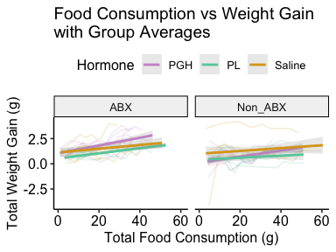

### Food Consumption vs Weight Gain Across Antibiotic Groups

Next I will see if the relationship differs across antibiotic groups:

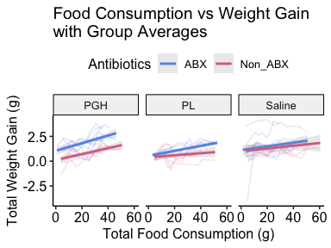 *Takeaway:* It looks like for the same amount of food consumed, ABX PGH mice on average gained more weight than Non-ABX PGH mice. This relationship doesn’t seem to hold for the PL or Saline mice, suggesting that it’s not simply driven by cecal enlargement.

*NOTE:* These weights are not accounting for / subtracting cecum mass.

### Food Consumption vs Weight Gain Statistical Testing

Verifying visual observation that the hormone group slopes don’t differ:

* None of the hormone slopes significantly differ for Non-ABX with saline as the reference
* For the ABX mice, PGH mice had a significantly different relationship between food consumption and weight gain than saline mice, with PGH mice gaining more weight at a higher rate (i.e., gaining more weight with the same of food consumption).
* There was no significant difference between the slopes for PL and Saline ABX mice.

Does the relationship between food consumption and weight gain significantly differ between Non-ABX and ABX mice in each hormone group?

**PGH:**

Significantly different interaction term of antibiotics for PGH mice.

*NOTE:* I’m a bit confused on which model is better, since the slopes look similar, just with different intercepts, so I included both above.

**PL:**

Significantly different interaction term of antibiotics for PL mice.

*NOTE:* I’m a bit confused on which model is better, since the slopes look similar, just with different intercepts, so I included both above.

**Saline:**

No significant interaction term of antibiotics for saline with either model type.

## 2.d.ii. Food Consumption and Weight Gain vs Other Variables

I’m not showing any of the plotting here because they all looked uninteresting and the sample sizes were too low to get any good insights, but for reference, I also looked to see if total food consumption and total weight gain had significant relationships (either overall or in specific groups) with the following:

* Change in lean mass (absolute and percentage) [i.e., did mice that gained more lean mass also gain more weight or eat more?]
* Change in fat mass (absolute and percentage)
* Change in free and total water (absolute and percentage)
* Endpoint ITT AUC
* Endpoint OGTT AUC
* Endpoint fasting blood glucose

# 3. Microbiome Data

# 3.a. qPCR (Bacterial Density)

## 3.a. Overview

The main purpose of qPCR in MFC2 was to:

1. broadly verify that our antibiotic cocktail successfully suppressed gut microbial density
2. quantify the extent of that suppression. By what order of magnitude did ABX and non-ABX groups differ in bacterial density?

Our qPCR DF includes measurements of genomes per gram of feces. These values can differ by several orders of magnitude between the ABX and non-ABX mice, making it difficult to visualize them on the same plot. To help us better compare their differences, let’s add a new column with the log-transformed values.

## 3.a.i. Longitudinal changes in bacterial density in ABX and Non-ABX groups over time

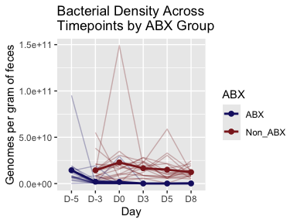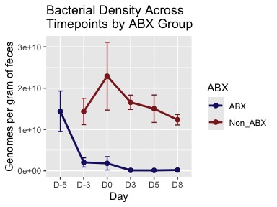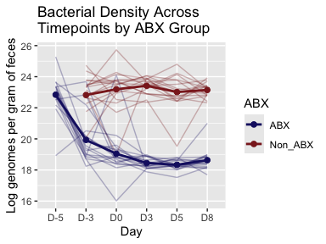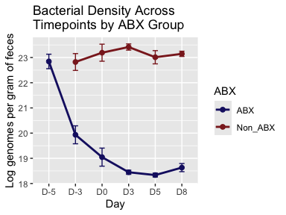 Seems like approximately a 50,000 fold decrease in bacterial density from D-5 to D5.

## 3.a.ii. Endpoint differences in bacterial density between ABX and Non-ABX

First I’m going to include all ABX days (D-3 to D8): 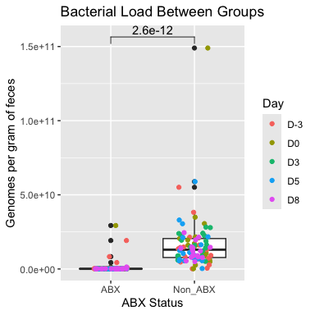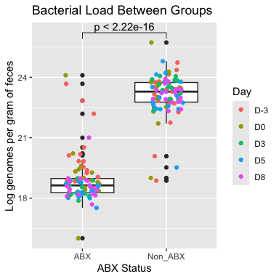

Next, to look at endpoint, we can include just days 5 and day 8, when we expect bacterial density to be maximally suppressed in the ABX mice: 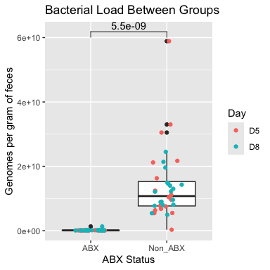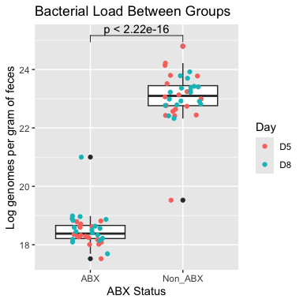

## 3.a.iii. Assessing any hormone-based differences in bacterial density

### Longitudinal group differences?

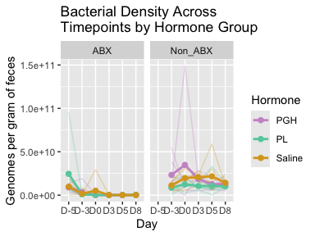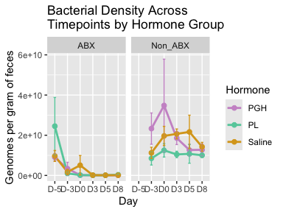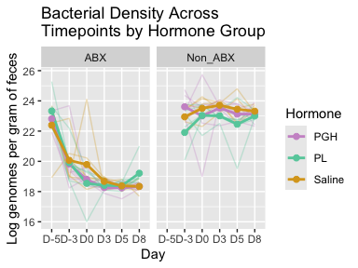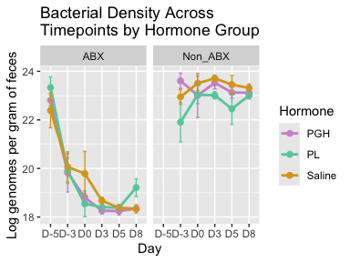

### Endpoint group differences?

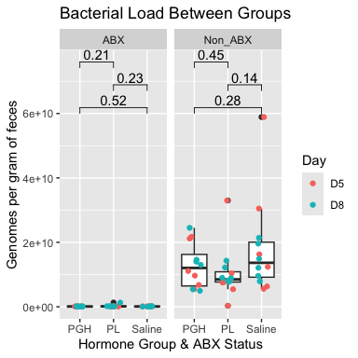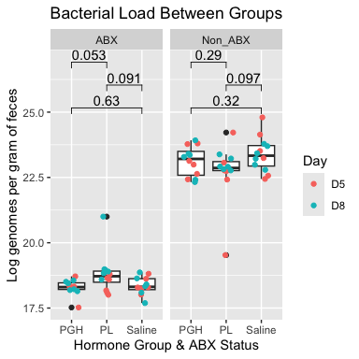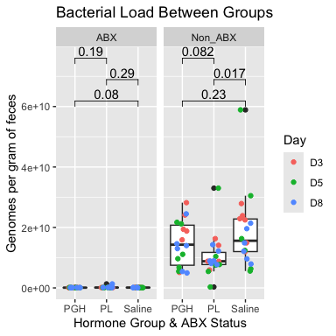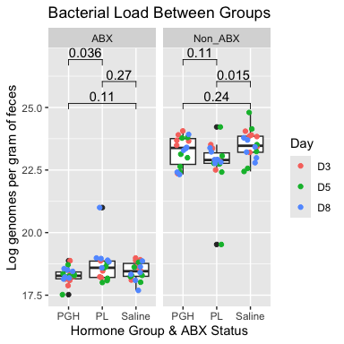 There is lower bacterial density in the PL Non-ABX mice than in the Saline Non-ABX mice when all antibiotic hormone days are included (D3, D5, and D8). However, this difference doesn’t reach significance when only days 5 and 8 are included. Additionally, as we can see from the longitudinal analyses, it appears that prior to any hormone exposure, the mice in the PL group had naturally lower fecal bacterial loads.

# 3.b. Alpha Diversity

## 3.b. Overview

**Motivation:** Late pregnancy is often associated with a reduction in maternal gut microbial alpha diversity, a pattern similarly observed in individuals with metabolic syndrome. This overlap has led researchers to hypothesize that gestational declines in alpha diversity may contribute to the shared metabolic alterations seen in both conditions. To investigate whether gestational changes in gut microbial alpha diversity are driven by placental hormones, we conducted a longitudinal analysis in non-pregnant mice treated with placental growth hormone (PGH) or placental lactogen (PL).

For all gut microbiome analyses, I will only be focusing on the non-abx mice. The purpose of including abx mice in the MFC2 study design was to quantify the *metabolic* effects of each hormone with and without a typical gut microbiome. While this design also allows us to examine the effects of the ampicillin + enrofloxacin cocktail on gut microbiome composition, that’s not the focus of this project and will not be included here.

I’ll be analyzing alpha diversity through both the **Chao1** and **Shannon** indices. These indices are calculated differently and provide complementary insights into alpha diversity. **Chao1** is a richness-based index that estimates the total number of species / OTUs in a sample, accounting for rare, lower abundance taxa. **Shannon** index incorporates both richness and evenness, emphasizing more abundant taxa and de-emphasizing rare taxa.

*NOTE: At this stage, I opted not to include other indices, such as Simpson or Observed OTUs, that measure similar aspects of alpha diversity already captured by Chao1 and Shannon. I also didn’t use analyses less common in gut microbiome literature, like Fisher*

## 3.b.i. Longitudinal changes in alpha diversity across each group

### Chao1

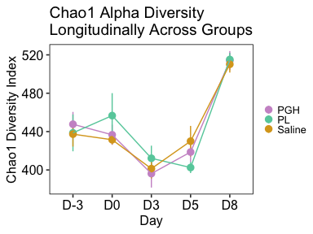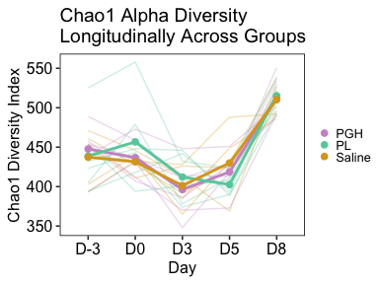 Because we are getting signals of contamination on day 8, we can opt to make day 5 our endpoint instead.

### Shannon

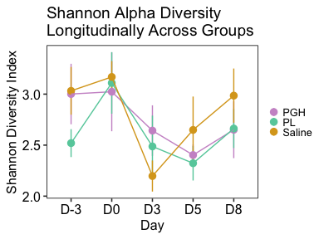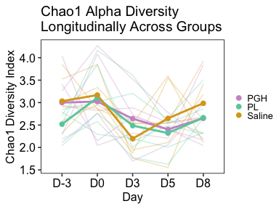

To me, it appears that day is the biggest driver of changes in alpha diversity, with similar patterns across time in all three groups (saline, PGH, PL) for both indices.

## 3.b.ii. Baseline vs Intervention Alpha Diversity

Excluding D8, let’s look at Baseline (pre-intervention – D-3 & D0) and Intervention (D3 & D5) to see if there are any changes to alpha diversity across the groups and whether these differences vary by group.

### Chao1

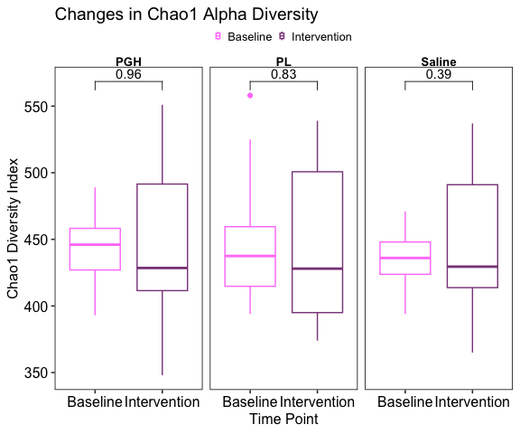

We can also look at just D0 to D5, rather than combining D-3 and D0 as baseline and D3 and D5 as intervention: 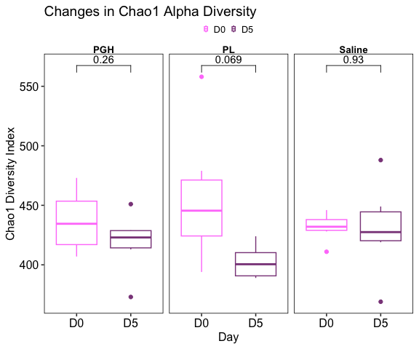

We also can do the same as above but comparing hormone groups at each time point or day, rather than looking longitudinally within the same group: 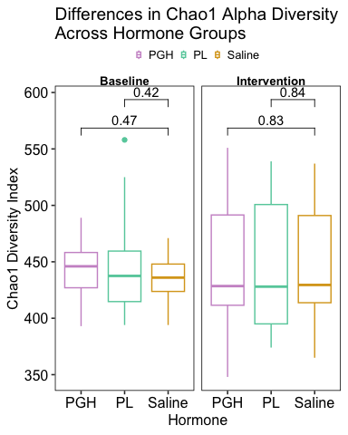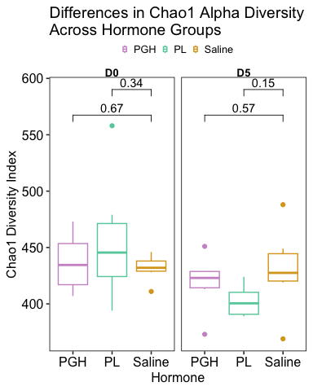

### Shannon

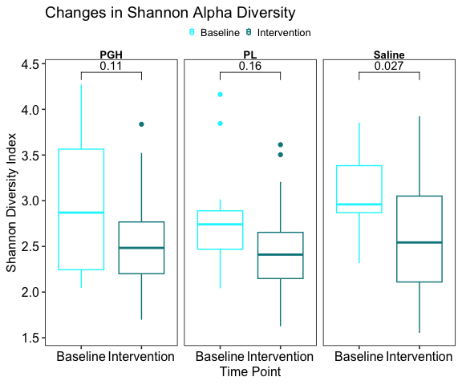

We can also look at just D0 to D5, rather than combining D-3 and D0 as baseline and D3 and D5 as intervention: 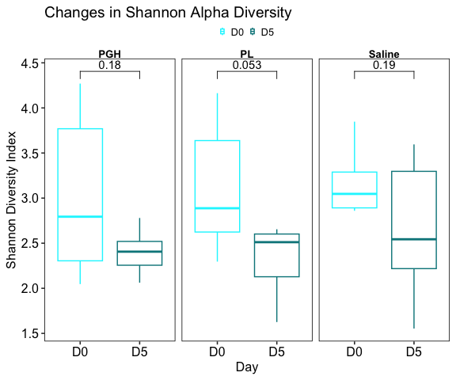

We also can do the same as above but comparing hormone groups at each time point or day, rather than looking longitudinally within the same group: 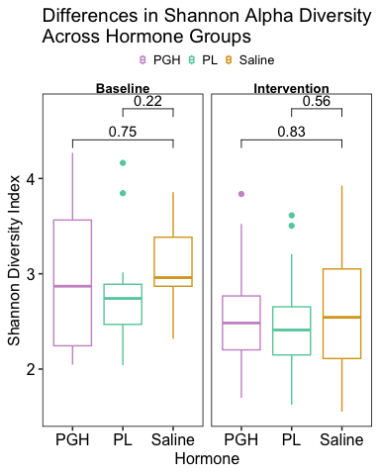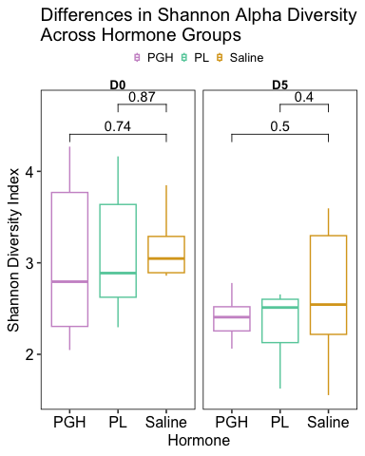

*Takeaway:* There are no consistent changes in alpha diversity driven by placental hormone exposure.

# 3.c. Beta Diversity

## 3.c. Overview

I’ll be analyzing beta diversity using four commonly used distance matrices in gut microbiome studies:

* **Jaccard** – considers only the presence or absence of taxa (focus on rare taxa)
* **Bray-Curtis** – incorporates relative abundances (focus on common taxa)
* **Unweighted UniFrac** – accounts for phylogenetic distances between taxa but focuses on presence/absence
* **Weighted UniFrac** – incorporates both phylogenetic distances and relative abundances

I’ll use these distance matrices to generate ordination plots using Principal Coordinates Analysis (PCoA) to visualize patterns of community variation over time and across hormone groups.

## 3.c.i. Jaccard

### All non-abx samples

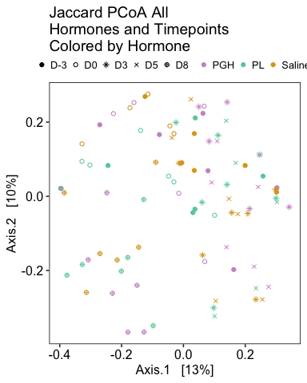

Since the D8s cluster together and we have reason to suspect contamination of those samples, now I’ll filter D8 out and re-do: 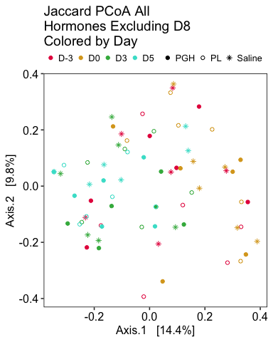

### Longitudinal changes within each group over time

Longitudinal changes in saline: 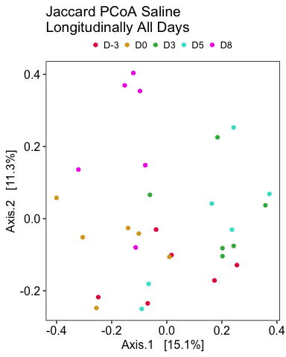

STATISTICAL ANALYSIS: Permutation test for adonis under reduced model Permutation: free Number of permutations: 999

adonis2(formula = jaccard_longitud_saline_distance_matrix ~ Day, data = jaccard_longitud_saline_data) Df SumOfSqs R2 F Pr(>F)  
Model 4 1.9333 0.22765 1.8422 0.001 *** Residual 25 6.5591 0.77235  
Total 29 8.4925 1.00000  
— Signif. codes: 0 ‘***’ 0.001 ’****’ 0.01 ’*’ 0.05 ‘.’ 0.1 ’ ’ 1

Longitudinal changes in saline excluding D8: 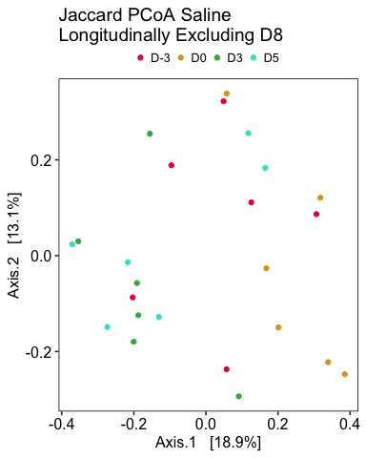

STATISTICAL ANALYSIS: Permutation test for adonis under reduced model Permutation: free Number of permutations: 999

adonis2(formula = jaccard_longitud_saline_nod8_distance_matrix ~ Day, data = jaccard_longitud_saline_nod8_data) Df SumOfSqs R2 F Pr(>F)  
Model 3 1.1531 0.18296 1.4928 0.013 * Residual 20 5.1494 0.81704  
Total 23 6.3024 1.00000  
— Signif. codes: 0 ‘***’ 0.001 ’****’ 0.01 ’*’ 0.05 ‘.’ 0.1 ’ ’ 1

Longitudinal changes in PGH: 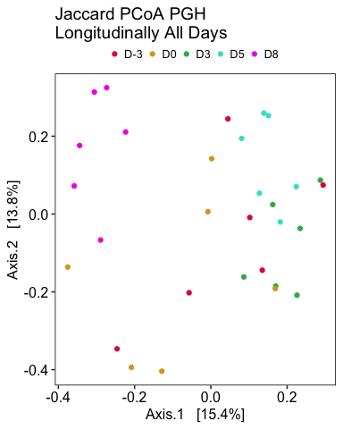

STATISTICAL ANALYSIS: Permutation test for adonis under reduced model Permutation: free Number of permutations: 999

adonis2(formula = jaccard_longitud_pgh_distance_matrix ~ Day, data = jaccard_longitud_pgh_data) Df SumOfSqs R2 F Pr(>F)  
Model 4 2.3273 0.26385 2.2401 0.001 *** Residual 25 6.4934 0.73615  
Total 29 8.8207 1.00000  
— Signif. codes: 0 ‘***’ 0.001 ’****’ 0.01 ’*’ 0.05 ‘.’ 0.1 ’ ’ 1

Longitudinal changes in PGH excluding D8: 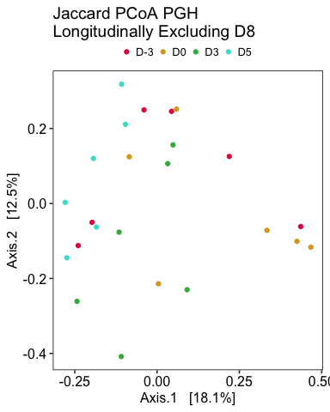

STATISTICAL ANALYSIS: Permutation test for adonis under reduced model Permutation: free Number of permutations: 999

adonis2(formula = jaccard_longitud_pgh_nod8_distance_matrix ~ Day, data = jaccard_longitud_pgh_nod8_data) Df SumOfSqs R2 F Pr(>F)  
Model 3 1.3229 0.1996 1.6625 0.005 ** Residual 20 5.3048 0.8004  
Total 23 6.6278 1.0000  
— Signif. codes: 0 ‘***’ 0.001 ’****’ 0.01 ’*’ 0.05 ‘.’ 0.1 ’ ’ 1

Longitudinal changes in PL: 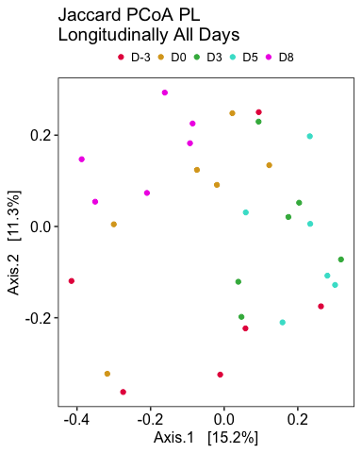

STATISTICAL ANALYSIS: Permutation test for adonis under reduced model Permutation: free Number of permutations: 999

adonis2(formula = jaccard_longitud_pl_distance_matrix ~ Day, data = jaccard_longitud_pl_data) Df SumOfSqs R2 F Pr(>F)  
Model 4 1.8233 0.19936 1.5563 0.003 ** Residual 25 7.3226 0.80064  
Total 29 9.1459 1.00000  
— Signif. codes: 0 ‘***’ 0.001 ’****’ 0.01 ’*’ 0.05 ‘.’ 0.1 ’ ’ 1

Longitudinal changes in PL excluding D8: 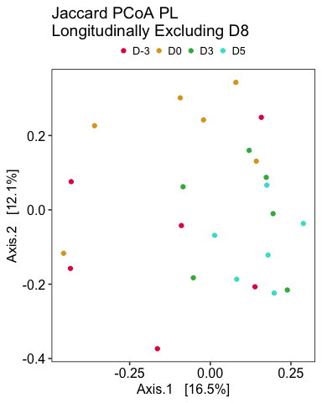

STATISTICAL ANALYSIS: Permutation test for adonis under reduced model Permutation: free Number of permutations: 999

adonis2(formula = jaccard_longitud_pl_nod8_distance_matrix ~ Day, data = jaccard_longitud_pl_nod8_data) Df SumOfSqs R2 F Pr(>F) Model 3 1.0817 0.1535 1.2089 0.102 Residual 20 5.9648 0.8465  
Total 23 7.0464 1.0000

### Endpoint clustering by hormone group

D3 clustering: 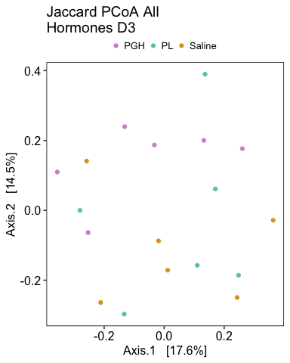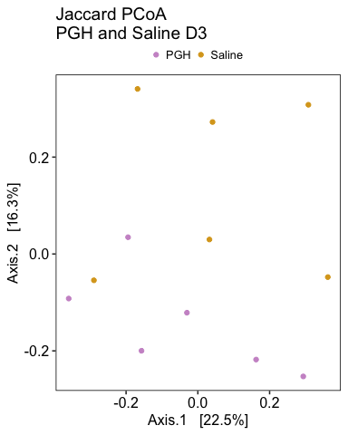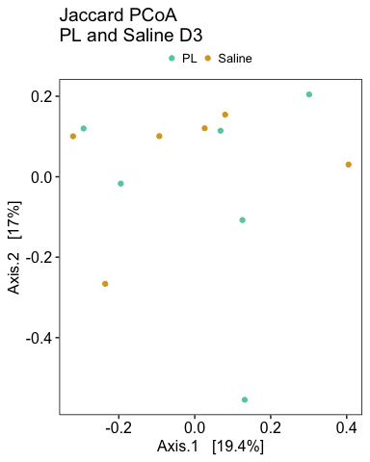

STATISTICAL ANALYSIS: Permutation test for adonis under reduced model Permutation: free Number of permutations: 999

adonis2(formula = jaccard_phylo_d3_distance_matrix ~ Hormone, data = jaccard_phylo_d3_data) Df SumOfSqs R2 F Pr(>F) Model 2 0.5652 0.12177 1.0399 0.399 Residual 15 4.0765 0.87823  
Total 17 4.6417 1.00000  
Permutation test for adonis under reduced model Permutation: free Number of permutations: 999

adonis2(formula = jaccard_phylo_d3_pghandsaline_distance_matrix ~ Hormone, data = jaccard_phylo_d3_pghandsaline_data) Df SumOfSqs R2 F Pr(>F) Model 1 0.3495 0.12185 1.3875 0.113 Residual 10 2.5188 0.87815  
Total 11 2.8683 1.00000

D5 clustering: 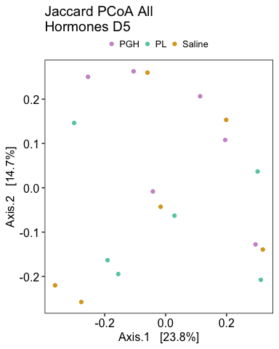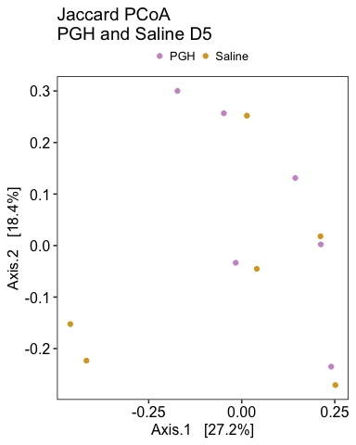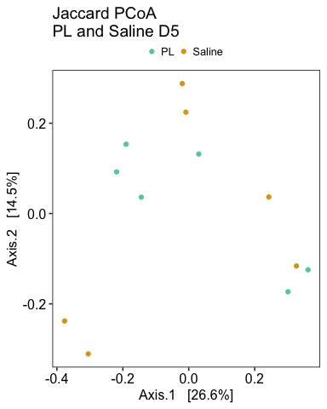

STATISTICAL ANALYSIS: Permutation test for adonis under reduced model Permutation: free Number of permutations: 999

adonis2(formula = jaccard_phylo_d5_distance_matrix ~ Hormone, data = jaccard_phylo_d5_data) Df SumOfSqs R2 F Pr(>F) Model 2 0.4421 0.11552 0.9796 0.482 Residual 15 3.3848 0.88448  
Total 17 3.8269 1.00000

D8 clustering: 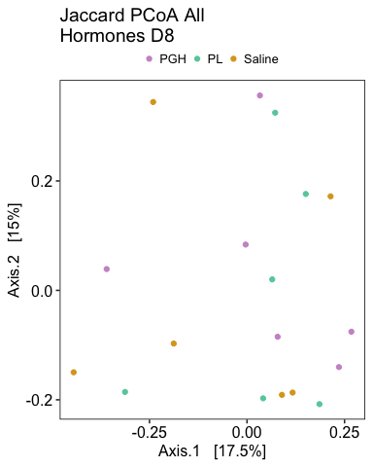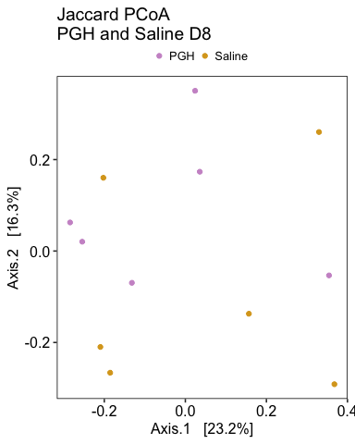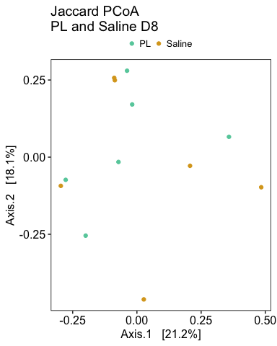

STATISTICAL ANALYSIS: Permutation test for adonis under reduced model Permutation: free Number of permutations: 999

adonis2(formula = jaccard_phylo_d8_distance_matrix ~ Hormone, data = jaccard_phylo_d8_data) Df SumOfSqs R2 F Pr(>F) Model 2 0.5380 0.11972 1.02 0.405 Residual 15 3.9561 0.88028  
Total 17 4.4942 1.00000

## 3.c.ii. Bray-Curtis

### All non-abx samples

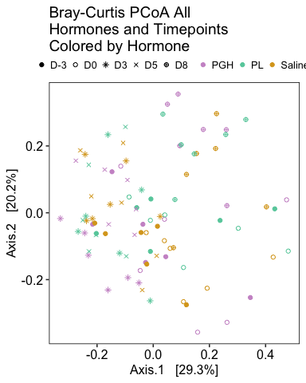

Since the D8s cluster together and we have reason to suspect contamination of those samples, now I’ll filter D8 out and re-do: 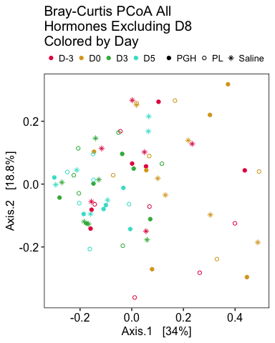

### Longitudinal changes within each group over time

Longitudinal changes in saline: 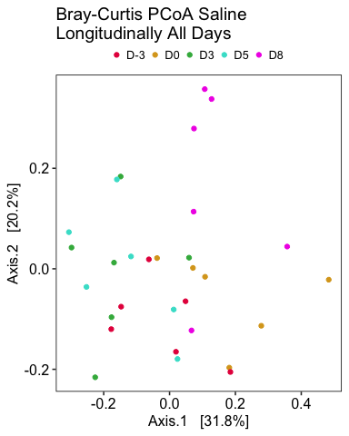

STATISTICAL ANALYSIS: Permutation test for adonis under reduced model Permutation: free Number of permutations: 999

adonis2(formula = bc_longitud_saline_distance_matrix ~ Day, data = bc_longitud_saline_data) Df SumOfSqs R2 F Pr(>F)  
Model 4 1.1286 0.34198 3.2481 0.001 *** Residual 25 2.1716 0.65802  
Total 29 3.3002 1.00000  
— Signif. codes: 0 ‘***’ 0.001 ’****’ 0.01 ’*’ 0.05 ‘.’ 0.1 ’ ’ 1

Longitudinal changes in saline excluding D8: 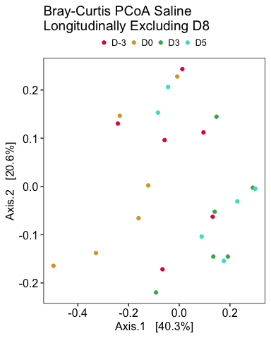

STATISTICAL ANALYSIS: Permutation test for adonis under reduced model Permutation: free Number of permutations: 999

adonis2(formula = bc_longitud_saline_nod8_distance_matrix ~ Day, data = bc_longitud_saline_nod8_data) Df SumOfSqs R2 F Pr(>F)  
Model 3 0.63051 0.27611 2.5428 0.004 ** Residual 20 1.65305 0.72389  
Total 23 2.28357 1.00000  
— Signif. codes: 0 ‘***’ 0.001 ’****’ 0.01 ’*’ 0.05 ‘.’ 0.1 ’ ’ 1

Longitudinal changes in PGH: 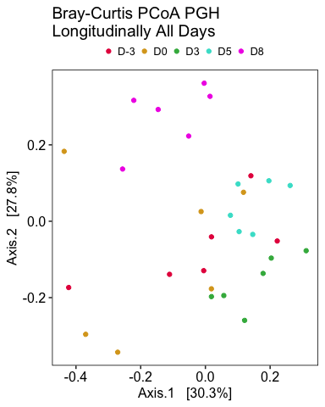

STATISTICAL ANALYSIS: Permutation test for adonis under reduced model Permutation: free Number of permutations: 999

adonis2(formula = bc_longitud_pgh_distance_matrix ~ Day, data = bc_longitud_pgh_data) Df SumOfSqs R2 F Pr(>F)  
Model 4 1.4298 0.3745 3.742 0.001 *** Residual 25 2.3881 0.6255  
Total 29 3.8178 1.0000  
— Signif. codes: 0 ‘***’ 0.001 ’****’ 0.01 ’*’ 0.05 ‘.’ 0.1 ’ ’ 1

Longitudinal changes in PGH excluding D8: 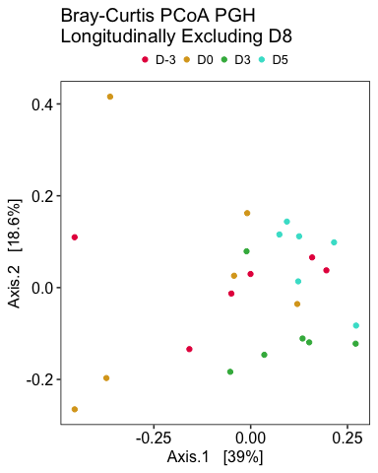

STATISTICAL ANALYSIS: Permutation test for adonis under reduced model Permutation: free Number of permutations: 999

adonis2(formula = bc_longitud_pgh_nod8_distance_matrix ~ Day, data = bc_longitud_pgh_nod8_data) Df SumOfSqs R2 F Pr(>F)  
Model 3 0.73498 0.26694 2.4276 0.006 ** Residual 20 2.01837 0.73306  
Total 23 2.75335 1.00000  
— Signif. codes: 0 ‘***’ 0.001 ’****’ 0.01 ’*’ 0.05 ‘.’ 0.1 ’ ’ 1

Longitudinal changes in PL: 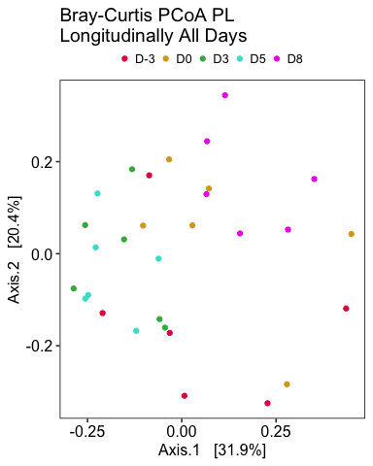

STATISTICAL ANALYSIS: Permutation test for adonis under reduced model Permutation: free Number of permutations: 999

adonis2(formula = bc_longitud_pl_distance_matrix ~ Day, data = bc_longitud_pl_data) Df SumOfSqs R2 F Pr(>F)  
Model 4 1.1638 0.28962 2.5482 0.003 ** Residual 25 2.8545 0.71038  
Total 29 4.0184 1.00000  
— Signif. codes: 0 ‘***’ 0.001 ’****’ 0.01 ’*’ 0.05 ‘.’ 0.1 ’ ’ 1

Longitudinal changes in PL excluding D8: 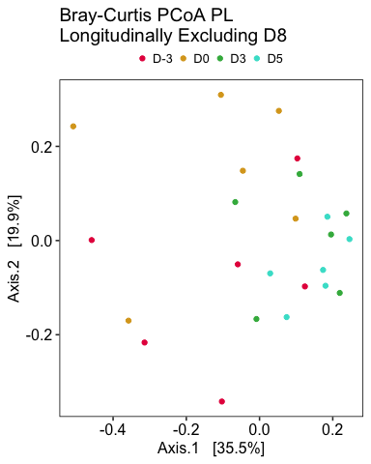

STATISTICAL ANALYSIS: Permutation test for adonis under reduced model Permutation: free Number of permutations: 999

adonis2(formula = bc_longitud_pl_nod8_distance_matrix ~ Day, data = bc_longitud_pl_nod8_data) Df SumOfSqs R2 F Pr(>F)  
Model 3 0.65641 0.21504 1.8263 0.029 * Residual 20 2.39611 0.78496  
Total 23 3.05252 1.00000  
— Signif. codes: 0 ‘***’ 0.001 ’****’ 0.01 ’*’ 0.05 ‘.’ 0.1 ’ ’ 1

### Endpoint clustering by hormone group

D3 clustering: 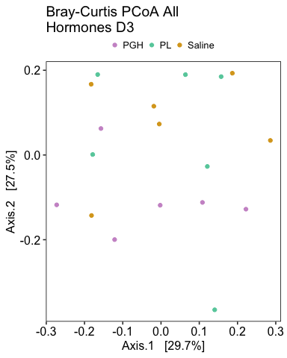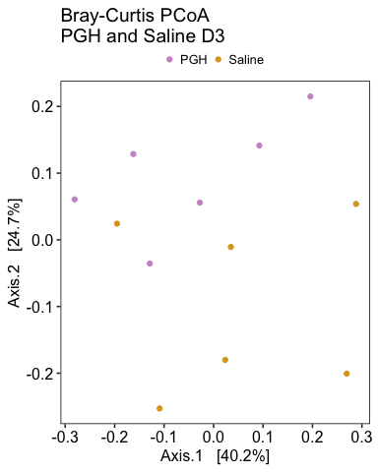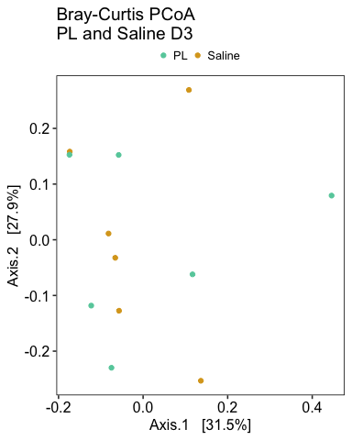

STATISTICAL ANALYSIS: Permutation test for adonis under reduced model Permutation: free Number of permutations: 999

adonis2(formula = bc_phylo_d3_distance_matrix ~ Hormone, data = bc_phylo_d3_data) Df SumOfSqs R2 F Pr(>F) Model 2 0.21906 0.13519 1.1724 0.324 Residual 15 1.40136 0.86481  
Total 17 1.62042 1.00000  
Permutation test for adonis under reduced model Permutation: free Number of permutations: 999

adonis2(formula = bc_phylo_d3_pghandsaline_distance_matrix ~ Hormone, data = bc_phylo_d3_pghandsaline_data) Df SumOfSqs R2 F Pr(>F)  
Model 1 0.15969 0.1705 2.0555 0.097 . Residual 10 0.77688 0.8295  
Total 11 0.93656 1.0000  
— Signif. codes: 0 ‘***’ 0.001 ’****’ 0.01 ’*’ 0.05 ‘.’ 0.1 ’ ’ 1

D5 clustering: 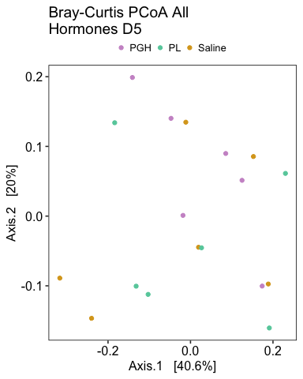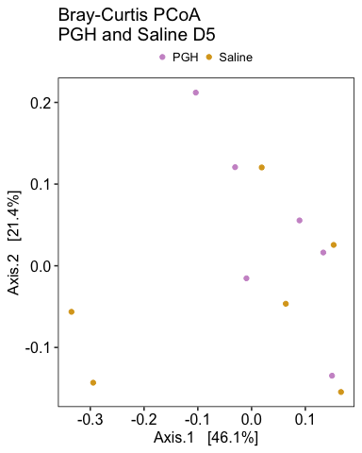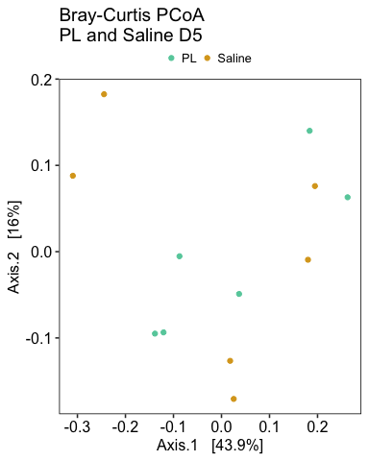

STATISTICAL ANALYSIS: Permutation test for adonis under reduced model Permutation: free Number of permutations: 999

adonis2(formula = bc_phylo_d5_distance_matrix ~ Hormone, data = bc_phylo_d5_data) Df SumOfSqs R2 F Pr(>F) Model 2 0.11972 0.10938 0.9211 0.538 Residual 15 0.97478 0.89062  
Total 17 1.09450 1.00000

D8 clustering: 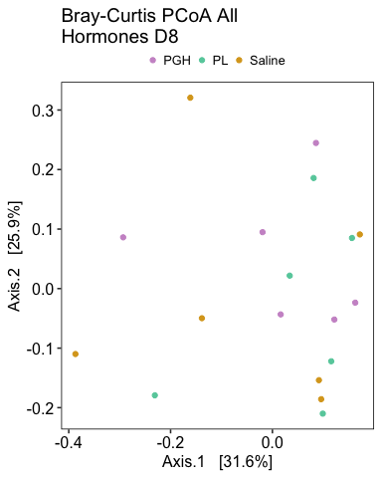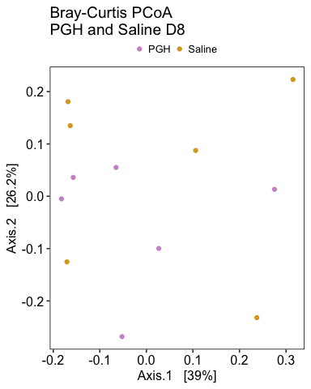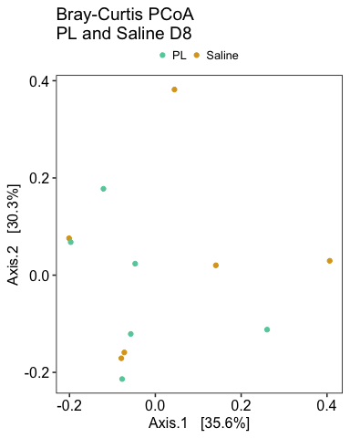

STATISTICAL ANALYSIS: Permutation test for adonis under reduced model Permutation: free Number of permutations: 999

adonis2(formula = bc_phylo_d8_distance_matrix ~ Hormone, data = bc_phylo_d8_data) Df SumOfSqs R2 F Pr(>F) Model 2 0.18981 0.12353 1.0571 0.398 Residual 15 1.34668 0.87647  
Total 17 1.53649 1.00000

## 3.c.iii. Unweighted Unifrac

### All non-abx samples

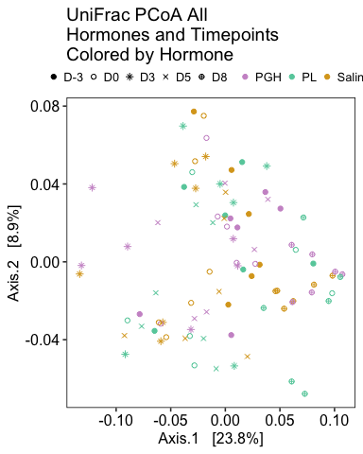

Since the D8s cluster together and we have reason to suspect contamination of those samples, now I’ll filter D8 out and re-do: 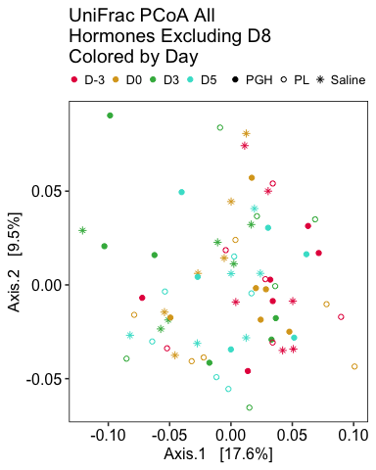

### Longitudinal changes within each group over time

Longitudinal changes in saline: 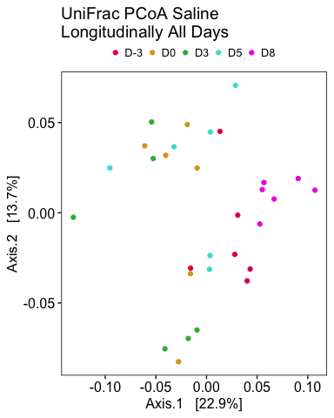

STATISTICAL ANALYSIS: Permutation test for adonis under reduced model Permutation: free Number of permutations: 999

adonis2(formula = unifrac_longitud_saline_distance_matrix ~ Day, data = unifrac_longitud_saline_data) Df SumOfSqs R2 F Pr(>F)  
Model 4 0.09385 0.26276 2.2276 0.001 *** Residual 25 0.26332 0.73724  
Total 29 0.35717 1.00000  
— Signif. codes: 0 ‘***’ 0.001 ’****’ 0.01 ’*’ 0.05 ‘.’ 0.1 ’ ’ 1

Longitudinal changes in saline excluding D8: 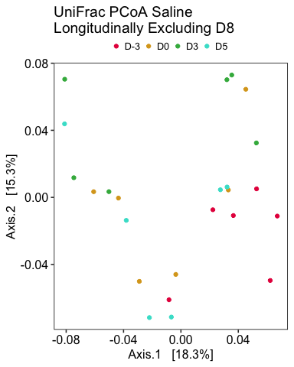

STATISTICAL ANALYSIS: Permutation test for adonis under reduced model Permutation: free Number of permutations: 999

adonis2(formula = unifrac_longitud_saline_nod8_distance_matrix ~ Day, data = unifrac_longitud_saline_nod8_data) Df SumOfSqs R2 F Pr(>F)  
Model 3 0.048339 0.16754 1.3418 0.069 . Residual 20 0.240176 0.83246  
Total 23 0.288515 1.00000  
— Signif. codes: 0 ‘***’ 0.001 ’****’ 0.01 ’*’ 0.05 ‘.’ 0.1 ’ ’ 1

Longitudinal changes in PGH: 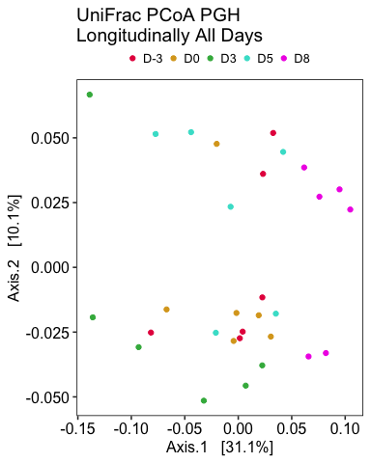

STATISTICAL ANALYSIS: Permutation test for adonis under reduced model Permutation: free Number of permutations: 999

adonis2(formula = unifrac_longitud_pgh_distance_matrix ~ Day, data = unifrac_longitud_pgh_data) Df SumOfSqs R2 F Pr(>F)  
Model 4 0.10451 0.28253 2.4611 0.001 *** Residual 25 0.26540 0.71747  
Total 29 0.36990 1.00000  
— Signif. codes: 0 ‘***’ 0.001 ’****’ 0.01 ’*’ 0.05 ‘.’ 0.1 ’ ’ 1

Longitudinal changes in PGH excluding D8: 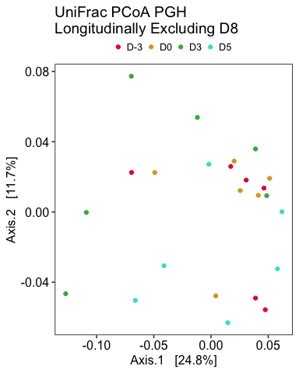

STATISTICAL ANALYSIS: Permutation test for adonis under reduced model Permutation: free Number of permutations: 999

adonis2(formula = unifrac_longitud_pgh_nod8_distance_matrix ~ Day, data = unifrac_longitud_pgh_nod8_data) Df SumOfSqs R2 F Pr(>F)  
Model 3 0.049562 0.17479 1.4121 0.051 . Residual 20 0.233980 0.82521  
Total 23 0.283542 1.00000  
— Signif. codes: 0 ‘***’ 0.001 ’****’ 0.01 ’*’ 0.05 ‘.’ 0.1 ’ ’ 1

Longitudinal changes in PL: 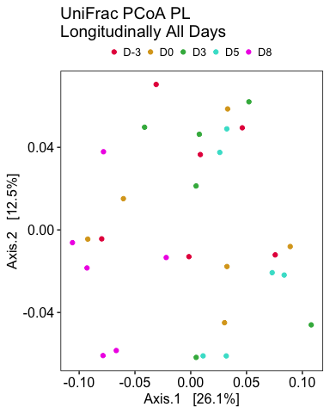

STATISTICAL ANALYSIS: Permutation test for adonis under reduced model Permutation: free Number of permutations: 999

adonis2(formula = unifrac_longitud_pl_distance_matrix ~ Day, data = unifrac_longitud_pl_data) Df SumOfSqs R2 F Pr(>F)  
Model 4 0.09516 0.23233 1.8915 0.002 ** Residual 25 0.31445 0.76767  
Total 29 0.40961 1.00000  
— Signif. codes: 0 ‘***’ 0.001 ’****’ 0.01 ’*’ 0.05 ‘.’ 0.1 ’ ’ 1

Longitudinal changes in PL excluding D8: 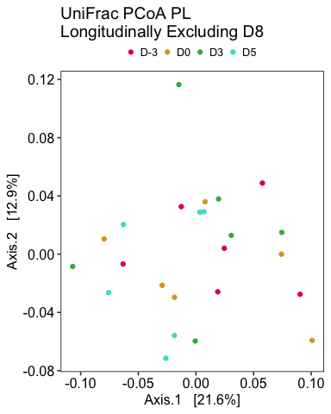

STATISTICAL ANALYSIS: Permutation test for adonis under reduced model Permutation: free Number of permutations: 999

adonis2(formula = unifrac_longitud_pl_nod8_distance_matrix ~ Day, data = unifrac_longitud_pl_nod8_data) Df SumOfSqs R2 F Pr(>F) Model 3 0.04652 0.14532 1.1335 0.279 Residual 20 0.27361 0.85468  
Total 23 0.32014 1.00000

### Endpoint clustering by hormone group

D3 clustering: 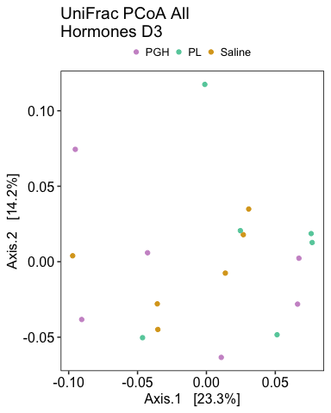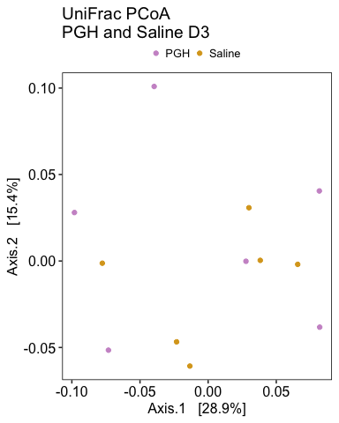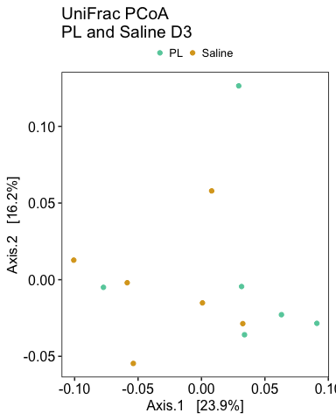

STATISTICAL ANALYSIS: Permutation test for adonis under reduced model Permutation: free Number of permutations: 999

adonis2(formula = unifrac_phylo_d3_distance_matrix ~ Hormone, data = unifrac_phylo_d3_data) Df SumOfSqs R2 F Pr(>F)  
Model 2 0.03878 0.1534 1.359 0.098 . Residual 15 0.21402 0.8466  
Total 17 0.25280 1.0000  
— Signif. codes: 0 ‘***’ 0.001 ’****’ 0.01 ’*’ 0.05 ‘.’ 0.1 ’ ’ 1 Permutation test for adonis under reduced model Permutation: free Number of permutations: 999

adonis2(formula = unifrac_phylo_d3_pghandsaline_distance_matrix ~ Hormone, data = unifrac_phylo_d3_pghandsaline_data) Df SumOfSqs R2 F Pr(>F) Model 1 0.016257 0.10637 1.1904 0.269 Residual 10 0.136573 0.89363  
Total 11 0.152830 1.00000

D5 clustering: 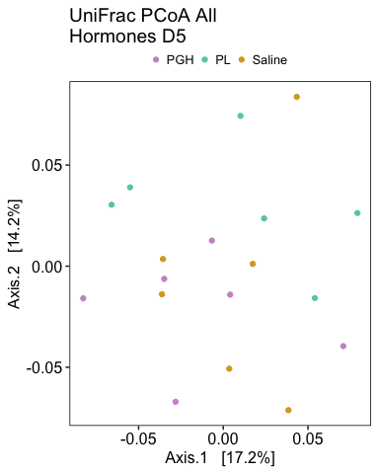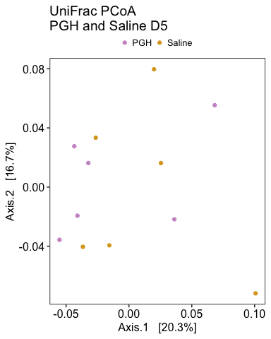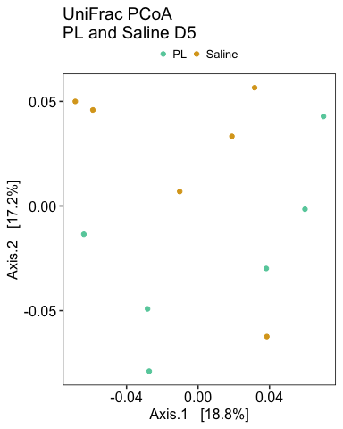

STATISTICAL ANALYSIS: Permutation test for adonis under reduced model Permutation: free Number of permutations: 999

adonis2(formula = unifrac_phylo_d5_distance_matrix ~ Hormone, data = unifrac_phylo_d5_data) Df SumOfSqs R2 F Pr(>F) Model 2 0.028717 0.13159 1.1365 0.269 Residual 15 0.189509 0.86841  
Total 17 0.218226 1.00000

D8 clustering: 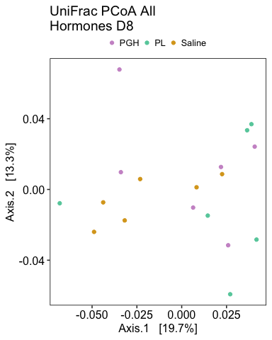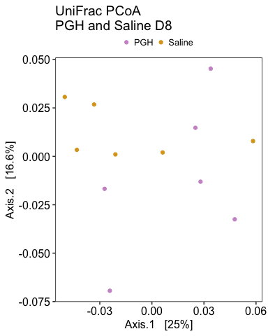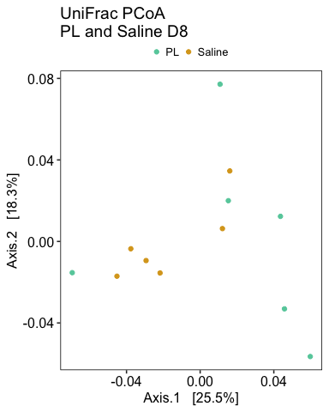

STATISTICAL ANALYSIS: Permutation test for adonis under reduced model Permutation: free Number of permutations: 999

adonis2(formula = unifrac_phylo_d8_distance_matrix ~ Hormone, data = unifrac_phylo_d8_data) Df SumOfSqs R2 F Pr(>F) Model 2 0.015061 0.13636 1.1841 0.182 Residual 15 0.095393 0.86364  
Total 17 0.110454 1.00000

## 3.c.iv. Weighted Unifrac

### All non-abx samples

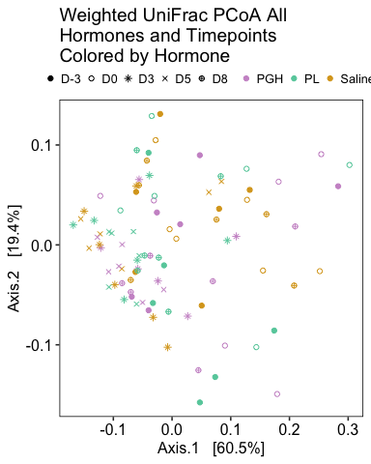

Since the D8s cluster together and we have reason to suspect contamination of those samples, now I’ll filter D8 out and re-do: 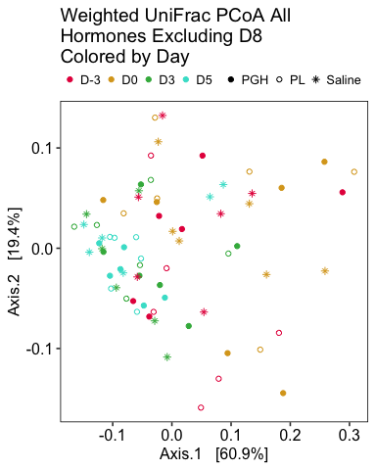

### Longitudinal changes within each group over time

Longitudinal changes in saline: 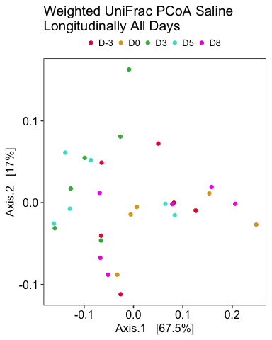

STATISTICAL ANALYSIS: Permutation test for adonis under reduced model Permutation: free Number of permutations: 999

adonis2(formula = wunifrac_longitud_saline_distance_matrix ~ Day, data = wunifrac_longitud_saline_data) Df SumOfSqs R2 F Pr(>F)  
Model 4 0.14232 0.26768 2.2846 0.04 * Residual 25 0.38935 0.73232  
Total 29 0.53167 1.00000  
— Signif. codes: 0 ‘***’ 0.001 ’****’ 0.01 ’*’ 0.05 ‘.’ 0.1 ’ ’ 1

Longitudinal changes in saline excluding D8: 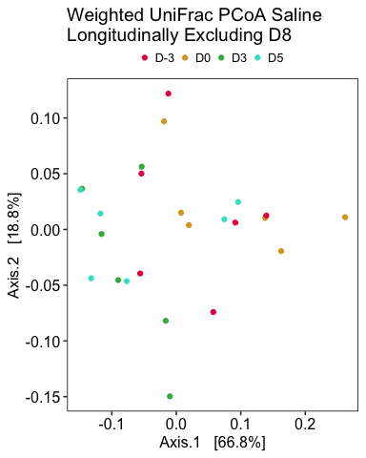

STATISTICAL ANALYSIS: Permutation test for adonis under reduced model Permutation: free Number of permutations: 999

adonis2(formula = wunifrac_longitud_saline_nod8_distance_matrix ~ Day, data = wunifrac_longitud_saline_nod8_data) Df SumOfSqs R2 F Pr(>F)  
Model 3 0.12355 0.30314 2.9 0.026 * Residual 20 0.28403 0.69686  
Total 23 0.40759 1.00000  
— Signif. codes: 0 ‘***’ 0.001 ’****’ 0.01 ’*’ 0.05 ‘.’ 0.1 ’ ’ 1

Longitudinal changes in PGH: 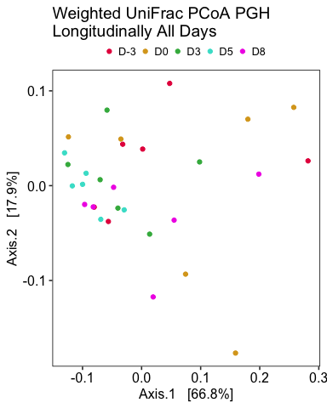

STATISTICAL ANALYSIS: Permutation test for adonis under reduced model Permutation: free Number of permutations: 999

adonis2(formula = wunifrac_longitud_pgh_distance_matrix ~ Day, data = wunifrac_longitud_pgh_data) Df SumOfSqs R2 F Pr(>F)  
Model 4 0.13844 0.23717 1.9431 0.06 . Residual 25 0.44527 0.76283  
Total 29 0.58371 1.00000  
— Signif. codes: 0 ‘***’ 0.001 ’****’ 0.01 ’*’ 0.05 ‘.’ 0.1 ’ ’ 1

Longitudinal changes in PGH excluding D8: 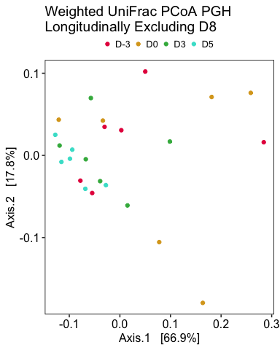

STATISTICAL ANALYSIS: Permutation test for adonis under reduced model Permutation: free Number of permutations: 999

adonis2(formula = wunifrac_longitud_pgh_nod8_distance_matrix ~ Day, data = wunifrac_longitud_pgh_nod8_data) Df SumOfSqs R2 F Pr(>F)  
Model 3 0.12596 0.25603 2.2942 0.048 * Residual 20 0.36601 0.74397  
Total 23 0.49197 1.00000  
— Signif. codes: 0 ‘***’ 0.001 ’****’ 0.01 ’*’ 0.05 ‘.’ 0.1 ’ ’ 1

Longitudinal changes in PL: 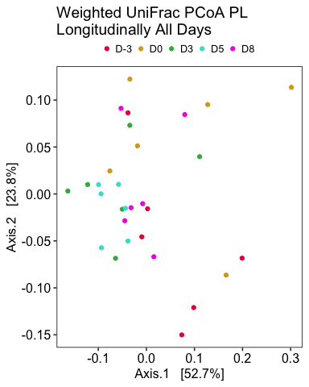

STATISTICAL ANALYSIS: Permutation test for adonis under reduced model Permutation: free Number of permutations: 999

adonis2(formula = wunifrac_longitud_pl_distance_matrix ~ Day, data = wunifrac_longitud_pl_data) Df SumOfSqs R2 F Pr(>F)  
Model 4 0.14866 0.25557 2.1457 0.019 * Residual 25 0.43303 0.74443  
Total 29 0.58169 1.00000  
— Signif. codes: 0 ‘***’ 0.001 ’****’ 0.01 ’*’ 0.05 ‘.’ 0.1 ’ ’ 1

Longitudinal changes in PL excluding D8: 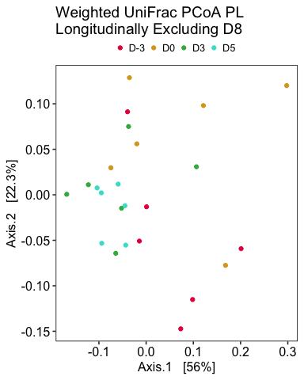

STATISTICAL ANALYSIS: Permutation test for adonis under reduced model Permutation: free Number of permutations: 999

adonis2(formula = wunifrac_longitud_pl_nod8_distance_matrix ~ Day, data = wunifrac_longitud_pl_nod8_data) Df SumOfSqs R2 F Pr(>F)  
Model 3 0.14569 0.27661 2.5492 0.022 * Residual 20 0.38101 0.72339  
Total 23 0.52670 1.00000  
— Signif. codes: 0 ‘***’ 0.001 ’****’ 0.01 ’*’ 0.05 ‘.’ 0.1 ’ ’ 1

### Endpoint clustering by hormone group

D3 clustering: 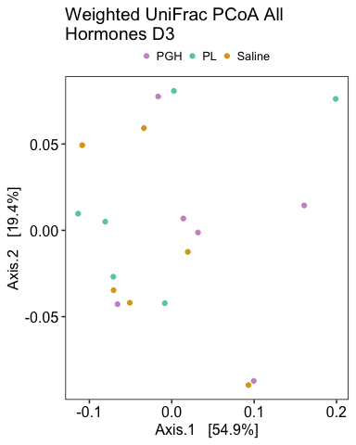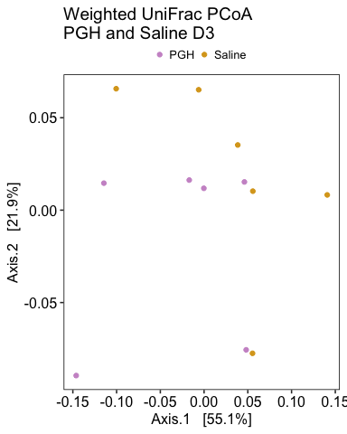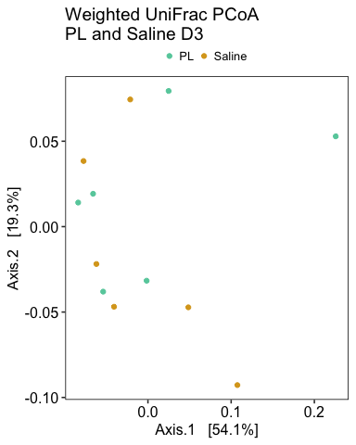

STATISTICAL ANALYSIS: Permutation test for adonis under reduced model Permutation: free Number of permutations: 999

adonis2(formula = wunifrac_phylo_d3_distance_matrix ~ Hormone, data = wunifrac_phylo_d3_data) Df SumOfSqs R2 F Pr(>F) Model 2 0.024242 0.09833 0.8179 0.568 Residual 15 0.222289 0.90167  
Total 17 0.246531 1.00000  
Permutation test for adonis under reduced model Permutation: free Number of permutations: 999

adonis2(formula = wunifrac_phylo_d3_pghandsaline_distance_matrix ~ Hormone, data = wunifrac_phylo_d3_pghandsaline_data) Df SumOfSqs R2 F Pr(>F) Model 1 0.015955 0.11451 1.2931 0.261 Residual 10 0.123383 0.88549  
Total 11 0.139338 1.00000

D5 clustering: 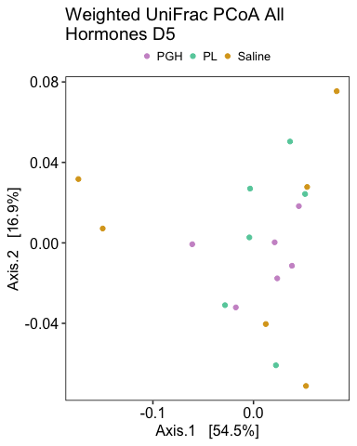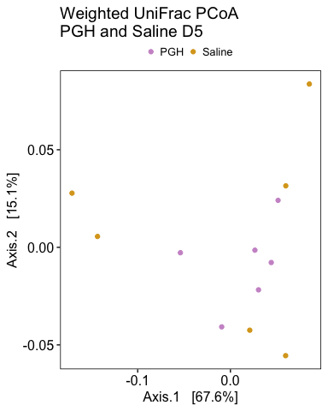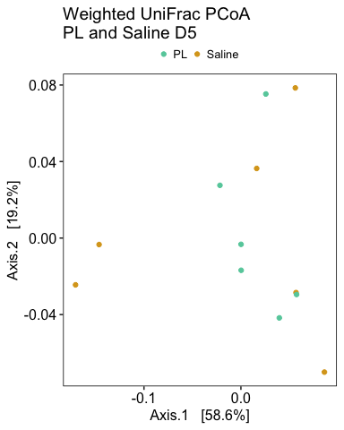

STATISTICAL ANALYSIS: Permutation test for adonis under reduced model Permutation: free Number of permutations: 999

adonis2(formula = wunifrac_phylo_d5_distance_matrix ~ Hormone, data = wunifrac_phylo_d5_data) Df SumOfSqs R2 F Pr(>F) Model 2 0.011666 0.08038 0.6556 0.73 Residual 15 0.133464 0.91962  
Total 17 0.145130 1.00000

D8 clustering: 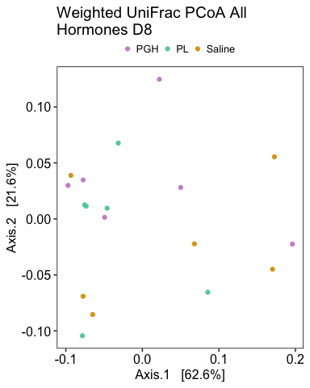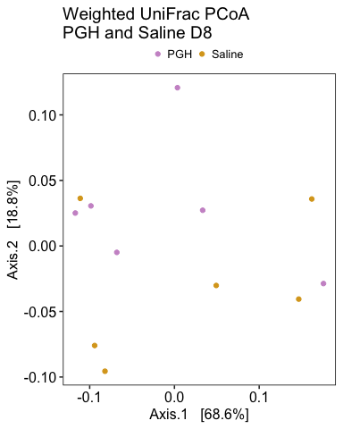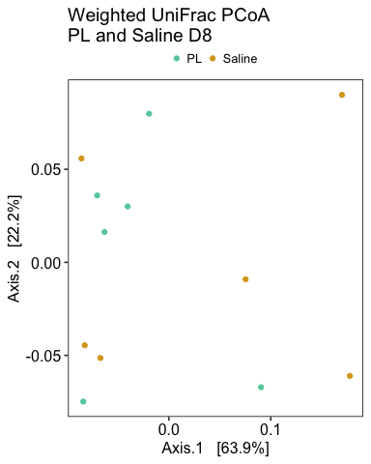

STATISTICAL ANALYSIS: Permutation test for adonis under reduced model Permutation: free Number of permutations: 999

adonis2(formula = wunifrac_phylo_d8_distance_matrix ~ Hormone, data = wunifrac_phylo_d8_data) Df SumOfSqs R2 F Pr(>F) Model 2 0.033458 0.12389 1.0606 0.378 Residual 15 0.236595 0.87611  
Total 17 0.270053 1.00000

**NOTE:** For most distance matrices, I was able to get significant clustering by hormone group when including multiple intervention days and accounting for each individual mouse as a random effect. However, this was not resulting in R^2 values any different than when mouse ID was the only dependent variable included, so I believe it was driving the significance and creating the illusion of significant group differences. I’d love to talk through those stats methods more to ensure I’m doing everything correctly.

**Key Takeaways:** While there was a significant pattern of PERMANOVA separation by Day within each hormone group, indicating a longitudinal effect, there was no consistent pattern of separation by hormone group at any time point.

## 3.c.v. Plotting axes against other variables!

I can extract the data on principal coordinates from the “vectors” part of an ordination object. I can then plot these vectors across other variables, like time.

### Bray-Curtis Vectors vs Time

I’ll start with plotting these in terms of Bray-Curtis ordination: 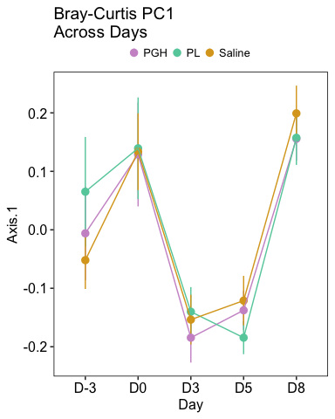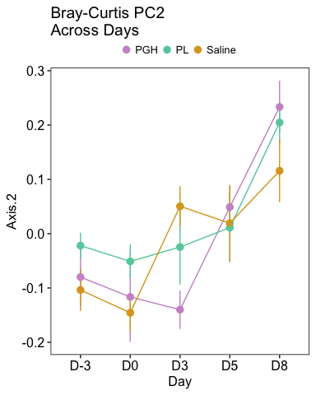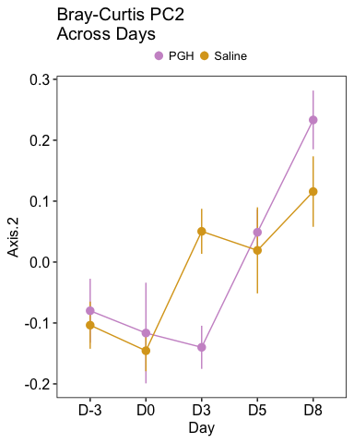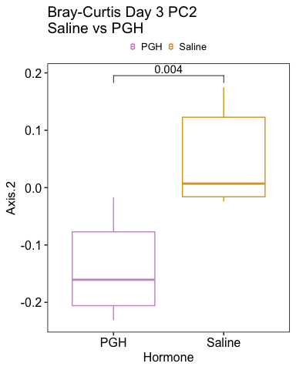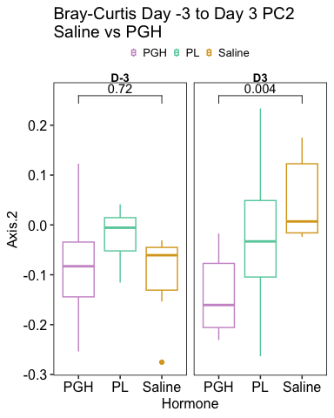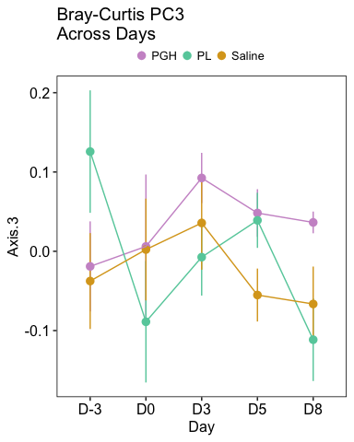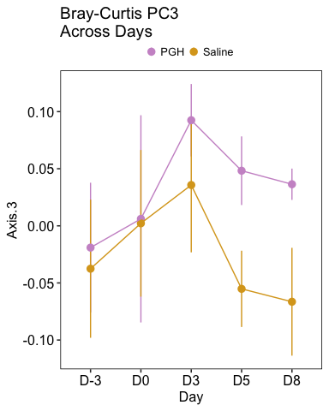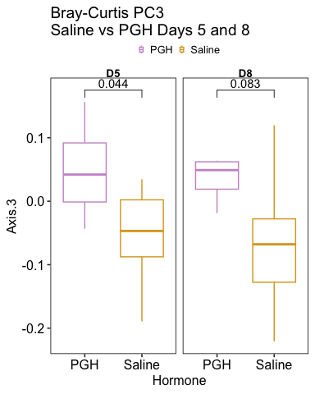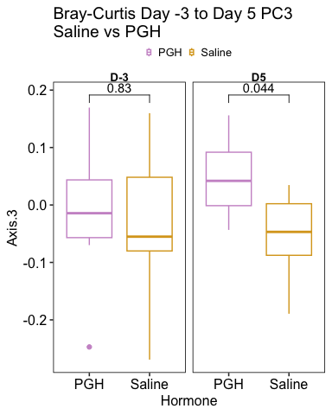

Time can also be plotted against axes derived from our other distance matrices.

### Jaccard Vectors vs Time

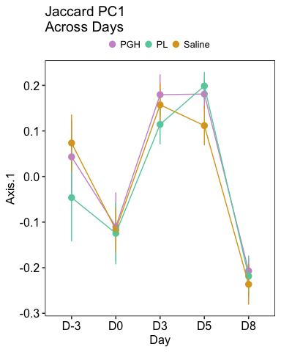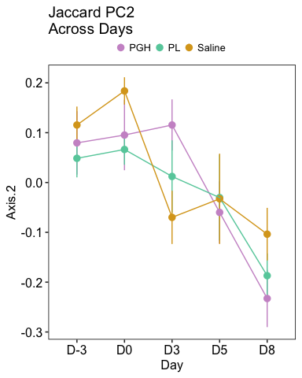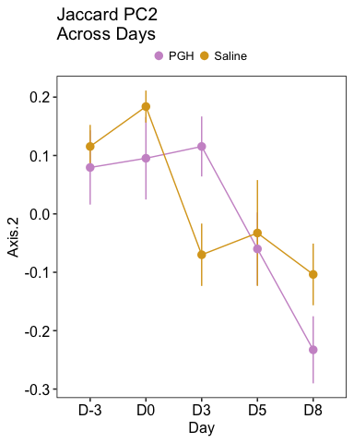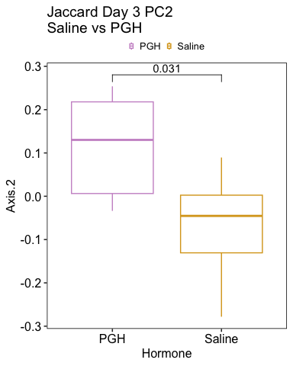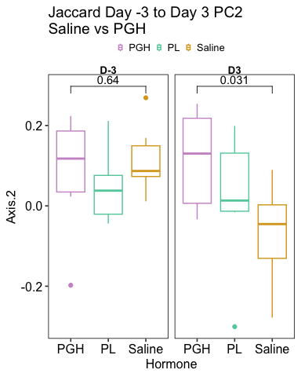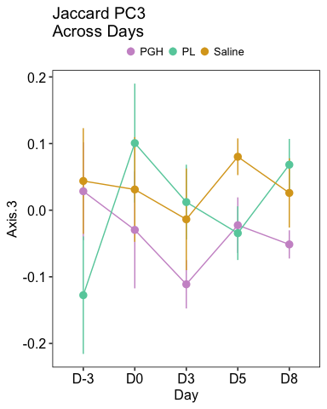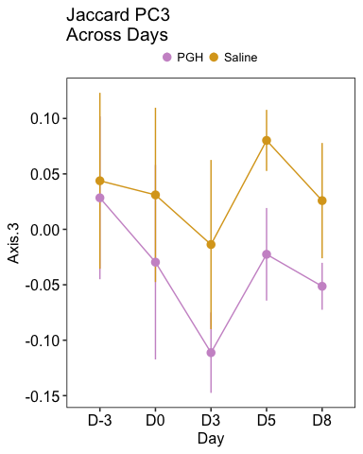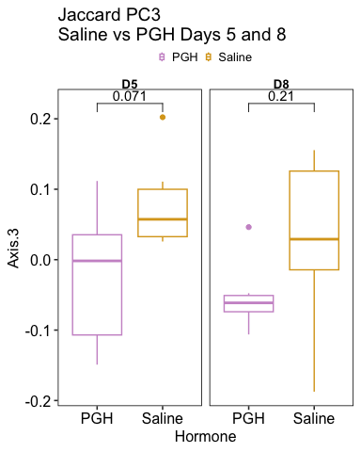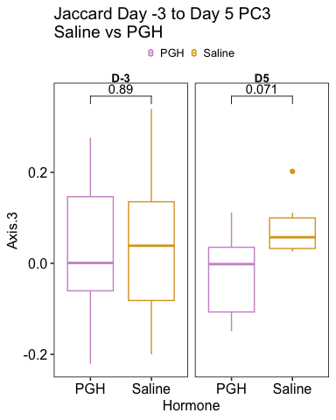

### Unweighted UniFrac Vectors vs Time

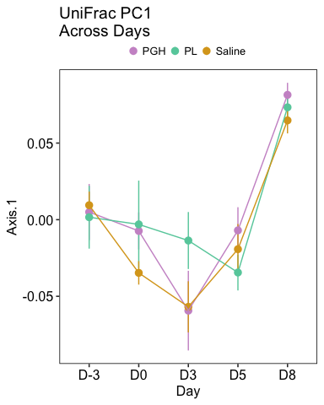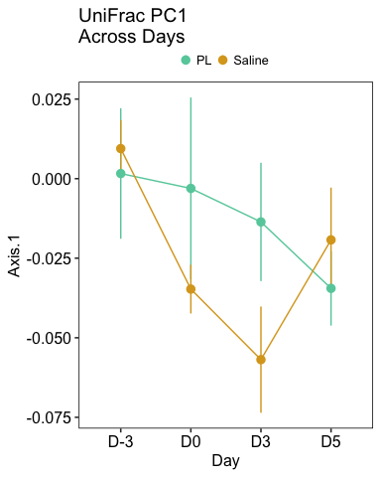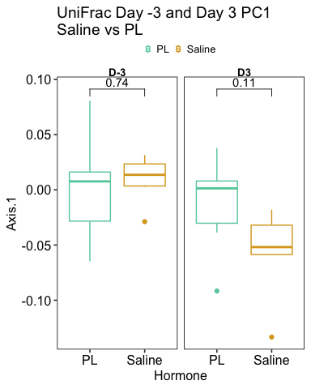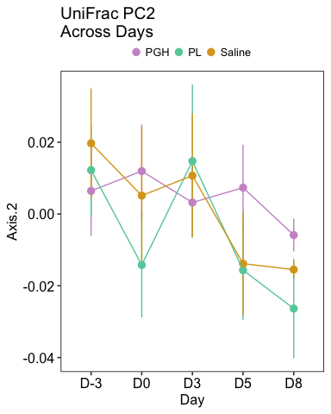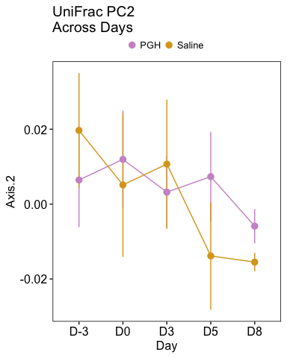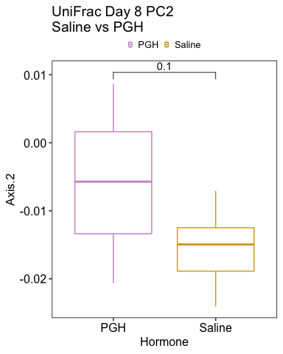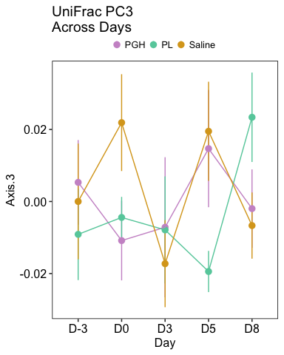

### Weighted Unifrac Vectors vs Time

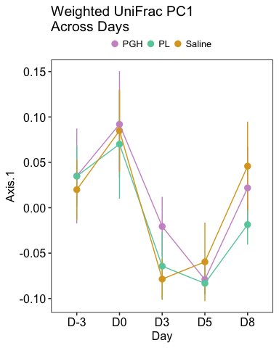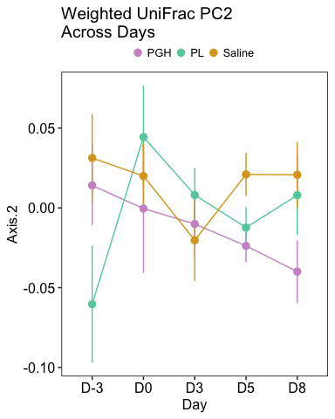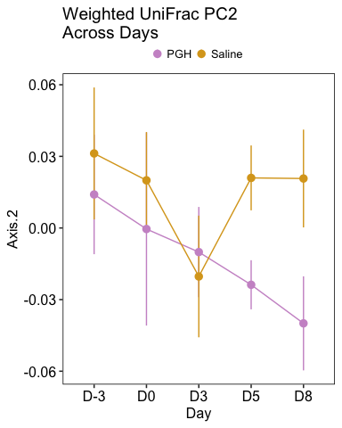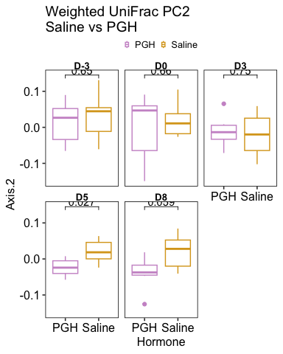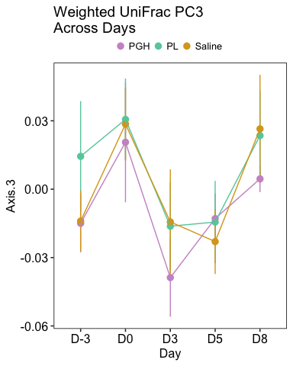

# 3.d. phyloseq Relative Abundance Analyses

## 3.d. Overview

In this section, I will quantify and visualize group differences and longitudinal changes in the relative abundance of targeted taxa.

I will start with a high level look at general taxonomic groups, and then zero in on taxa in the literature that have previously been identified as differentially abundant either in murine pregnancy or in murine models of metabolic syndrome or GDM.

I will then do some visualizations of overall taxonomic composition

## 3.d.i. High level taxonomic investigation

Changes / differences in individual taxa can be presented a number of ways. Below shows some experimentation with different visualization styles — I’m undecided on which tell the “story of the data” best.

Additionally, due to my caution around my Day 8 samples, I will sometimes opt to visualize with D5 set as endpoint.

First let’s investigate broad strokes changes in the relative abundances of two major bacterial phyla: **Bacteroidetes** and **Firmicutes**.

For our first plot, I’ll visualize relative abundance in each group across all days 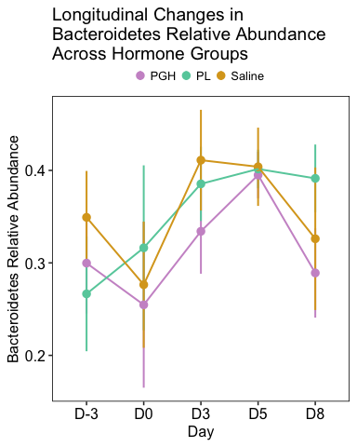

We can also show each hormone in it’s own panel 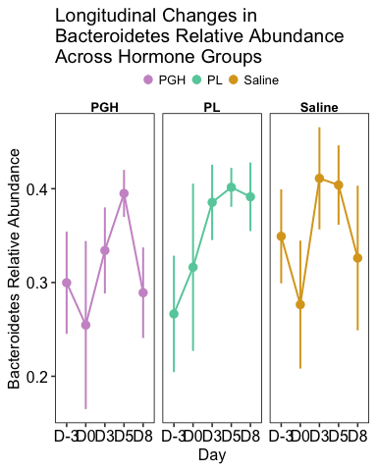

Next I’ll visualize this as baseline to intervention changes 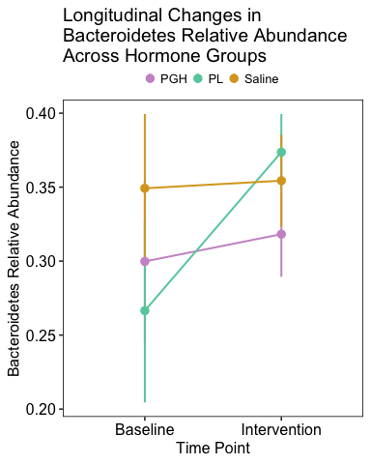

I’m curious to visualize as a bar graph showing changes from baseline (D-3) to endpoint (D8).

To be comprehensive, I will then do the same with baseline (D-3) to endpoint (D5), since the D8s are suspicious. 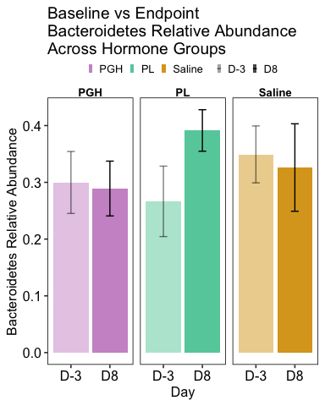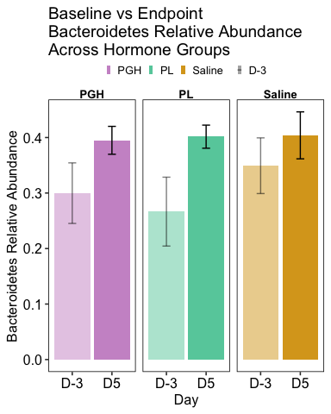 Stats testing is hidden from this html output, but these are the key results:

* No paired t-tests are significant for differences in Bacteroidetes relative abundance at D-3 and D8 for any of the hormone groups
* For differences in Bacteroidetes relative abundance at D-3 and D5, the paired t-test is significant for PL mice (p = 0.036) but not for saline or PGH.

Next I’m going to calculate and plot the absolute change in Bacteroidetes % for each mouse

*Change in Bacteroidetes from D-3 to D8 (i.e., D8 rel abundance - D-3 rel abundance)* 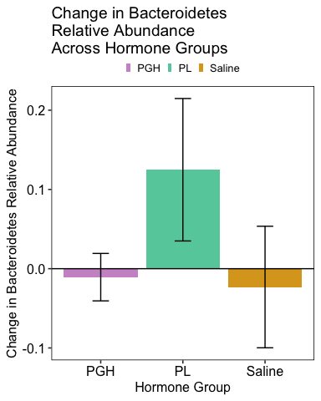

The stats analyses are hidden in this HTML, but with this group comparision in Bacteroidetes change, error bars are high enough that no two groups reach significance in difference.

Next I’m going to repeat everything that I did above, but for Firmicutes.

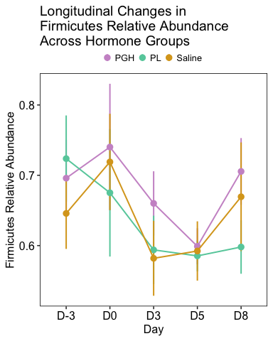

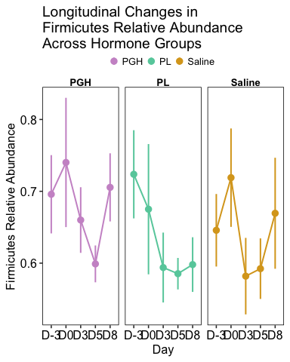

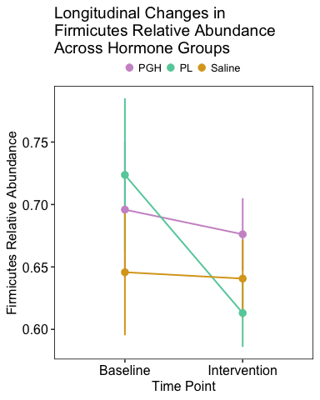

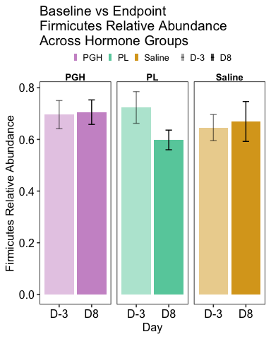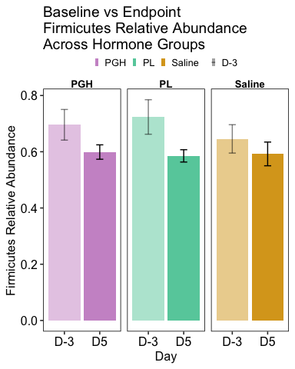 Stats testing is hidden from this html output, but these are the key results:

* No paired t-tests are significant for differences in Firmicutes relative abundance at D-3 and D8 for any of the hormone groups
* For differences in Firmicutes relative abundance at D-3 and D5, the paired t-test is significant for PL mice (p = 0.035) but not for saline or PGH.
* This matches the results found for Bacteroidetes.

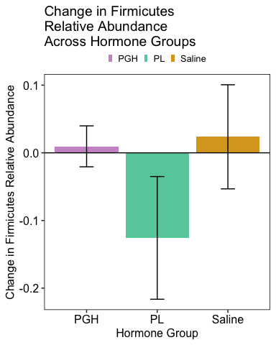

Though its a bit of an outdated metric, we can also quantify the B:F ratio: 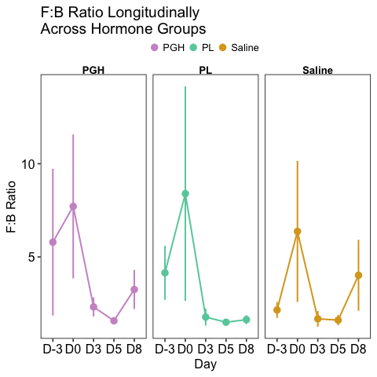 Those have some massive error bars on the baseline days!

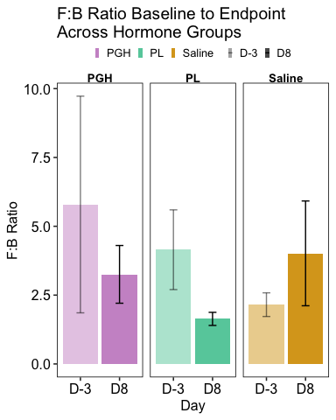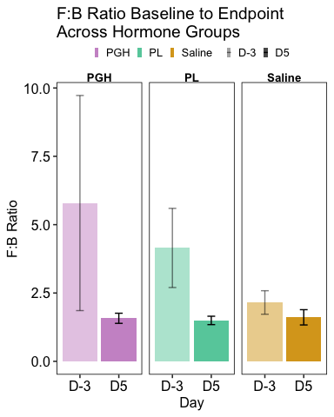

Stats testing is hidden from this html output, but these are the key results:

* No paired t-tests are significant for differences in Bacteroidetes relative abundance at D-3 and D8 for any of the hormone groups
* No paired t-tests are significant for differences in Bacteroidetes relative abundance at D-3 and D5 for any of the hormone groups, but for PL mice, it is approaching significance (p = 0.098)

To increase my sample size, I’m going to combine D-3 and D0 into baseline and have D3 and beyond as intervention: 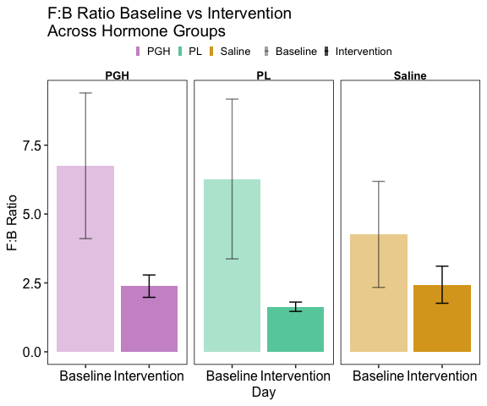

Stats testing is hidden from this html output, but interestingly, it seems that because the baseline error bars are so high, there is no significant difference between baseline and intervention for F:B ratio for any of the hormone groups. Potentially also because these had to be done as unpaired rather than as paired t-tests, reducing our power.

## 3.d.ii. Taxa known to change in abundance during murine pregnancy OR in mouse models of metabolic syndrome / GDM

I decided to look at the following taxonomic groups based on what I’d seen in the literature: 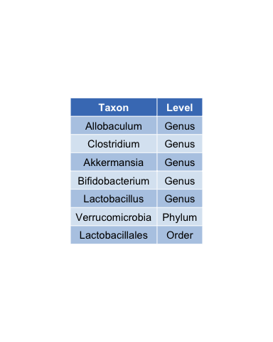

I’m not going to show every possible plot for each of the above 7 taxa, but I’lll show some highlights for each below: *(complete rel and abs abundance analyses are found in Grace’s HEB 114 Lab 2 Draft RMarkdown*

### 1. Allobaculum

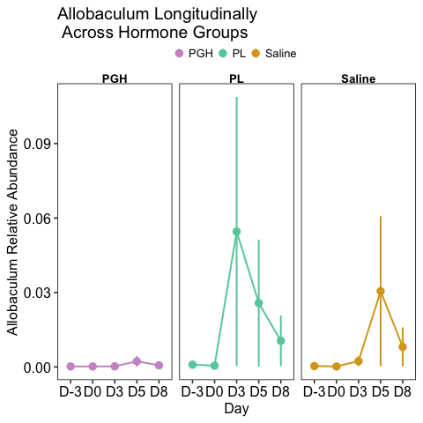

This might look like a bloom in PL mice, but when we scrutinize more closely, it’s likely driven by a single individual (one in PL and one in saline), rather than being a consistent trend: 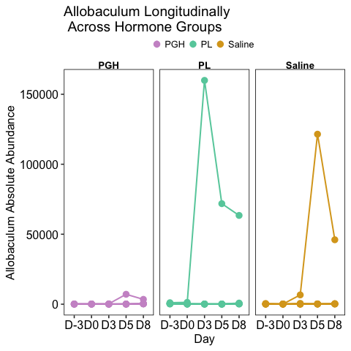 From this plot, I decided that when abundances are predominantly low, it’s better to plot each mouse individually to see if blooms are constrained to one individual.

### 2. Clostridia

Seems to bloom in all groups on day 8 (day with likely contamination): 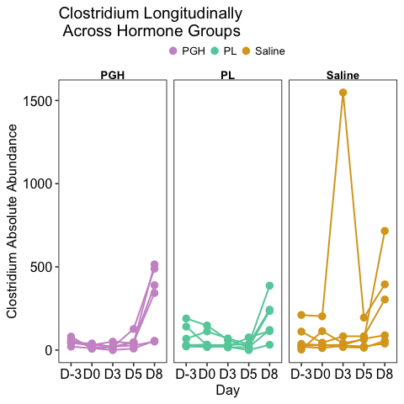

### 3. Akkermansia

Given the distrust of D8 samples, I’m going to filter them out: *(Note: There was one clear crazy outlier mouse, so I filtered it out)* 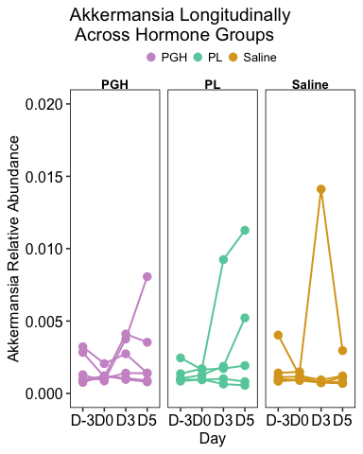

### 4. Bifidobacterium

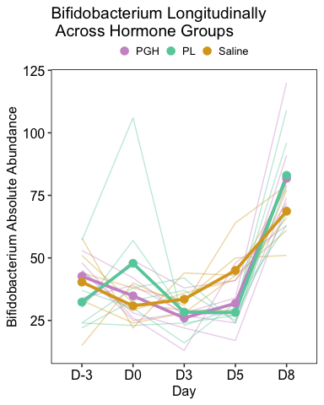 This also increased across groups on the day of likely contamination

But if you look at relative and absolute abundace without D8, it might be more interesting: 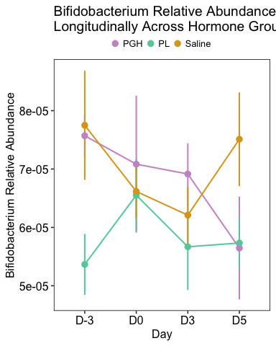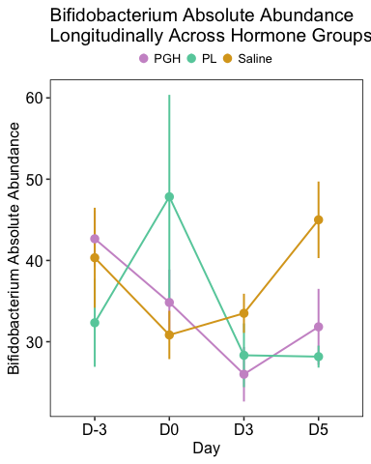 It looks like it might decrease in PGH? But unclear if this is significant at all…

### 5. Lactobacillus

This is another that spikes in absolute abundance on D8 in all groups: 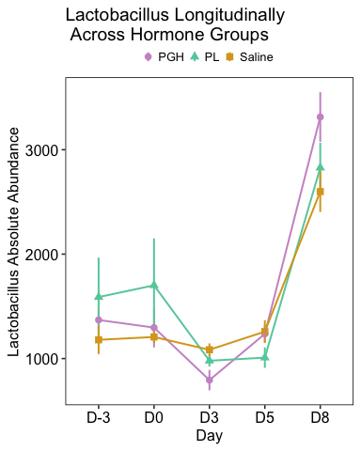

### 6. Verrucomicrobia

Below I’ll show relative abundance both with and without the outlier mouse (just by changing y-axis scale) 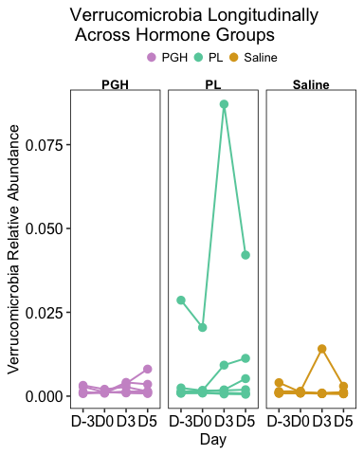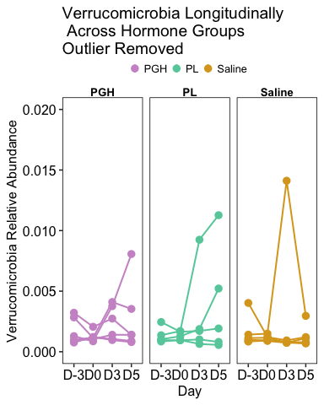 So this taxa increases in several of the PL individuals (3), although one mouse started with an abnormally high concentration?

### 7. Lactobacillales

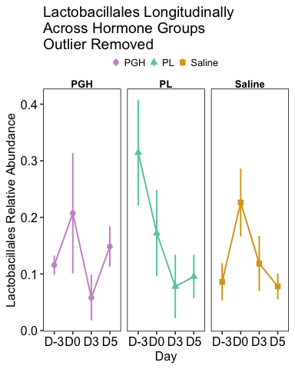 Seems to have decreased in PL mice, but started from baseline at an abnormally high level.

# Bonus 9: The genus SMB53 within the family Clostridiaceae

* This is a genus that popped up a couple times in my early Maaslin2 studies as increasing in abundance in PGH mice, so I decided to make my own plots of its relative abundance here.

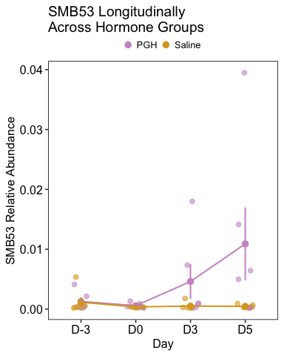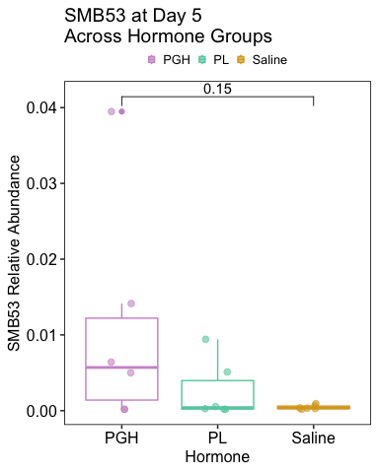

## 3.d.iii. Whole Body Taxonomic Composition

I’m going to start by looking at phylum-level taxonomic composition across groups.

Because we saw potential shifts in the F:B ratio of PL mice, let’s start at the phylum level:

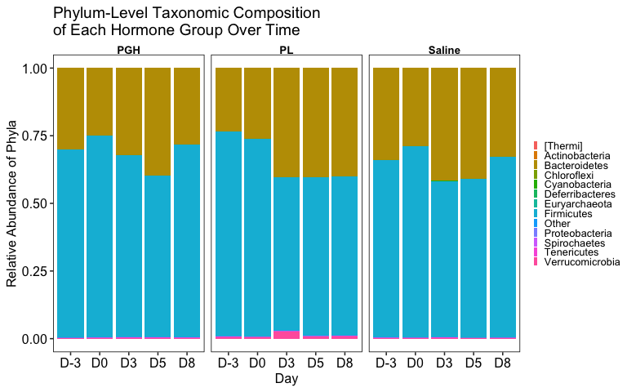

I’ll now do the same for the levels of class, order, family, and genus: 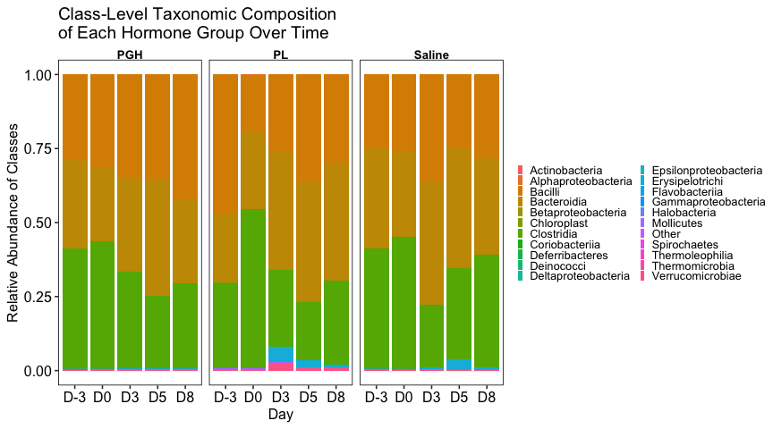

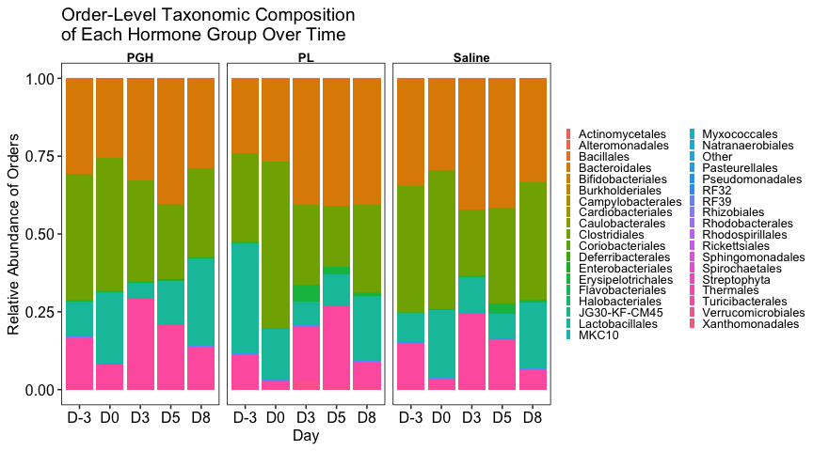

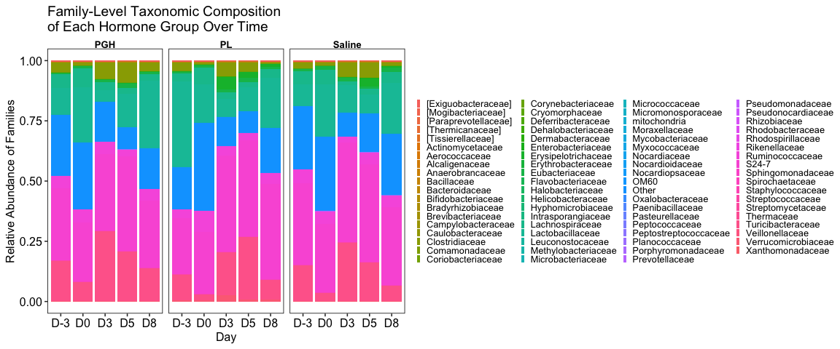

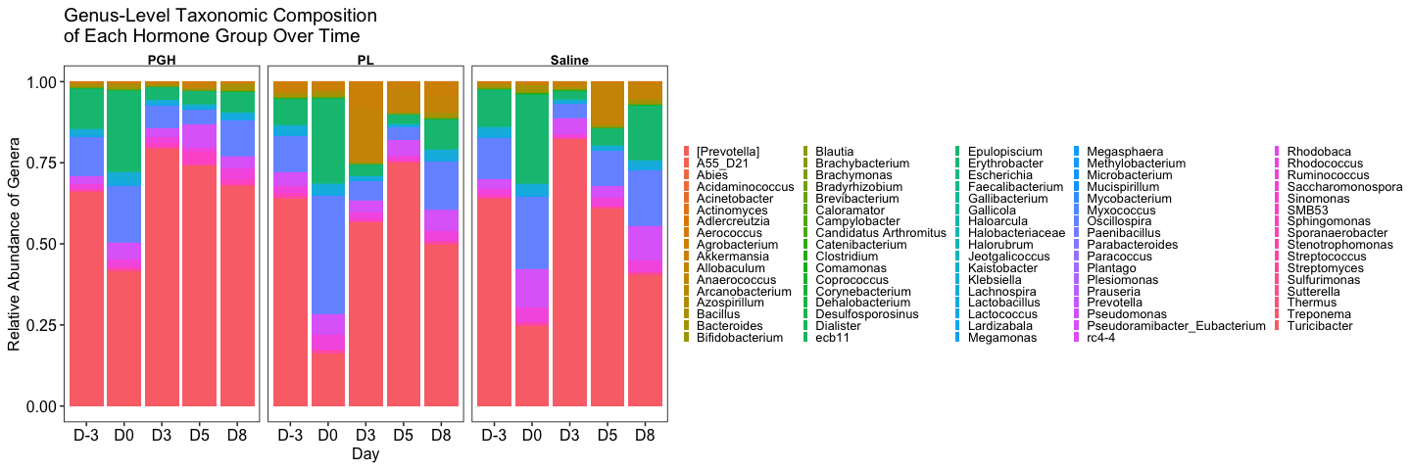

# 3.e. Maaslin2 Analyses

## 3.e. Overview

* This section compiles and summarizes all Maaslin2 analyses conducted for MFC2.
* Rather than rerunning the analyses and regenerating output files, this document presents a comprehensive overview of the results using figures and tables generated in prior files (both on github for easy reference). This avoids redundant file creation and allows me to embed Maaslin2 outputs directly into this file.
* Within each category, Maaslin2 analyses were conducted at all taxonomic levels.

Analysis categories include:

1. **Cross-Sectional Analyses** – Identifying significant microbial differences between PL or PGH groups and saline controls at a given time point
2. **Longitudinal Analyses** – Identifying significant microbial differences over time within each group
3. **Pre-Post Intervention Analyses** – Identifying microbial changes in response to hormonal intervention (comparing pre- vs. post-intervention time points, incorporating multiple measurements per mouse)
4. **Microbiome-Metabolic Correlation Analyses** – Assessing relationships between specific microbial taxa and various metabolic metrics:

* **Glucose metabolism** (endpoint OGTT and ITT AUCs, fasting blood glucose levels)
* **Body composition** via EchoMRI (lean, fat, total, and free water)
* **Weight** (absolute and relative to baseline)
* The above analyses were conducted both in terms of within-group variation (i.e., does individual microbiome variation correlates with individual metabolic variation within a group?) and cross-group variation (i.e., testing whether study-wide metabolic variation influences microbiome composition more than hormonal group affiliation)

Each section will include a brief methodological explanation before presenting the corresponding results.

## 3.e.i. Cross-Sectional Analyses

When comparing PGH or PL mice to Saline mice including all intervention day samples (D0 and beyond), we get no significant results.

## 3.e.ii. Longitudinal Analyses

### Saline

I did not test for significant microbial differences between baseline and intervention days for mice given just saline, because I wasn’t sure what the value would be at this stage. But I am happy to if we think it would be beneficial!

### PGH

I tested for significant longitudinal microbial differences in mice given PGH.

#### Phylum Level:

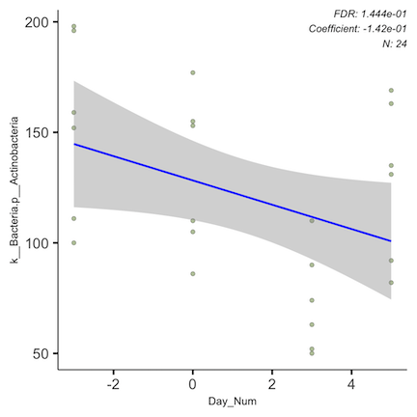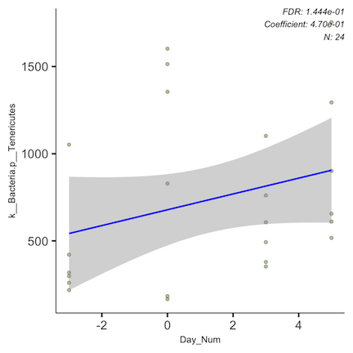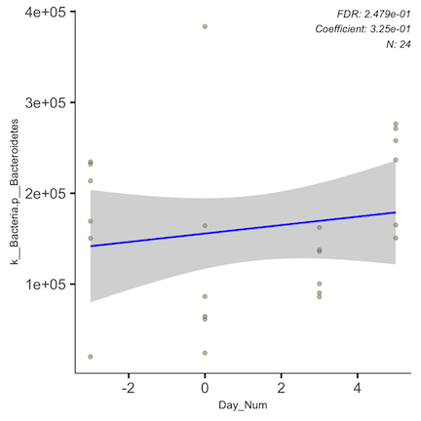

Here is the statistical info on the significant result above:

* Increases were seen in the phyla *Tenericutes* and *Bacteroidetes*
* Decreases were seen in the phylum *Actinobacteria*

#### Class Level:

At the class level, nothing popped up as significant after correcting for FDR, but it appears that enrichment in *Tenericutes* is driven by the class *Mollicutes* (unadjusted p = 0.022).

#### Order Level:

At the order level, nothing popped up as significant after correcting for FDR, but it appears that enrichment in *Mollicutes* is driven by an order called “RF39” (unadjusted p = 0.022).

#### Family AND Genus Level:

*Note: Many of the family-level trends here could then be differentiated to the genus level. To make this document easier to follow, when applicable, I am going to nest those trends here, presenting the family information and then the related genus-level plots directly after.*

* There was a significant decrease in the family *Streptomycetaceae*, which is in the phylum *Actinobacteria*, which showed a general trend of decreased abundance.

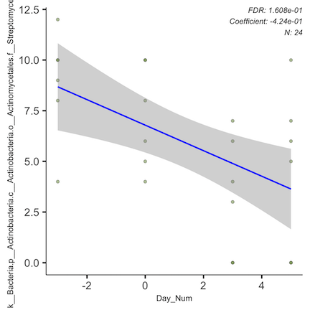

This trend was predominantly driven by the genus *Streptomyces*.

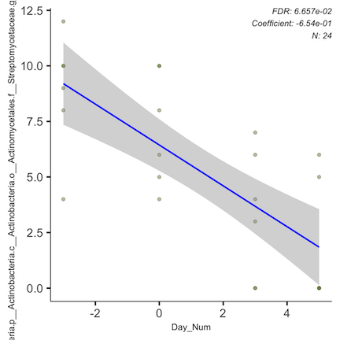

* Though directions of effect differed, significant effects were found in five different families within the order *Clostridiales*
  1. *Lachnospiraceae* (decrease)

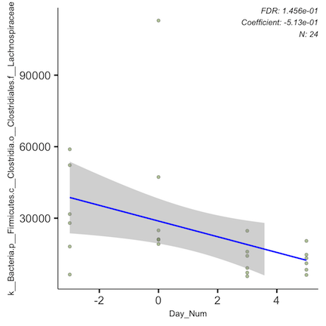

(here’s another strong figure showing that *Lachnospiraceae* decrease, but from day 0 to 5): 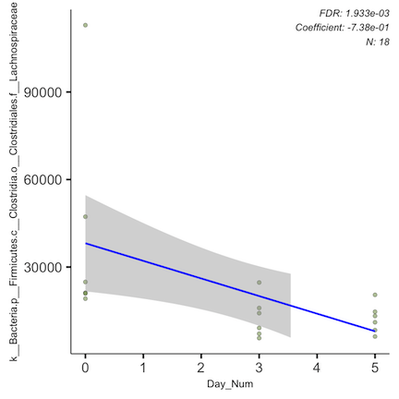

This trend was driven by decreases in three different genera within this family:

1. *Epulopiscium*

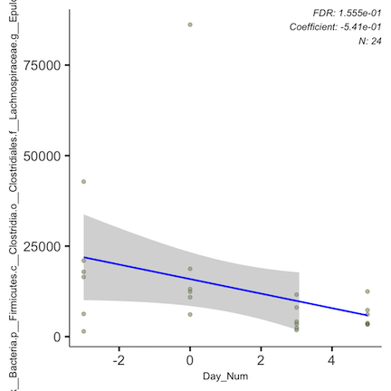

1. *Blautia*

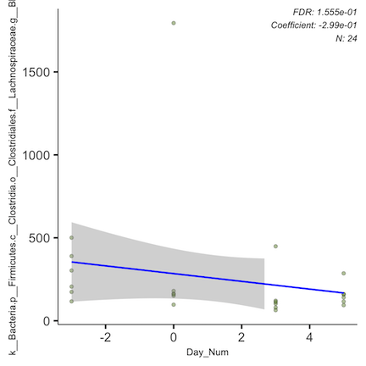

1. *Lachnospira*

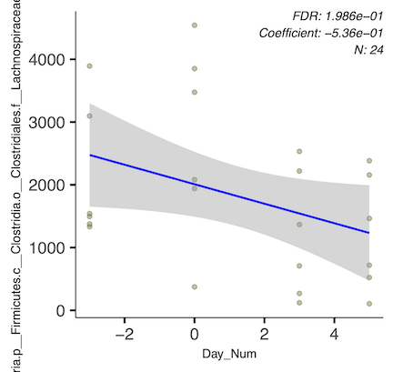

1. *Eubacteriaceae* (increase)

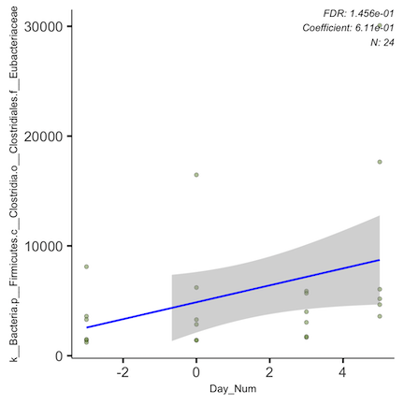

This trend was predominantly driven by the genus *Pseudoramibacter*.

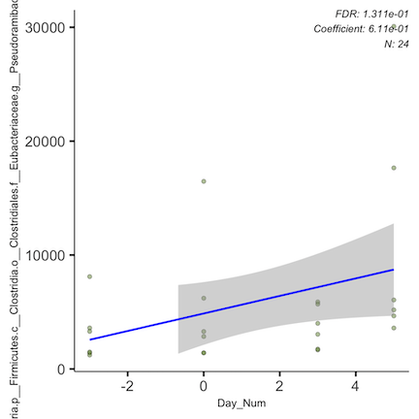

1. *Peptococcaceae* (decrease)

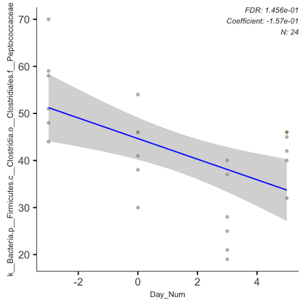

This trend was predominantly driven by a genus noted as “rc4.4”.

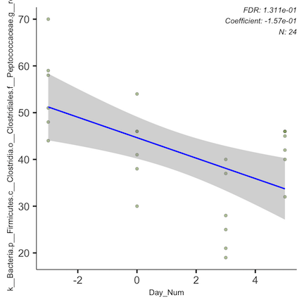

1. *Dehalobacteriaceae* (decrease)

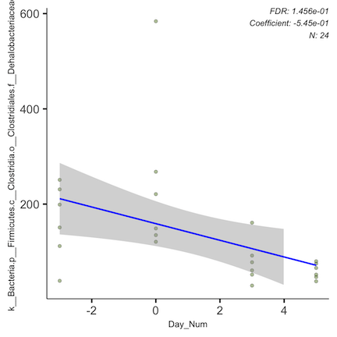

(here’s another strong figure showing that *Dehalobacteriaceae* decrease, but from day 0 to 5): 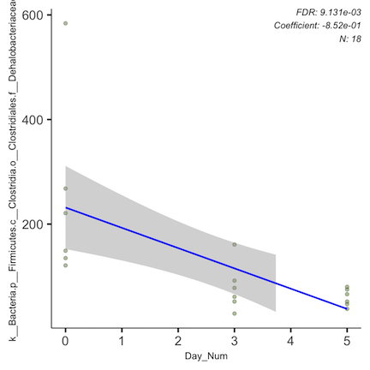

This trend was predominantly driven by the genus *Dehalobacterium*.

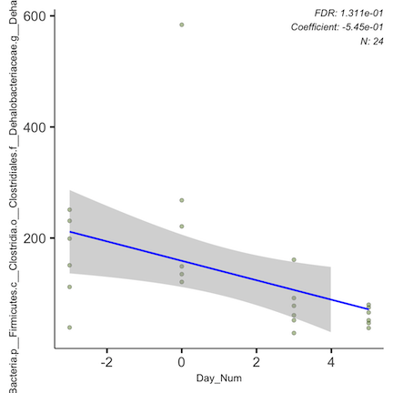

1. *Clostridiaceae* (increase)

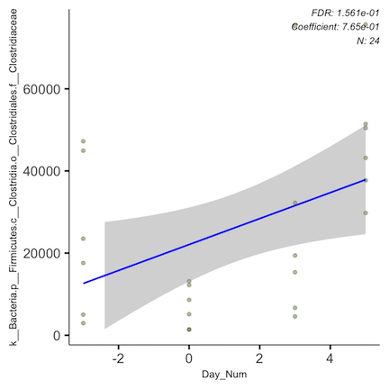

(here is also a figure for *Clostridiaceae* increases in PGH mice from days 0 to 5): 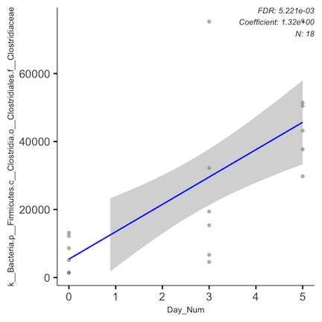

This trend was predominantly driven by a genus noted as “SMB53”.

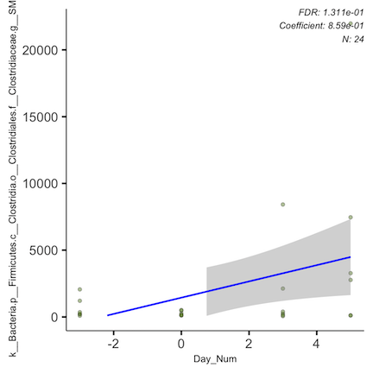

* There was also a general decrease of *Clostridiales* that could not be differentiated to the family level

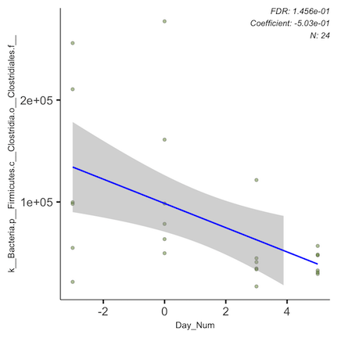

* Additionally, the order “RF39” noted above, though not further differentiated, did pop up as significant at this level

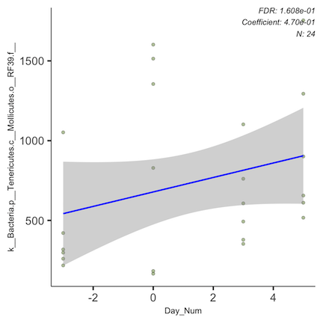

Here is the statistical info on the significant result above:

#### Genus Level:

* 8 of the genus-level analyses were included above under their corresponding family-level analyses that also were significant.
* Excluding those, there were significant *decreases* in 4 genera:
  1. *Faecalibacterium*

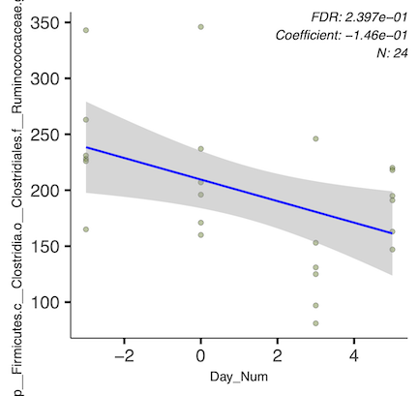

1. *Jeotgalicoccus*

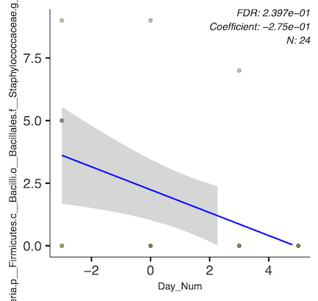

1. *Lactococcus*

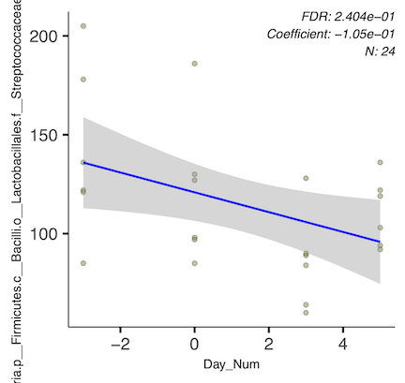

1. *Oscillospira*

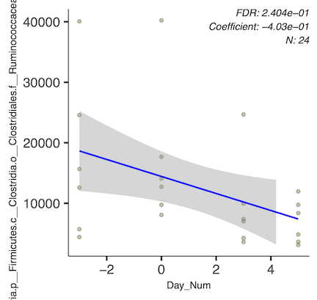

* There were also 4 new families that popped up as significant in this analysis that lack genus-level identification, despite not appearing in the family-level analysis round.
  + Of these, two are in the phylum *Proteobacteria*, which both increased:
  1. *Rhodobacteraceae*

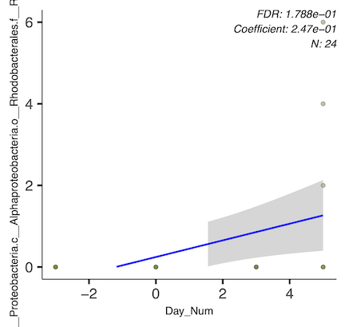

1. *Methylobacteriaceae*

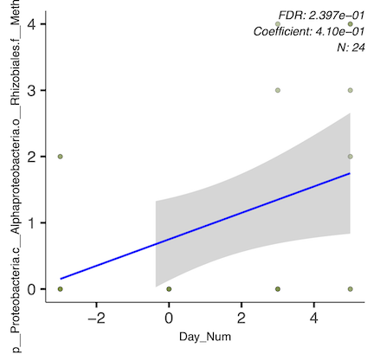

* The other two families are *Firmicutes*, and they decreased:

1. *Paenibacillaceae*

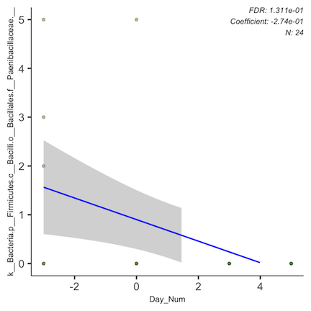

1. *Ruminococcaceae* (same family as the genus Faecalibacterium that also popped up separately above)

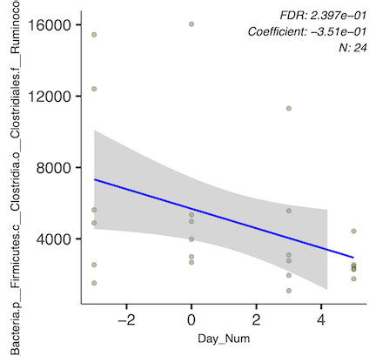

Here is the statistical info on the significant result above:

#### Species Level:

(Through D5): None of the groups identified above could be narrowed down by Maaslin beyond the genus level, so the species-level plots are all identical to those above.

(Through D5): We saw significant longitudinal decreases in the following species: 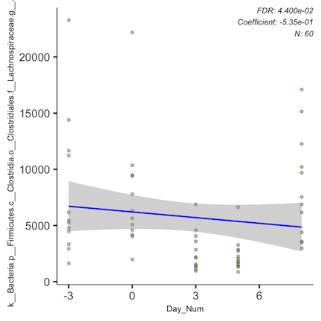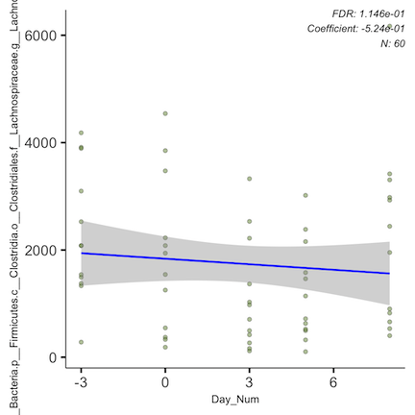

We saw significant longitudinal increases in the following species: 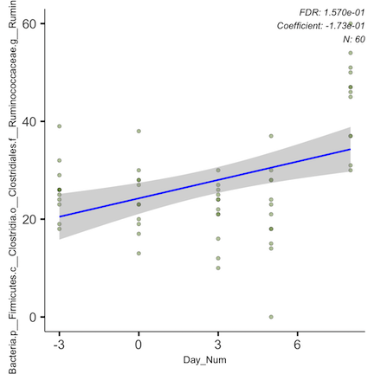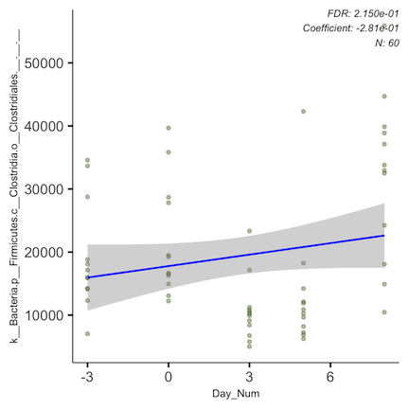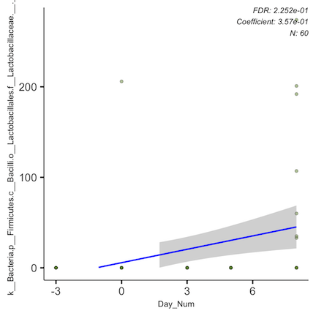

Here is the statistical info on the significant result above:

* None of these could be identified at the species level, but both decreases came from the family *Lachnospiraceae*, with the first plot unable to differentiate beyond family and the second able to get down to the genus *Lachnospira*
* Increases were seen in the order *Clostridiales*, with Maaslin also able to distinguish that some (but not all) of these increases were driven by members of the genus *Ruminococcus*.
* Increases were also seen in the family *Lactobacillaceae*.

NOTE: The weirdness of our Day 8 samples could be driving these trends. ***

### PL

I tested for significant longitudinal microbial differences in mice given PL. Because I was very skeptical of D8 values, I ran analysis at all levels that stopped at D5:

#### Phylum Level:

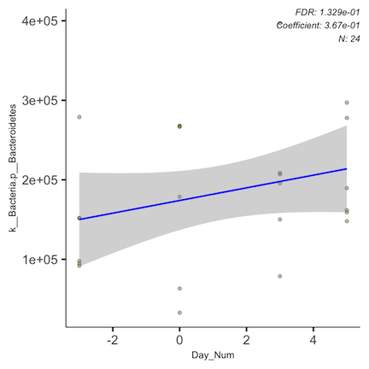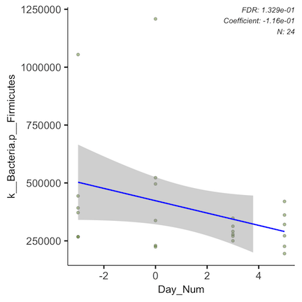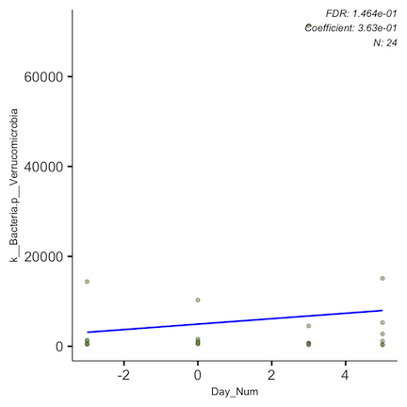

Here is the statistical info on the significant result above:

* We see a mild longitudinal enrichment of *Bacteroidetes* and depletion of *Firmicutes*
* We also see a mild enrichment of *Verrucomicrobia*

#### Class Level:

At the class level, nothing popped up as significant after correcting for FDR, but it appears that enrichment in *Bacteroidetes* is driven by the class *Bacteroidia* (unadjusted p = 0.027) and enrichment in *Verrucomicrobia* is driven by the class *Verrucomicrobiae* (unadjusted p = 0.044).

#### Order Level:

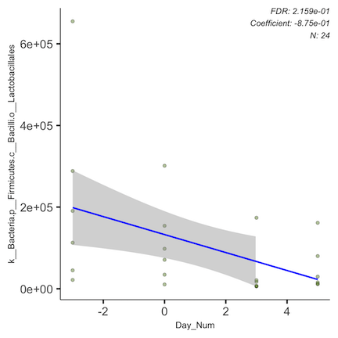

Here is the statistical info on the significant result above:

* Depletion of *Firmicutes* appears to be dominantly driven by the order *Lactobacillales*

#### Family Level:

At the family level, nothing popped up as significant after correcting for FDR, but the depletion of *Lactobacillales* seems to be driven by the family *Lactobacillaceae* (unadjusted p = 0.00076).

Several other adjusted p values also were fairly low. See table below:

#### Genus Level:

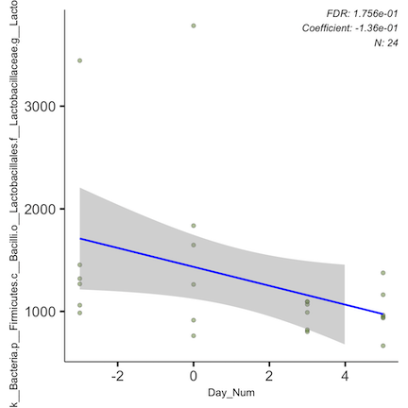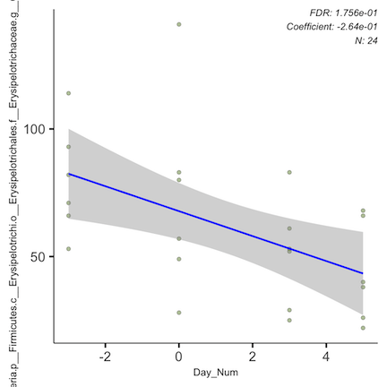

Significant depletion was identified in the following genera of *Firmicutes*:

* *Lactobacillus*
* *Catenibacterium*

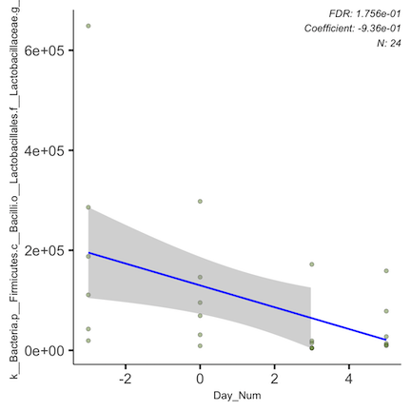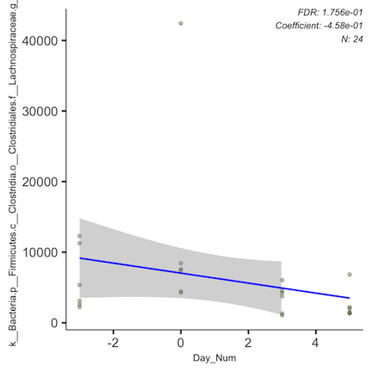

Additionally, the following *Firmicutes* families showed significant depletion, but only popped up as significant in the genus-level analysis, despite not being able to be identified beyond the family level:

* *Lactobacillaceae* (as noted above)
* *Erysipelotrichaceae*

Here is the statistical info on the significant result above (out of order from presentation of figures above):

#### Species Level (through D5):

None of the groups identified above could be narrowed down by Maaslin beyond the genus level, so the species-level plots are all identical to those above.

#### Species Level (through D8):

To show my suspicious of the D8 samples, this is an example of what one of the species-level trends look like including those days.

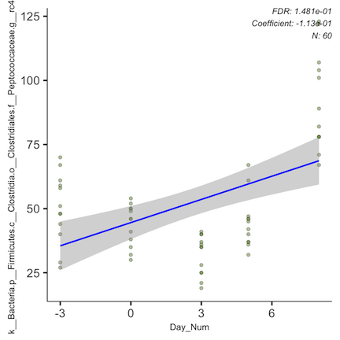

To me, this trend look clearly driven by D8 contamination.

## 3.e.iii. Pre-Post Intervention Analyses

### Saline

I did not test for significant microbial differences between baseline and intervention days for mice given just saline, because I wasn’t sure what the value would be at this stage. But I am happy to if we think it would be beneficial!

### PGH

I tested for significant microbial differences between baseline and intervention days for mice given PGH.

#### Phylum Level:

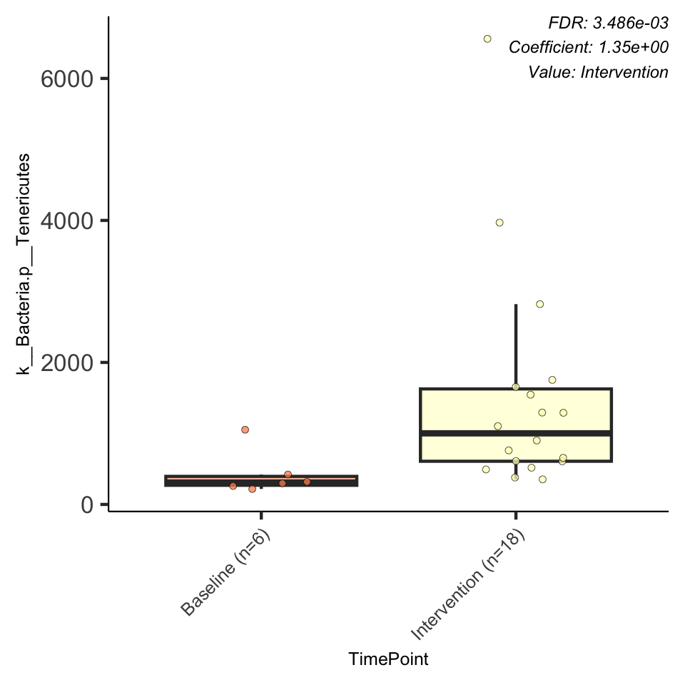

Here is the statistical info on the significant result above (it’s only one result so it’s a bit boring of a table):

PGH injected-mice had a significant enrichment in *Tenericutes*.

#### Class Level:

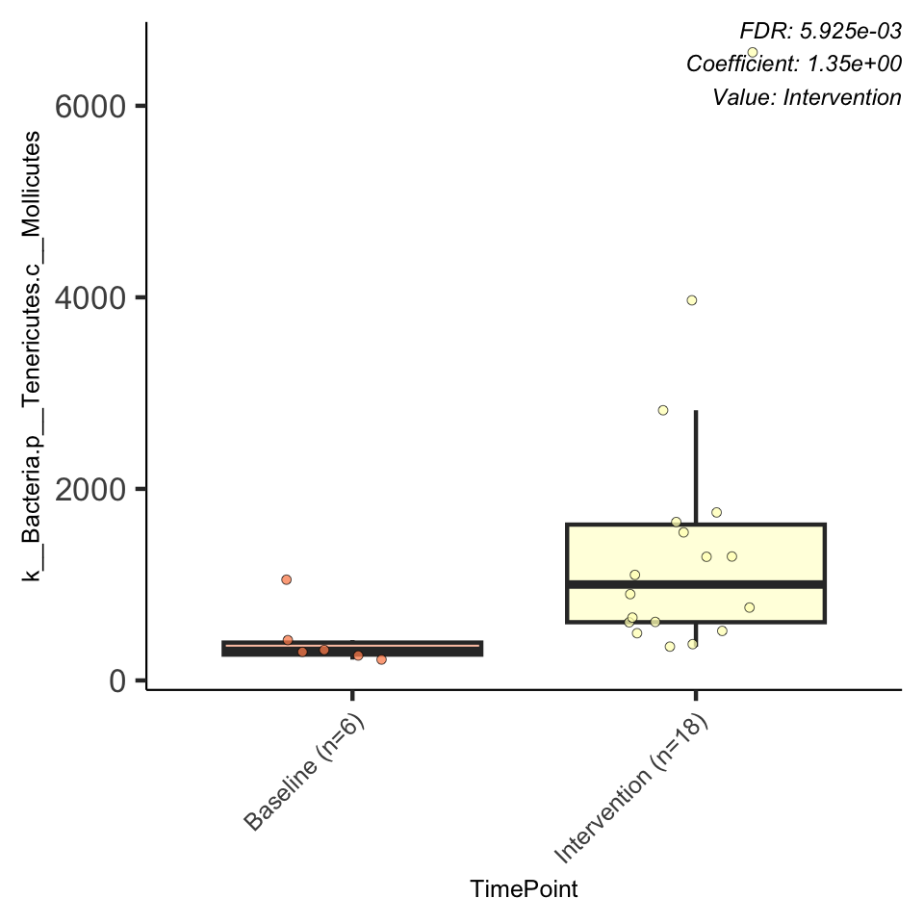

Here is the statistical info on the significant result above:

The enrichment in *Tenericutes* is predominantly within the *Mollicutes* class.

#### Order Level:

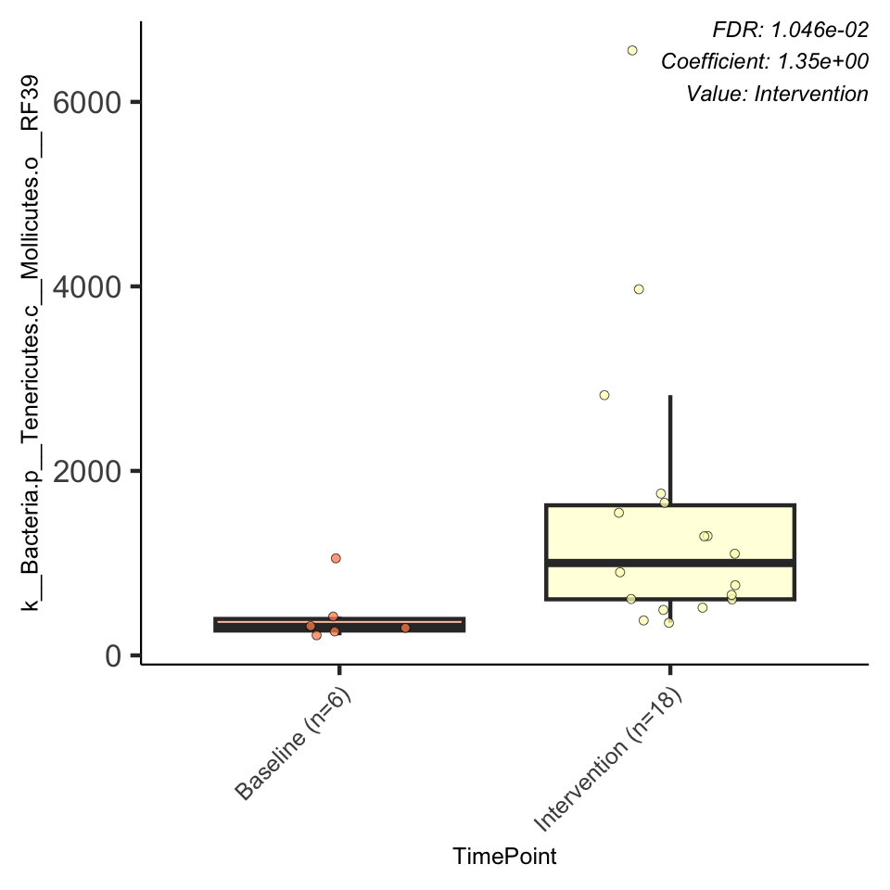

Here is the statistical info on the significant result above:

The enrichment in *Mollicutes* is predominantly within an order called “RF 39.”

#### Family Level:

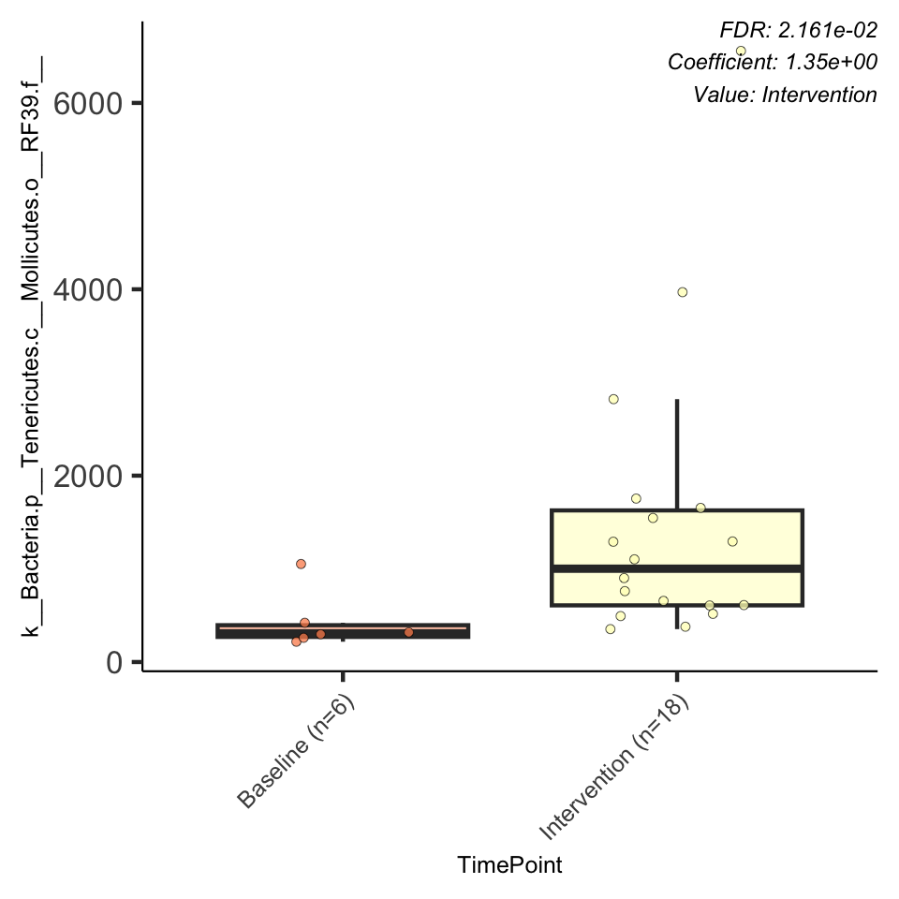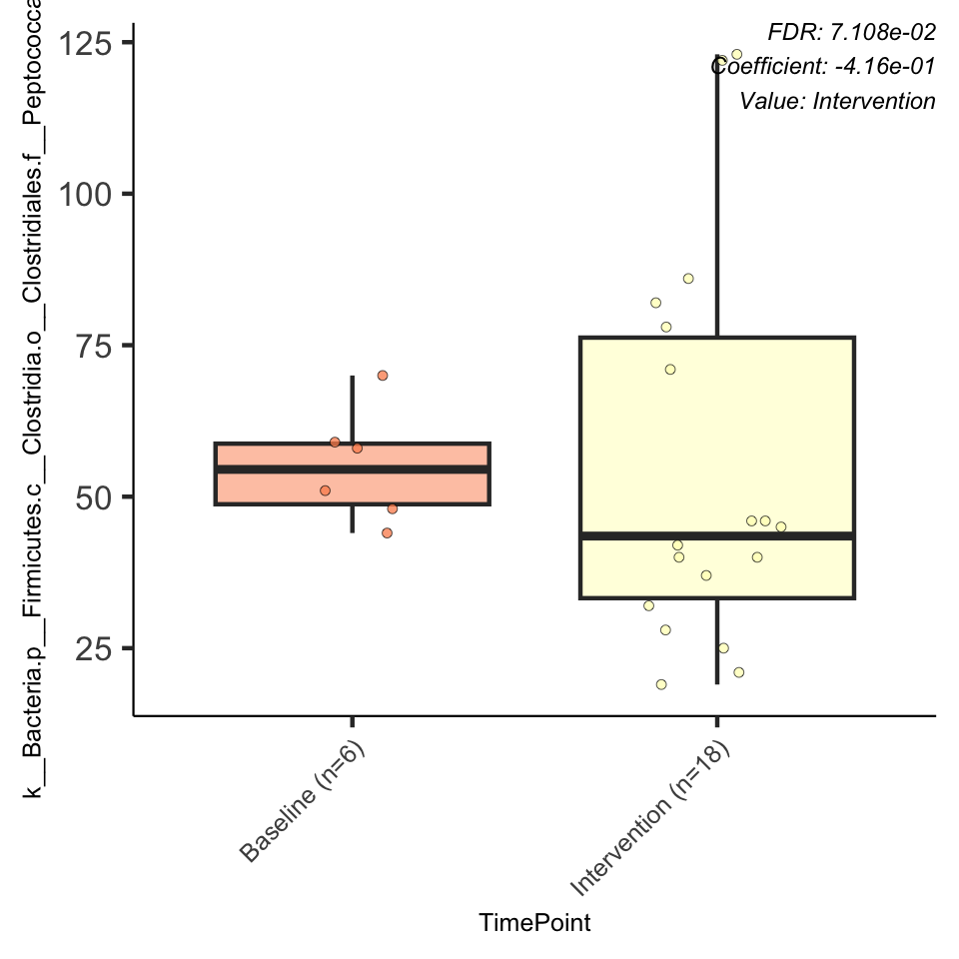

Here is the statistical info on the significant results above:

* Within that order “RF 39,” we are not able to get any additional information on the family, genus, or species that is enriched. Because of this I will not show the subsequent identical figures for the lower taxonomic levels.
* There is also significant depletion of a family called *Peptococcaceae*

#### Genus Level:

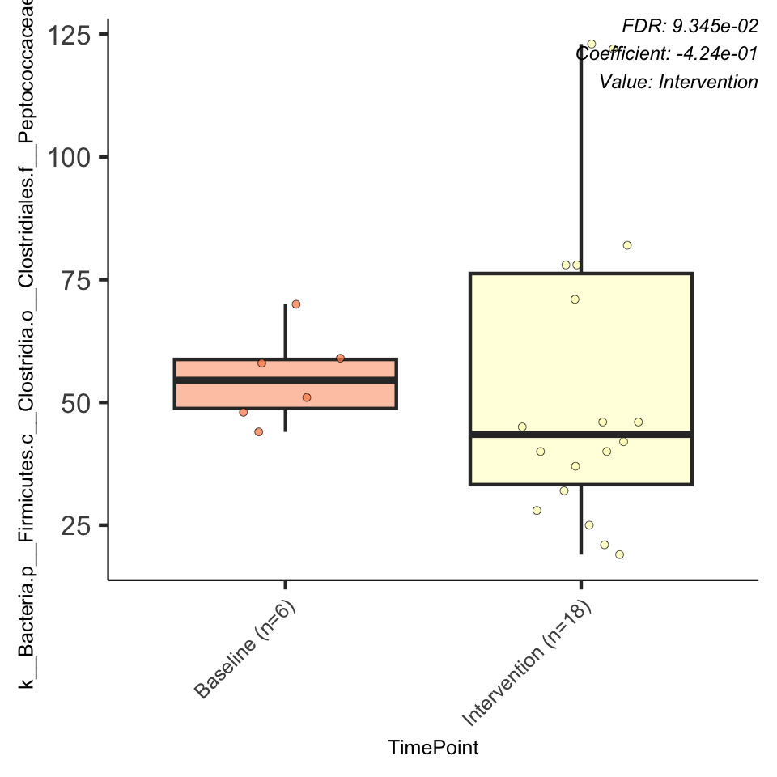

Here is the statistical info on the significant results above:

Within *Peptococcaceae*, depletion is predominantly within a genus called “rc4.4”

#### Species Level:

Within that genus “rc4.4,” Maaslin cannot give species-level information, so the figures and stats are redundant and won’t be repeated.

### PL

I tested for significant microbial differences between baseline and intervention days for mice given PL.

#### Phylum Level:

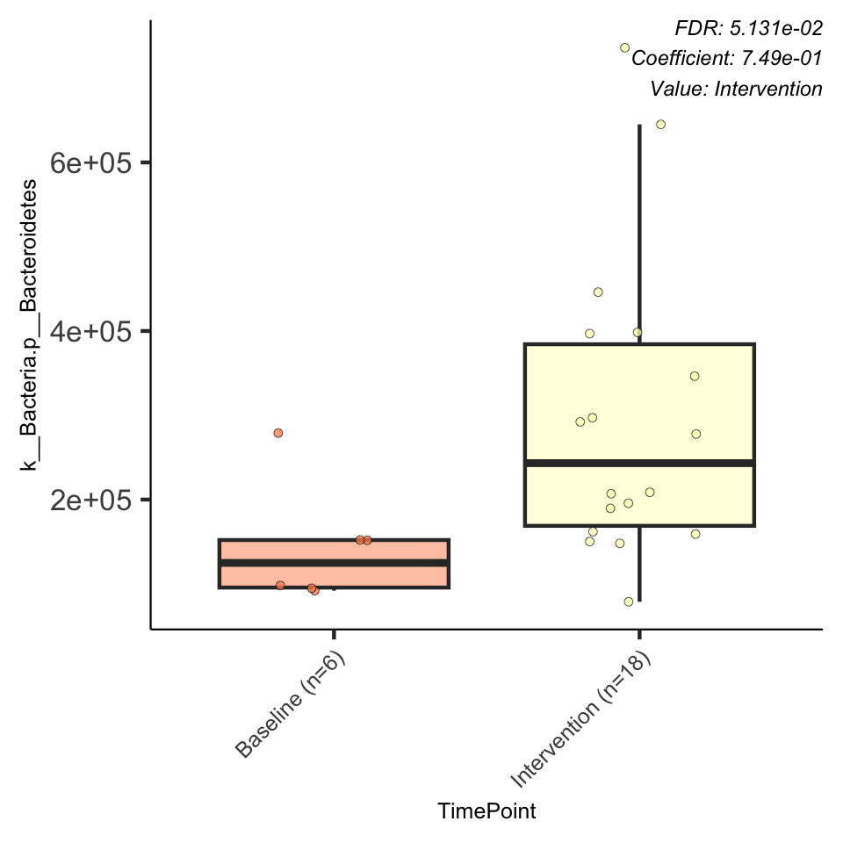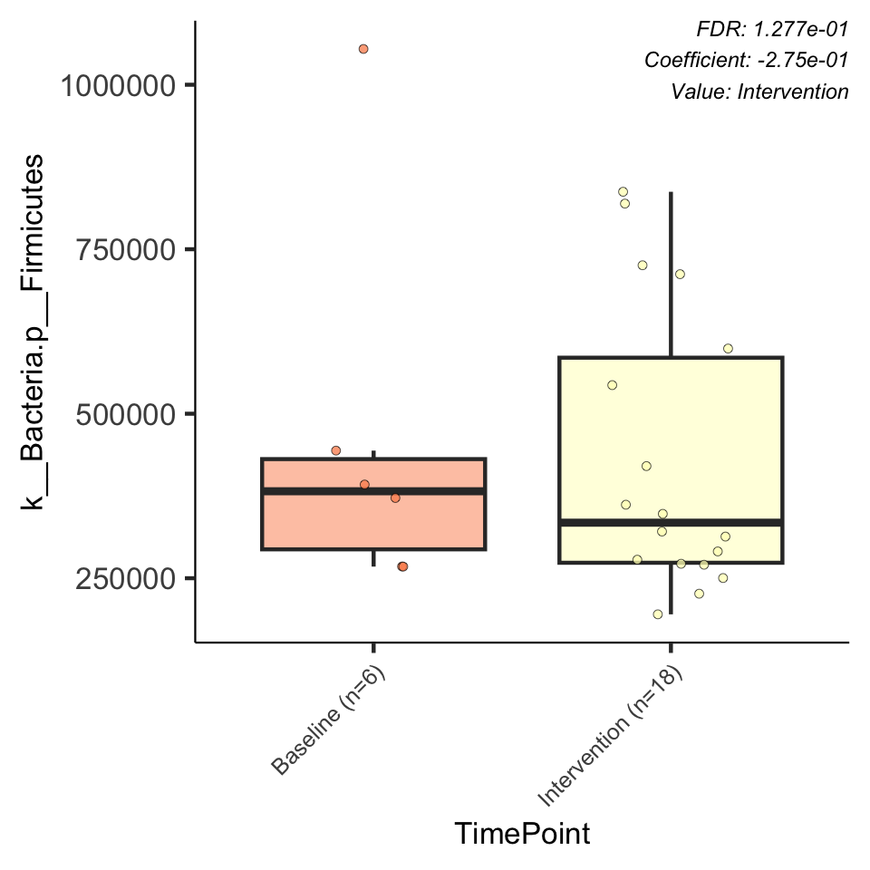

Here is the statistical info on the significant results above:

Matching the results we found in phyloseq, pl-exposed mice showed an enrichment in *Bacteroidetes* and a depletion in *Firmicutes*.

#### Class Level:

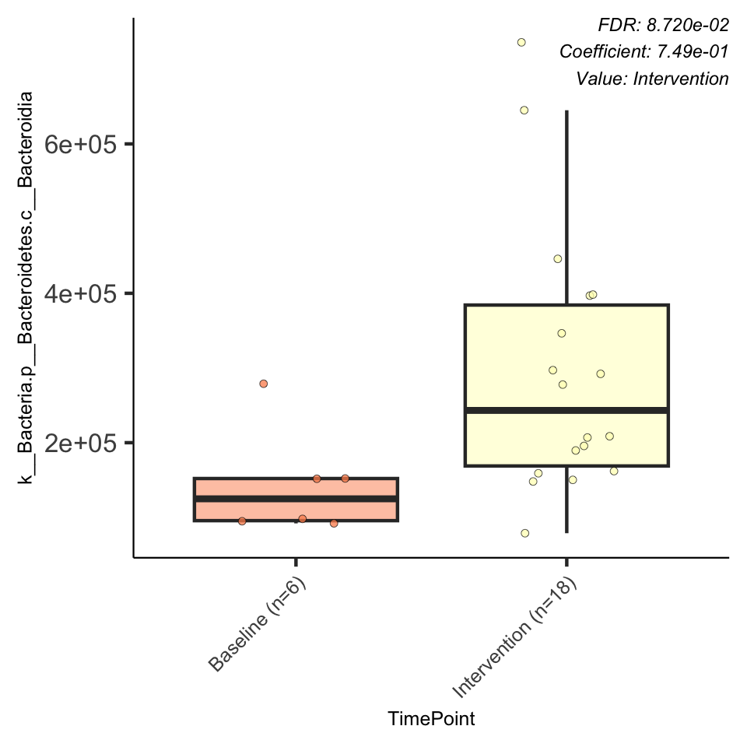

Here is the statistical info on the significant result above:

* It appears the depletion in *Firmicutes* was spread across many lower level taxa, because no classes showed significance
* The enrichment in *Bacteroidetes* was predominantly within the class *Bacteroidia*

#### Order Level:

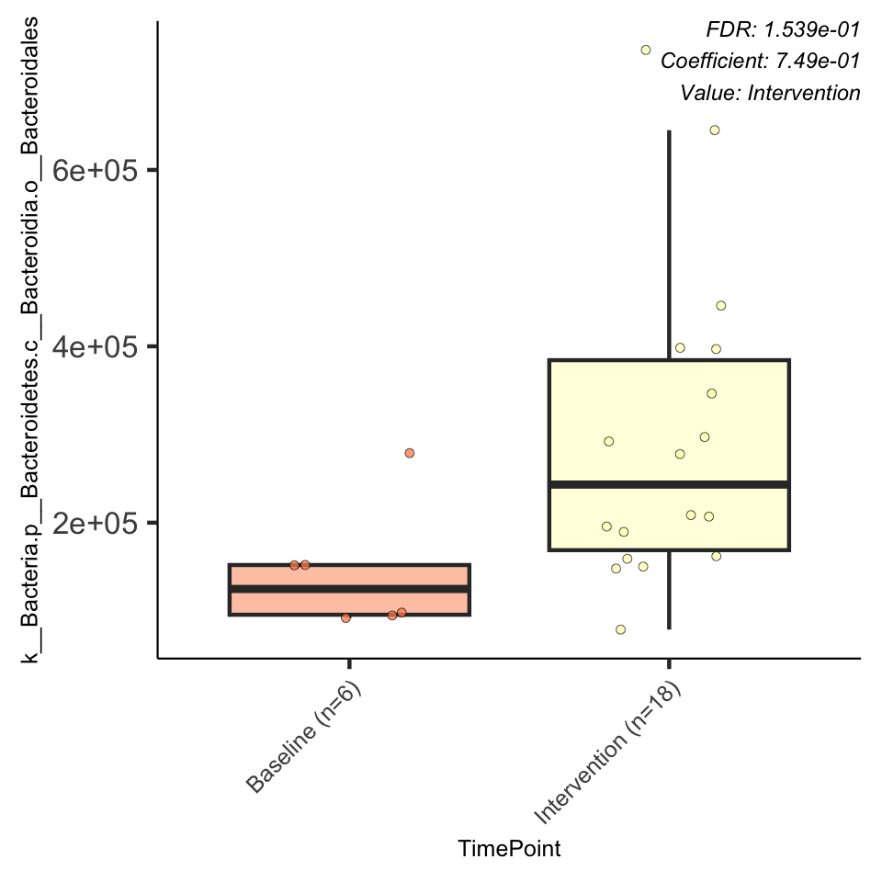

Here is the statistical info on the significant result above:

The enrichment in *Bacteroidia* was predominantly within the order *Bacteroidiales*.

#### Family Level:

At the family level, *Bacteroidiales* enrichment appears to have been concentrated within two families, *Porphyromonadaceae* and one called “S24.7.” However, while unadjusted p values were significant (p = 0.005 and 0.009, respectively), with false discovery correction, neither reached significance.

#### Genus Level:

* Within *Porphyromonadaceae*, the family that popped up as significant when p was unadjusted but not with false discovery correction, the majority of the effect came from the genus *Parabacteroides* (unadjusted p = 0.009)
* From what I see online, *Parabacteroides* is considered a common gut commensal. It has also been found to “alleviate obesity and obesity-related dysfunctions in mice” (Wang *et al*, 2019 paper in Cell Reports), and has specifically been linked to glycemic control.
* My quick lit search shows that *Parabacteroides* pops up a lot in GDM research, but is inconsistently found to be positively or negatively correlated. Kuang *et al*. (2017) did shotgun on healthy and GDM patients in the 2nd-3rd trimester (21–29 weeks) and found both that GDM patients had significantly higher *Parabacteroides* levels, but also that women with *Parabacteroides* abundance positively correlated with glucose levels during an OGTT. Their random forest model found that: *“Bacterial species providing the highest discriminatory power were primarily members of the… Parabacteroides genera …consistent with our observation that Parabacteroides is the predominant genus accounting for differences in the gut microbiome between GDM patients and controls.”* Dong *et al*. (2020) and Su *et al*. (2021) also found that GDM patients had a significantly higher relative abundance of *Parabacteroides,* as well as that “HOMA-IR increased with the higher abundance genus of *Parabacteroides*”. In contrast, Cortez *et al*. (2018) and Ma *et al*. (2020), found that healthy pregnant women had higher levels of *Parabacteroides* than GDM women. Ma *et al*. additionally found that women with higher *Parabacteroides* had lower fasting blood glucose levels.
* In CD1 mice, Priyadarshini *et al*. (2017 – one of my fav papers) found that *Parabacteroides* were highest at D0 and gradually decreased during pregnancy, continuing to decrease through postpartum day 3.

#### Species Level:

Within *Parabacteroides*, the genus that popped up as significant when p was unadjusted but not with false discovery correction, the majority of the effect came from the species *gordonii*. Unadjusted p = 0.009).

## 3.e.iv. Microbiome-Metabolic Correlation Analyses

### Glucose Metabolism

#### Endpoint OGTT AUCs

I had high hopes for this but nothing popped up as significant.

#### Endpoint ITT AUCs

The only significant effect found was at the level of order: *Clostridia* has a negative correlation with ITT AUC. A smaller ITT AUC indicates lower insulin resistance. So, mice with greater *Clostridia* levels also had greater insulin sensitivity. This effect held true when hormone both was and was not included as a random effect. The figure and stats below are for it not being included as a random effect.

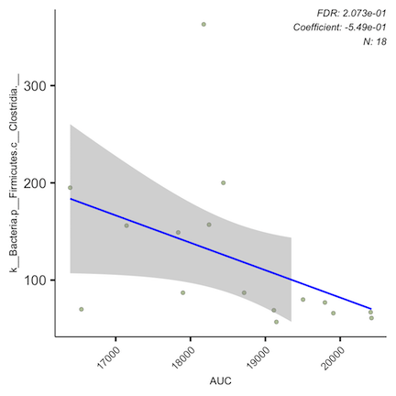

Here is the statistical info for this result:

#### Endpoint fasting blood glucose levels

I ran these analyses two different ways: with hormone group included as a random effect, and not included.

When hormone is not included as a random effect, four taxonomic groups pop out as significant.

1. *Akkermansia muciniphila* has a positive correlation with fasting BG levels.

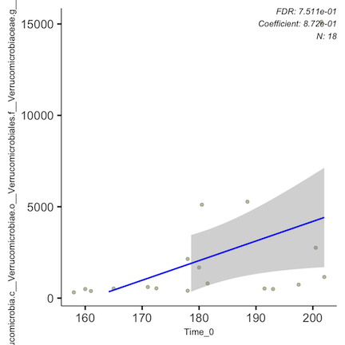

1. *Plesiomonas shigelloides* has a positive correlation with fasting BG levels. *However*, all but two samples had none of this bug, so the effect is driven by two mice with both high fasting BG and measurable levels of this bug.

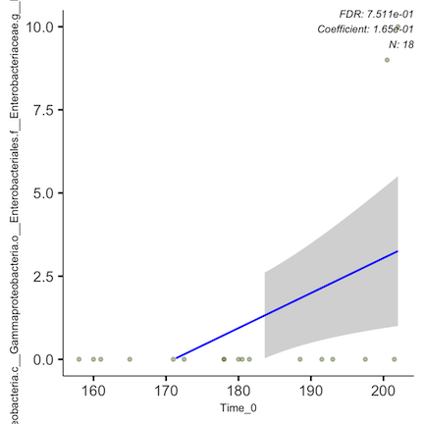

1. The family *Coriobacteriaceae* in the phylum *Actinobacteria* has a positive correlation with fasting BG levels.

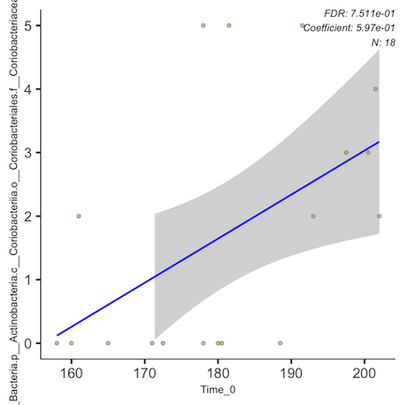

1. The genus *Megamonas* has a negative correlation with fasting BG levels. *However*, all but three samples had none of this bug, so the effect is driven by two mice with both low fasting BG and measurable levels of this bug.

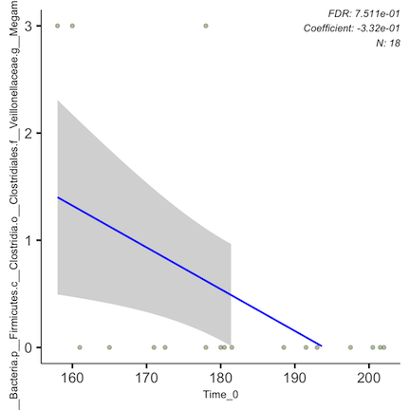

Here is the statistical info for these results:

When hormone is included as a random effect, the significance for those four taxonomic groups remains fairly unchanged, with the exception of the p-value for *Megamonas* increasing from 0.02 to 0.002.

### Body Composition

#### Lean mass

I was unsure the ideal way to run these analyses, so I did them a few ways. First, I included lean masses from both timepoints, with individual mouse and time point included as random effects. This is basically ignoring the effects of the hormones.

NOTE: These plots all say lean mass *percentage* as the x axis, but are actually showing *absolute* lean mass. I ran these analyses before I realized the EchoMRI returns absolute and not relative lean mass values.

I only ran this analysis as the genus level (cannot remember why), and found the following:

* A negative correlation between *Akkermansia* (presumably muciniphila) and lean mass. However, this seems to be driven by two samples with very low lean mass and very high *Akkermansia* loads.

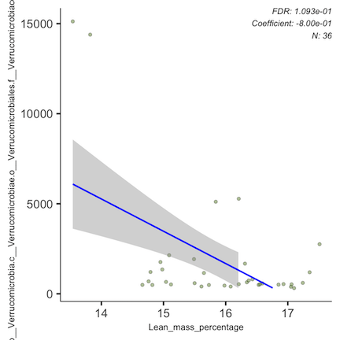

* A positive correlation between the family *Clostridiaceae* and lean mass. This seems to be particularly driven by a genus called “SMB53.”

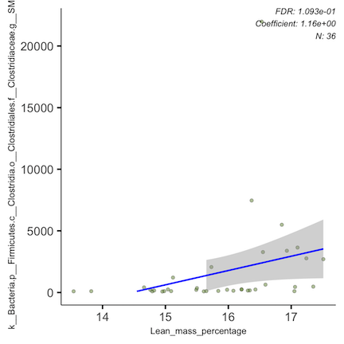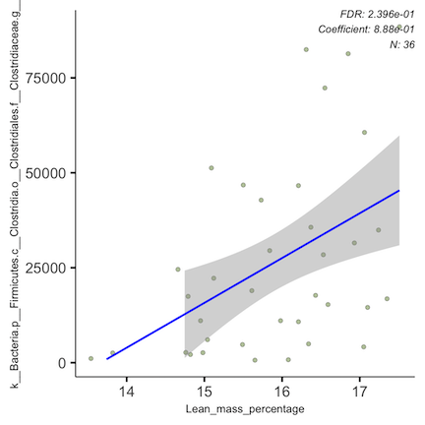

In previous mouse studies, including Zhang *et al*. (2024), “SMB53 showed a stronger positive correlation with body weight, white adipose tissues, liver weight and AA metabolites, and a simultaneously negative correlation with the anti-inflammatory cytokine IL-10.”

Here is the statistical info for these results:

I then analyzed lean mass only at endpoint, accounting for hormone group as a fixed effect. The output for this was a little funky – it didn’t make plots for me, but the full results table shows some interesting things:

Here are my takeaways:

* *SMB53*, which was positively associated with lean mass, was (unsurprisingly) also positively associated with being a PGH mouse (p = 0.035).
* 3 new genera popped up as having associations with lean mass:

1. *Prevotella* – positively correlated, p = 0.019
2. *Jeotgalicoccus* – positively correlated, p = 0.018 (was previously found to decrease in PGH, which is surprising)
3. *Coprococcus* – negatively correlated, p = 0.005

* I probably should go back and run this analysis at all taxonomic levels, but for now this is what I have.

#### Fat mass

Similarly, I started with looking at fat masses from both timepoints, with individual mouse and time point included as random effects. This is basically ignoring the effects of the hormones.

I found a positive correlation with the Proteobacterium *Gallibacterium*, but it was only at non-zero levels in 6 out of 36 samples.

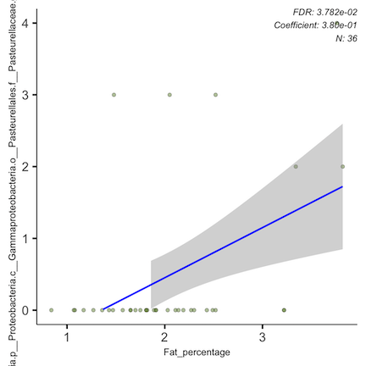

When I analyzed fat mass only at endpoint, accounting for hormone group as a fixed effect, I found no significant associations.

#### Free and total water

I wasn’t super interested in these, but there were tons of significant correlations with both. I’ll include the significance tables for both at the genus level below:

**Free water**

And here are the figures (I’ll keep them tiny): 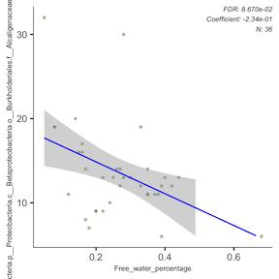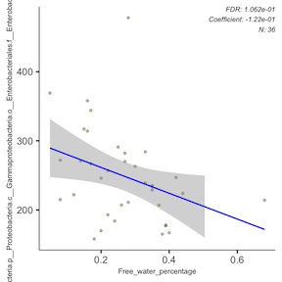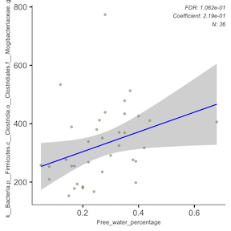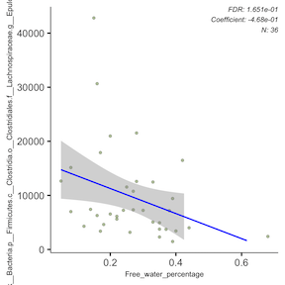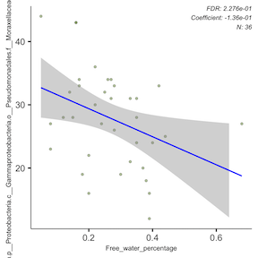

**Total water**

And here are the figures (I’ll keep them tiny): 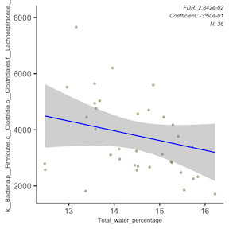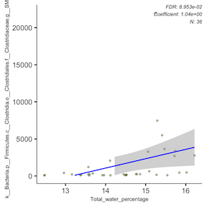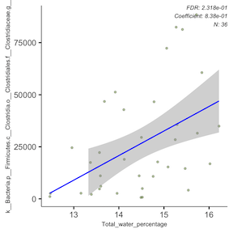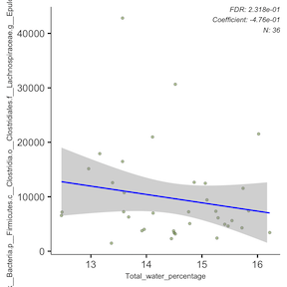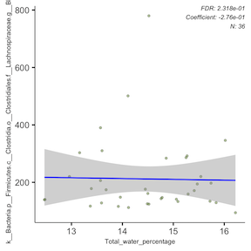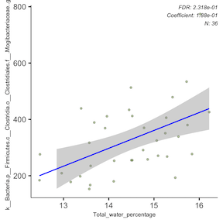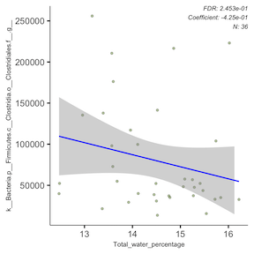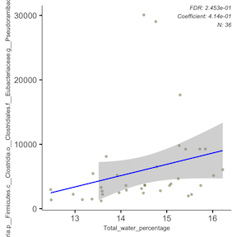

#### Complete body composition heat map

I also looked at genus-level correlations between the four body comp variables and microbial taxa, and got this heat map:

I’m not sure how to interpret it though…

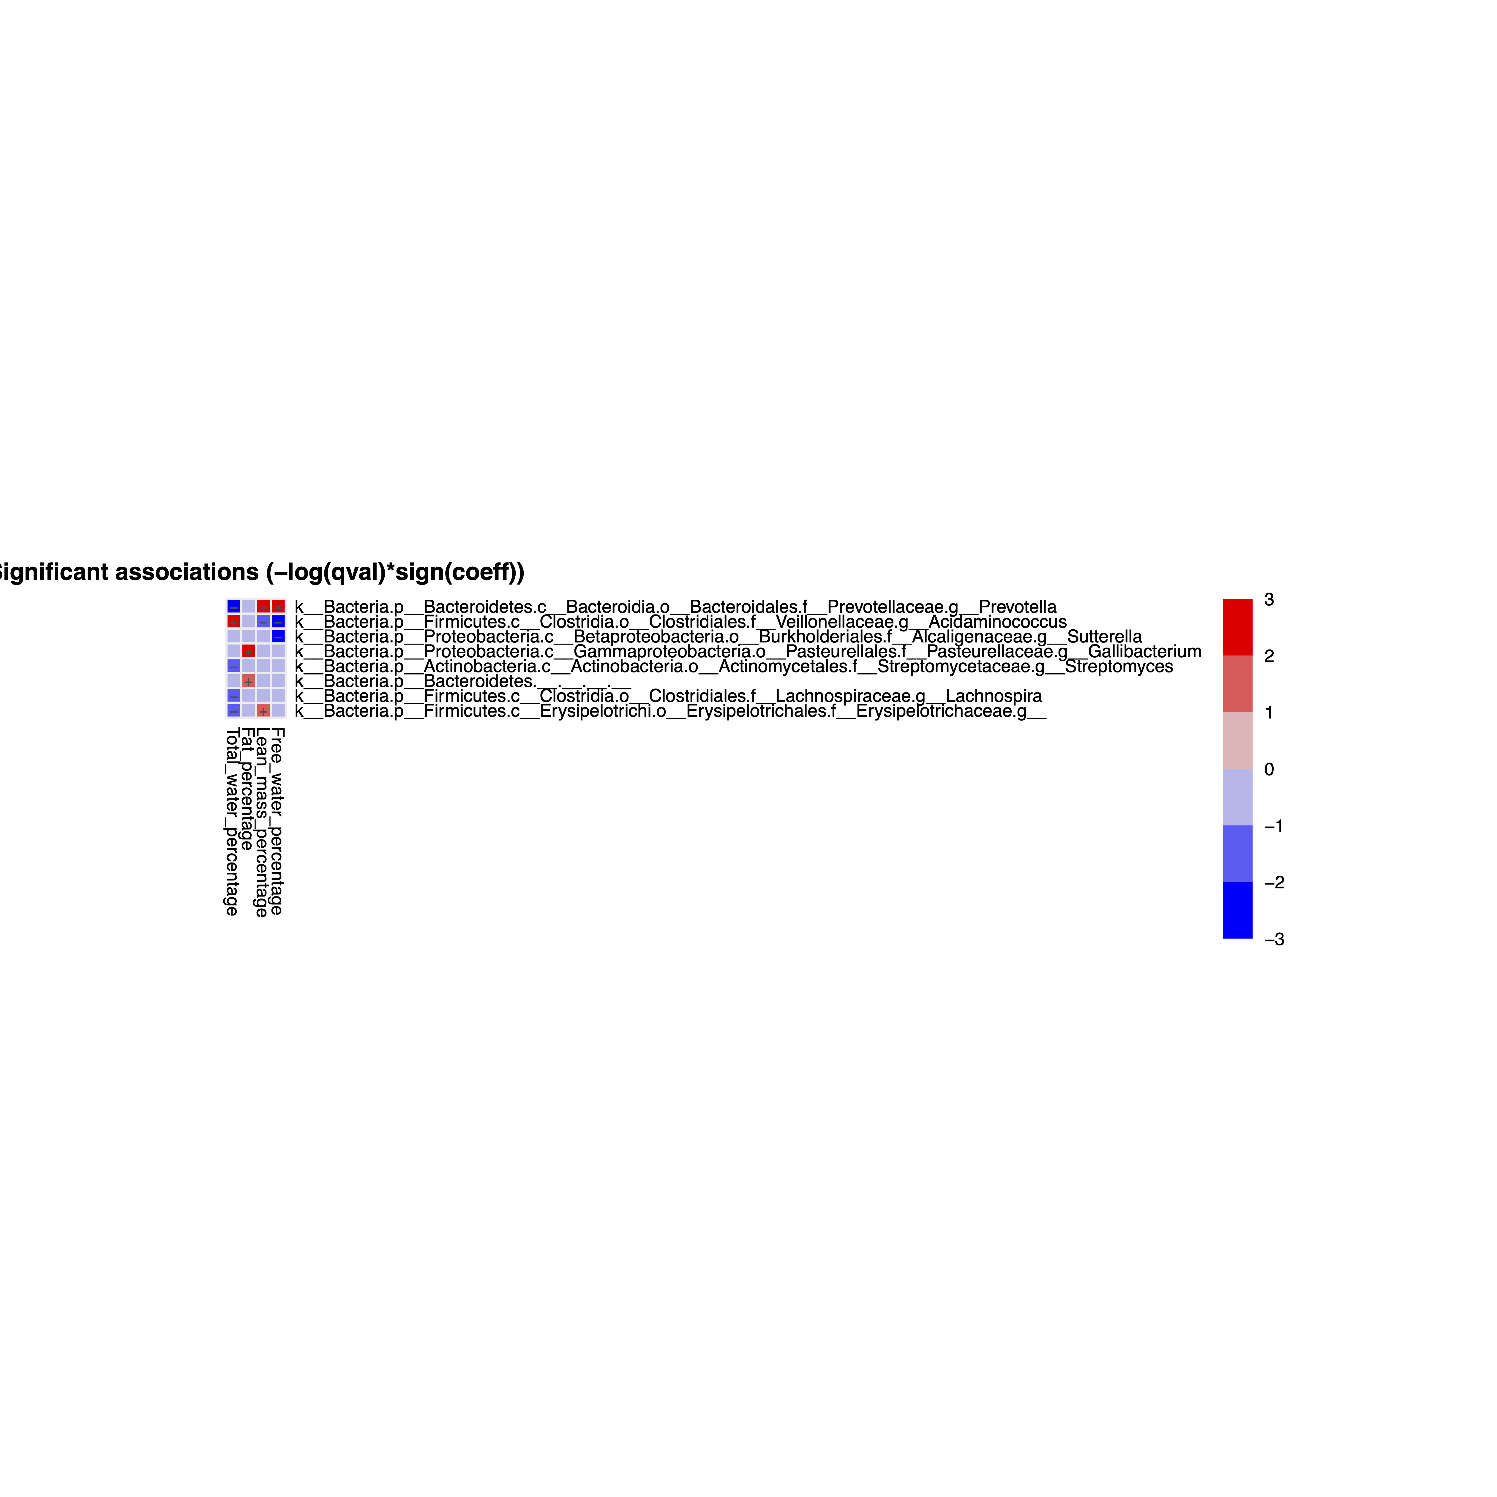

### Weight

I started with looking at microbial associations with weight for ALL mice, not considering hormone or day as effects, but including mouse ID as a random effect. To me, this is asking if, ignoring the experiment itself, can variation in weight across our samples be correlated with certain microbial taxa?

I ran this at the phylum and genus level, and found many significant effects for both. I won’t include ALL of the figures here, but will show the full table of significant results, and highlight some key taxa.

**Phylum Level:**

These results seems to correlate with commonly understood microbial correlations with adiposity: higher *Firmicutes*, *Proteobacteria*, and *Actinobacteria,* and lower *Bacteroidetes* and *Verrucomicrobia*.

Here is the figure for *Firmicutes*:

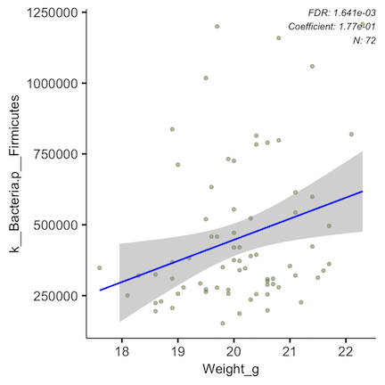

**Genus Level:**

Many of these taxa also popped up on our longitudinal analyses of the hormone groups (e.g., Lactobacillaceae, *Faecalibacterium*, *Clostridium*, *Megamonas*, etc.)

Several are also well-studied in the context of metabolism and body mass, like *Akkermansia*, *Blautia*, *Bacteroides*, and *Lactobacillus*.

Here are the plots for *Lactobacillus*, *Akkermansia*, and *Bacteroides*:

*Lactobacillus*

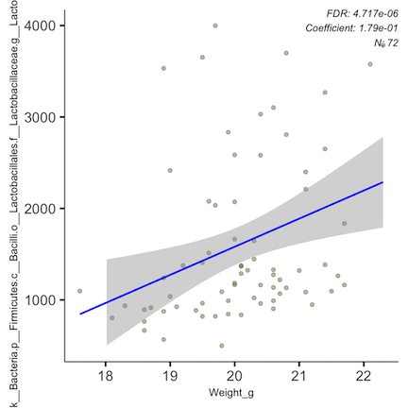

*Akkermansia*

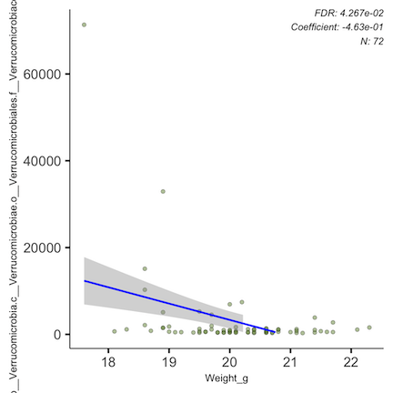

*Bacteroides*

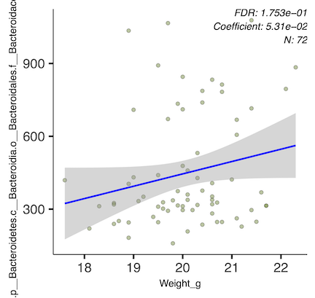

I next wanted to run analyses looking to integrate this into our actual experimental design. We can’t really parse out cause and effect, but I wanted to know if either a) Hormone exposure-driven changes in weight produce corresponding shifts in microbiome composition, or b) Hormone exposure-driven changes in microbiome composition produce corresponding shifts in weight.

I wasn’t sure what to include as fixed and random effects, and I didn’t want to miss any interesting results, so I ran a bunch of different combinations (with mouse ID always included as a random effect):

1. Hormone as a fixed effect with an interaction term (Weight:Hormone), and day as a random effect
2. Analyses run on each hormone group independently with day as a random effect
3. Analyses run on each hormone group independently with day as a fixed effect, filtering out the weird day 8 data

Here are the stats for analysis 1:

**Phylum Level:**

**Genus Level:**

The second analysis narrowed down our list of significant genera (see stats table below). Interestingly, one genus, **“SMB53”** within *Clostridiaceae*, which did not appear in our initial analysis list, now emerges as both positively associated with body weight AND with the PGH group. No other taxa appeared to be significantly associated with both weight and hormone group from this analysis.

Here are the associated figures for **“SMB53”**:

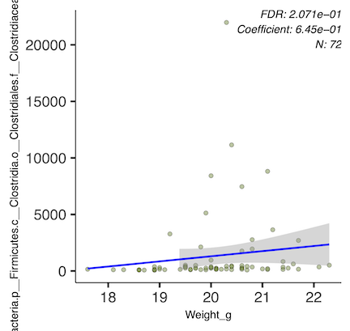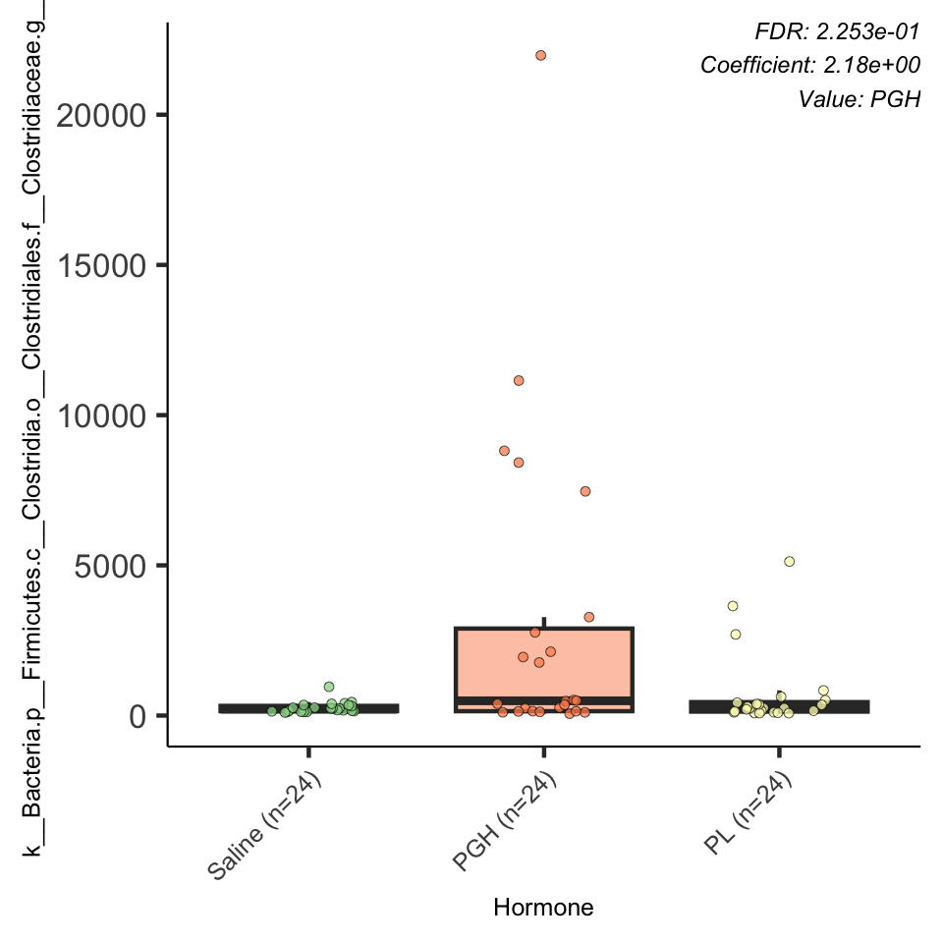

In the third analysis, day was included as a random effect and each hormone group was assessed independently.

In the PGH-dosed mice, significant weight-taxa correlations (done at genus and family level) were limited to “SMB53”, *Akkermansia*, *Mogibacteriaceae*, *Bacillales*, *Streptophyta*, and *Lactobacillaceae*.

In the PL-dosed mice, significant weight-taxa correlations (done at genus level) were primarily limited to members of *Lactobacillales*. Here is the full list:

As an example, here is the figure showing the correlation of *Lactobacillus* abundance and weight in PL mice:

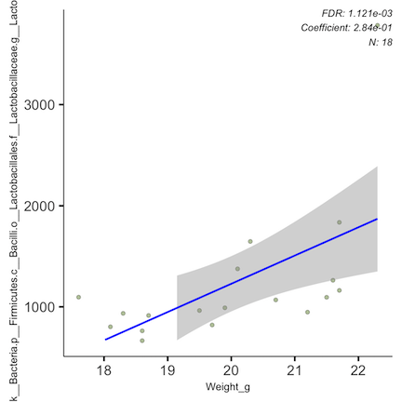

This is relationship is also very clear at the order level of *Lactobacillales*: 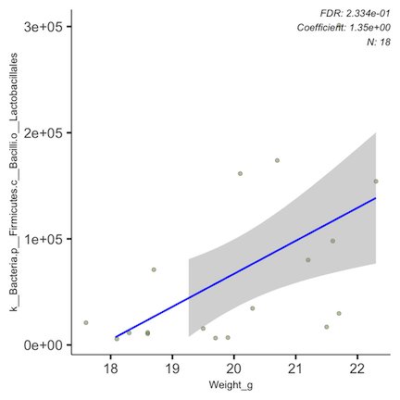

In fourth analysis, day was included as fixed effect and day 8 samples were filtered out (for each hormone group independently).

In the PGH mice, **“SMB53”** appeared again, showing a significant increase over time and with increasing weight: 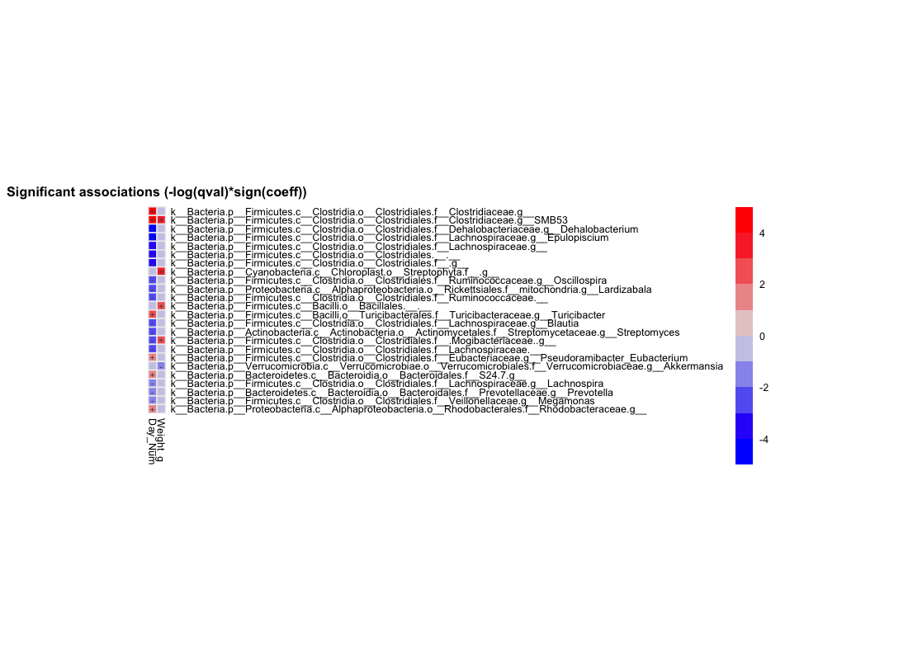

Other than that, the PGH correlations with time and with weight largely match those discussed above.

In PL mice, there was no overlap in the taxa that significantly changed over time and that significantly explained within-group weight variation. However, this analysis also highlighted the strong longitudinal decreases in the order *Clostridiales* in PL mice. I re-ran the analysis at the order level to make this figure demonstrating that:

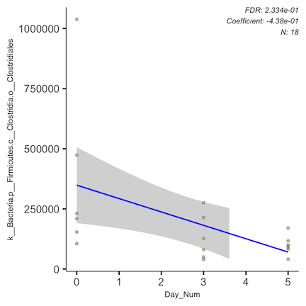

Here’s the genus-level stats:

And here’s the order-level stats: